MA/CSSE 474 Day 35 Summary
- An example of a program for which it is difficult to tell whether it always halts.
- The language H = {<M, w> : TM M halts on input string w} Is H decidable?
  - Of course we can decide halting for specific simple TMs. Or can we? (Collatz conjecture, 1937, still no proof).
  - It's easy to see that H is semidecidable.
M'_{H}(<M, w>) =
1. Run M on w.
2. Accept.
    - M'_{H} accepts <M, w> iff M halts on input w.
    - So M'_{H} semidecides H
    - Can there be a TM that decides H?
- The language H = {<M, w> : TM M halts on input string w} is not decidable.
  - Proof
  - This proof can be viewed as a diagonalization argument
- If H were in D, then SD would equal D

- Every CF language is in D.
- D is closed under complement
- SD is not closed under complement.
- A language L is in D iff both L and its complement are in SD.
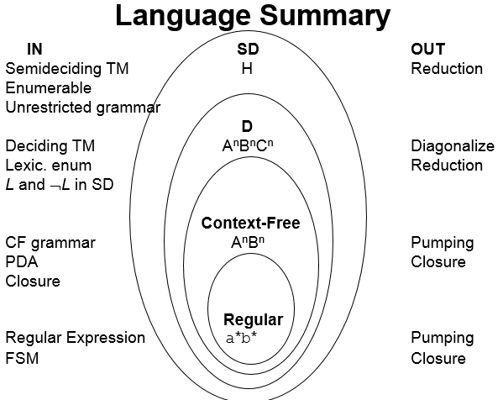
- The language
¬H = {<M, w> : TM M does not halt on input
string w}
is not in SD.
- A language is Turing-enumerable iff there is a Turing machine that enumerates it.
  - Another term that is often used is recursively enumerable.
- A language is SD iff it is Turing-enumerable.
- A language is in D iff it is lexicographically Turing-enumerable.

