MA/CSSE 474 Day 34 Summary
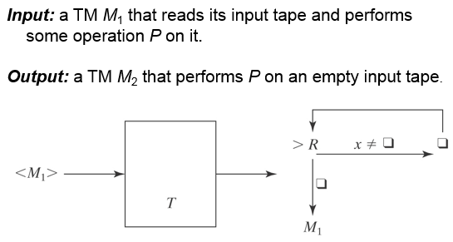
- Recap of TM encoding from last class (a place for your notes, if any).
We can enumerate all TMs, so that we have the concept of "the ith TM"
- We can have processes (TMs?) whose input and outputs are TM encodings:

- Encoding multiple inputs: <x₁, x₂, …x_{n}>

- Specification of U, the Universal Turing Machine (UTM):
  - U starts with <M,w> on its input tape, then simulates M's action when it has input w:
  - U halts iff M halts on w.
  - If M is a deciding or semideciding machine, then:
    - If M accepts, U accepts.
    - If M rejects, U rejects.
  - If M computes a function, then U(<M, w>) must equal M(w).
- Operation of U
  - Three tapes:
    - M's tape
    - <M>
    - M's state
  - Initialize U:
    - start with <M,W> on tape 1
    - Move the <M> part to tape 2, leaving <w> on tape 1.
    - Figure out how many bits in encoded states, and use this to write <s> on tape 3.
  - U simulates a move of M. Repeat:
    - On tape 2 find a quintuple on tape 2 (if any) that matches the current state and tape symbol
    - Perform the transition by appropriately changing tapes 1 and 3
    - If no matching quintuple on tape 2, halt
    - If U halts, report the same info that M would report.
- How long does U take to run?
- The Church-Turing Thesis: If it is computable, it can be computed by a Turing Machine.

- Recap: TMs as language recognizers. Let M = (K, Σ, Γ, δ, s, {y, n}).
  - M accepts a string w iff (s, ☐w) |-_{M}* (y, w′) for some string w′.
  - M rejects a string w iff (s, ☐w) |-_{M}* (n, w′) for some string w′.
  - M decides a language L ⊆ Σ* iff for any string w ∈ Σ* it is true that:
    - w ∈ L → M accepts w, and
    - w ∉ L → M rejects w.
  - A language L is decidable (in the set D) iff there is a Turing machine M that decides it.
  - M semidecides L iff, for any string w ∈ Σ_{M}*:
    - w ∈ L → M accepts w
    - w ∉ L → M does not accept w. For each string w, M may either reject or fail to halt.
  - A language L is semidecidable (in the set SD) iff there is a Turing machine that semidecides it.
  - Clearly SD contains D, and SD is properly contained in the set of all languages (countability argument)
- Complement: relative to what universe?
  - For now, we will usually consider that universe to be the set of strings that fit the syntax of the problem.
  - Define the complement of any language L whose member strings include at least one Turing machine description to be with respect to a universe of strings that are of the same syntactic form as L.
  - If L₁ = {<M, w> : TM M halts on input string w}, then ¬L₁ = {<M, w> : TM M does not halt on input string w}.
- The language H = {<M, w> : TM M halts on input string w} Is H decidable?
  - Of course we can decide halting for specific simple TMs. Or can we? (Collatz conjecture, 1937, still no proof).
  - It's easy to see that H is semidecidable.
M'_{H}(<M, w>) =
1. Run M on w.
2. Accept.
    - M'_{H} accepts <M, w> iff M halts on input w.
    - So M'_{H} semidecides H

