MA/CSSE 474 Day 33 Summary
- TM extensions. For each extension, we can show that every extended machine has an equivalent basic machine.
  - Multi-track TM. Implementation: Input symbols are tuples of the input symbols from the tracks
  - Multiple-tape TM
    - The transition function for a k-tape Turing machine:
- Example: Use two tapes to add two natural numbers (represented in binary)
Exercise: Use multiple tapes to multiply two natural numbers represented in binary. Description can be high-level.

- Theorem (adding tapes adds no computing power): Let M = (K, Σ , Γ, δ, s, H} be a k-tape Turing machine for some k > 1. Then there is a standard TM M' where Σ ⊆ Σ', and:
      - On input x, M halts with output z on the first tape iff M' halts in the same state with z on its tape.
      - On input x, if M halts in n steps, M' halts in O(n2) steps.
        - Proof by construction:
          - Treat the single tape as if it were multi-track. This gives M' a large number of tape symbols.

- Encoding a TM M = (K, Σ, Γ, δ, s, H) as a string <M>:
Example:
q0000
q0001 q0010 y0011 n0100 q0101 q0110 q0111 q1000

    - Encode the states: Let i be ⎡log₂(|K|)⎤.
      - Number the states from 0 to |K|-1 in binary (i bits for each state number):
      - The start state, s, is numbered 0; Number the other states in any order.
      - If t′ is the binary number assigned to state t, then:
        - If t is the halting state y, assign it the string yt′.
        - If t is the halting state n, assign it the string nt′.
        - If t is the halting state h, assign it the string ht′.
Example: Γ = { ☐, b, c, d }.
☐ = a00
b = a01
c = a10
d = a11

        - If t is any other state, assign it the string qt′.
    - Encode the tape alphabet: Let j be ⎡log₂(|Γ|)⎤.
      - Number the tape alphabet symbols from 0 to |Γ| - 1 in binary.
      - The blank symbol is always symbol number 0.
      - The other symbols can be numbered in any order.
    - Encode a transition: (state, input, state, output, move_direction). Example: (q000,a000,q110,a000,→)
    - Encode s and H (already included in the above)
    - A special case of TM encoding
      - One-state machine with no transitions that accepts only ε is encoded as (q0)
    - Encode other TMs: The encoding is just a list of the machine's transitions (in any order). Details on slides.

    - Consider the alphabet Σ = {(, ), a, q, y, n, h, 0, 1, comma, →, ←}. Is the following question decidable?
      - Given a string w in Σ*, is there a TM M such that w = <M> ?
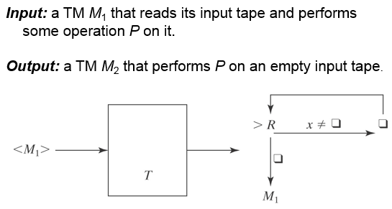
- We can enumerate all TMs, so that we have the concept of "the ith TM"
- We can have processes (TMs?) whose input and outputs are TM encodings:

- Encoding multiple inputs: <x₁, x₂, …x_{n}>

- Specification of U, the Universal Turing Machine (UTM):
  - U starts with <M,w> on its input tape, then simulates M's action when it has input w:
  - U halts iff M halts on w.
  - If M is a deciding or semideciding machine, then:
    - If M accepts, U accepts.
    - If M rejects, U rejects.
  - If M computes a function, then U(<M, w>) must equal M(w).
- Operation of U
  - Three tapes:
    - M's tape
    - <M>
    - M's state
  - Initialize U:
    - start with <M,W> on tape 1
    - Move the <M> part to tape 2, leaving <w> on tape 1.
    - Figure out how many bits in encoded states, and use this to write <s> on tape 3.
  - U simulates a move of M. Repeat:
    - On tape 2 find a quintuple on tape 2 (if any) that matches the current state and tape symbol
    - Perform the transition by appropriately changing tapes 1 and 3
    - If no matching quintuple on tape 2, halt
    - If U halts, report the same info that M would report.
- How long does U take to run?
- The Church-Turing Thesis: If it is computable, it can be computed by a Turing Machine.

