MA/CSSE 474 Day 31 Summary

- TMs as language recognizers. Let M = (K, Σ, Γ, δ, s, {y, n}).
a) M accepts a string w iff (s, qw) |-M* (y, w′) for some string w′.
b) M rejects a string w iff (s, qw) |-M* (n, w′) for some string w′.
c) M decides a language L ⊆ Σ* iff for any string w ∈ Σ* it is true that:
i) if w ∈ L then M accepts w, and
ii) if w ∉ L then M rejects w.
d) A language L is decidable iff ________________________________________.
e) We define the set D to be the set of all decidable languages.
f) M semidecides L iff, for any string w ∈ ΣM*:
i) w ∈ L → M accepts w
ii) w ∉ L → M does not accept w. M may either ________________ or _____________________.
g) A language L is semidecidable iff there is a Turing machine that semidecides it.
h) We define the set SD to be the set of all semidecidable languages.
i) Another term that means the same thing as semidecidable: recursively enumerable.
j) Regular languages ⊂ CFLs ⊂ D ⊆ SD ⊆ all languages. [The last two ⊆s are realy ⊂s, but we still need to show it].
- TMs can compute functions. Let M = (K, Σ, Γ, δ, s, {h}).
a) M(w) = z iff (s, ☐w) |-M* (h, ☐z).
b) Let Σ′ ⊆ Σ be M’s output alphabet, and let f be any function from Σ* to Σ′*.
i) M computes f iff, for all w ∈ Σ*:
(1) if w is an input on which f is defined, then M(w) = f(w).
(2) otherwise M(w) does not halt.
c) A function f is recursive or computable iff there is a Turing machine M that computes it and that always halts.
d) Computing numeric functions:
i) For any positive integer k, valuek(n) returns the nonnegative integer that is encoded, base k, by the string n.
ii) TM M computes a function f from ℕm to ℕ iff, for some k, valuek(M(n1;n2;…nm)) = f(valuek(n1), … valuek(nm)).
Notice that the TM's function computes with strings (Σ* ↦ Σ′*), not directly with numbers.
- TM extensions. For each extension, we can show that every extended machine has an equivalent basic machine.
  - Multi-track TM. Input symbols are tuples of the input symbols from the tracks
  - Multiple-tape TM
    - The transition function for a k-tape Turing machine:
- Theorem (adding tapes adds no computing power): Let M = (K, Σ , Γ, δ, s, H} be a k-tape Turing machine for some k > 1. Then there is a standard TM M' where Σ ⊆ Σ', and:
      - On input x, M halts with output z on the first tape iff M' halts in the same state with z on its tape.
      - On input x, if M halts in n steps, M' halts in O(n2) steps.
        - Proof by construction:
          - Treat the single tape as if it were multi-track. This gives M' a large number of tape symbols:
- Example: Use two tapes to add two natural numbers (represented in binary)

- Exercise: Use multiple tapes to multiply two natural numbers (represented in binary)
- Encoding a TM M = (K, Σ, Γ, δ, s, H) as a string <M>:
    - Encoding the states: Let i be ⎡log₂(|K|)⎤.
      - Number the states from 0 to |K|-1 in binary (i bits for each state number):
      - The start state, s, is numbered 0; Number the other states in any order.
      - If t′ is the binary number assigned to state t, then:
        - If t is the halting state y, assign it the string yt′.
        - If t is the halting state n, assign it the string nt′.
        - If t is the halting state h, assign it the string ht′.
        - If t is any other state, assign it the string qt′.
    - Encoding the tape alphabet: Let j be ⎡log₂(|Γ|)⎤.
      - Number the tape alphabet symbols from 0 to |Γ| - 1 in binary.
      - The blank symbol is number 0.
      - The other symbols can be numbered in any order
    - Encoding the transitions:
      - (state, input, state, output, direction to move)
      - Example: (q000,a000,q110,a000,→)
    - Encoding s and H (already included in the above)
    - A special case of TM encoding
      - One-state machine with no transitions that accepts only ε is encoded as (q0)
    - Encoding other TMs: It is just a list of the machine's transitions:
      - Detailed example on slide
    - Consider the alphabet Σ = {(, ), a, q, y, n, h, 0, 1, comma, →, ←}. Is the following question decidable?
      - Given a string w in Σ*, is there a TM M such that w = <M> ?
- We can enumerate all TMs, so that we have the concept of "the ith TM"
- We can have processes (TMs?) whose input and outputs are TM encodings: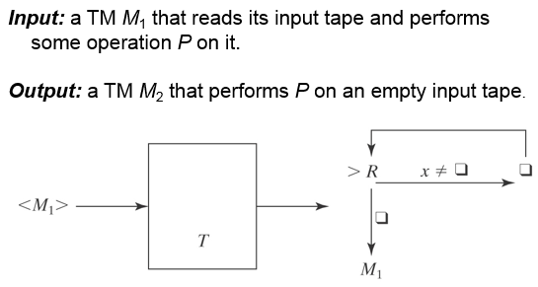
- Encoding multiple inputs: <x₁, x₂, …x_{n}>

