MA/CSSE 474 Day 29 Summary
- A macro language for TMs. On a separate handout. You need to learn to read and write this language.
Suggestion: Write notes about the macro language on your handout.
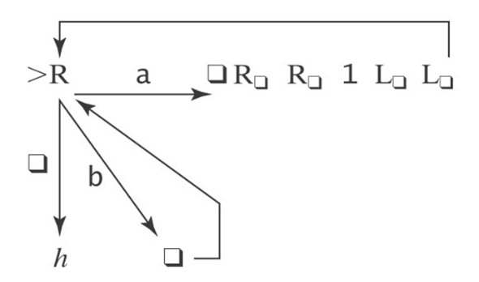
- Exercise: What does this machine do?
- Exercise: Initial input on the tape is an integer written in binary, most significant bit first (110 represents 6).
Design a TM that replaces the binary representation of n by the binary representation of n+1.
- TMs as language recognizers. Let M = (K, Σ, Γ, δ, s, {y, n}).
  - M accepts a string w iff (s, ☐w) |-_{M}* (y, w′) for some string w′.
  - M rejects a string w iff (s, ☐w) |-_{M}* (n, w′) for some string w′.
  - M decides a language L ⊆ Σ* iff for any string w ∈ Σ* it is true that:
    - if w ∈ L then M accepts w, and
    - if w ∉ L then M rejects w.
  - A language L is decidable iff there is a Turing machine M that decides it.
  - We define the set D to be the set of all decidable languages.
  - M semidecides L iff, for any string w ∈ Σ_{M}*:
    - w ∈ L → M accepts w
    - w ∉ L → M does not accept w. M may either reject or fail to halt.
  - A language L is semidecidable iff there is a Turing machine that semidecides it.
  - We define the set SD to be the set of all semidecidable languages.

