MA/CSSE 474 Day 28 Summary
- Turing machine (TM) intro
  - Tape alphabet, blank symbol, two-way-infinite tape, read/write head.
  - Transition: based on current state and tape symbol, the TM
    - Changes to next state
    - Writes a symbol on current tape square
    - Moves left or right (
      - In some other authors' equivalent TM models, staying on same square is option. Not here.
  - Formal TM definition. A deterministic TM M is (K, Σ, Γ, δ, s, H):
    - K is a finite set of states;
    - Σ is the input alphabet, which does not contain ☐;
    - Γ is the tape alphabet, which must contain ☐ and have Σ as a subset.
    - s ∈ K is the initial state;
    - H ⊆ K is the set of halting states;
    - δ is the transition function: (for a nondeterministic TM, we will need a more general relation Δ )
(K - H) × Γ to K × Γ × {→, ←}
non-halting × tape → state × tape × direction to move
state char char (R or L)

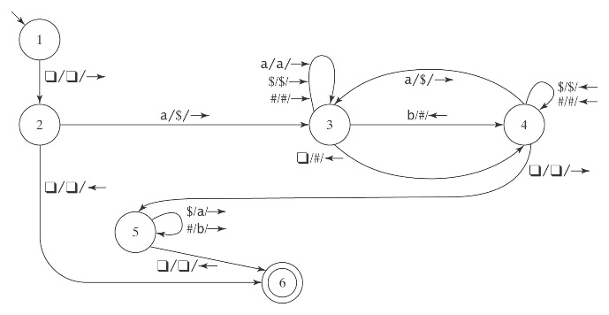
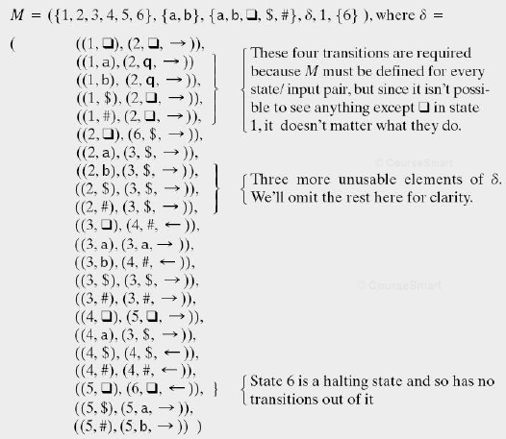
- Example: M takes as input a string in the language: {a^{i}b^{j}, 0 ≤ j ≤ i}, and adds b’s as required to make the number of b’s equal the number of a’s.

- We will see how this machine works on several inputs.
- You should then trace its action on aab:

- Halting:
  - DFSM:
  - PDA:
  - TM:
- Formal definitions of TM computation. Most of this is like same definitions for FSM, PDA.
  - Configuration: an element of
K × ((Γ- {☐}) Γ*) ∪ {ε} × Γ × (Γ* (Γ- {☐})) ∪ {ε}
state before current after
current square current
square square

  - Abbreviation: (q, ab, b, b) can be abbreviated as (q, abbb). (q, ε, ☐, abbb) as (q, ☐abbb)
  - Initial configuration is always (s, ☐w). Tape head starts on the square before the input string.
  - Yields (similar to FSM and PDA yields, but δ is different):
    - (q₁, w₁) ⊢_{M} (q₂, w₂) iff (q₂, w₂) is derivable, via δ, in one step.
    - For any TM M, let ⊢_{M}* be the reflexive, transitive closure of ⊢_{M}.
    - Configuration C₁ yields configuration C₂ if: C₁ ⊢_{M}* C₂.
    - A path through M is a sequence of configurations C₀, C₁, …, C_{n} for some n ≥ 0 such that C₀ is the initial configuration and C₀ ⊢_{M} C₁ ⊢_{M} C₂ ⊢_{M} … ⊢_{M} C_{n}.
    - A computation by M is a path that halts.
    - If a computation is of length n (has n steps), we can write: C₀ ⊢_{M}^{n} C_{n}
Class exercise: Try to build this TM together: If n and m are non-negative integers, monus(n, m) is defined to be
n – m if n > m, and 0 if n ≤ m.
Draw the diagram for a TM M whose input is 1^{n};1^{m} and whose output is 1^{monus(n, m)} .
When M halts, the read/write head should be positioned on the blank before the first 1.

For practice later: A TM to recognize { ww^{R} : w ∈ {a, b}* }.
If the input string is in the language, the machine should halt with y as its current tape symbol
If not, it should halt with n as its current tape symbol.
The final symbols on the rest of the tape may be anything.

