MA/CSSE 474 Day 27 Summary
If L is a context-free language, then
∃k ≥ 1 (∀ strings w ∈ L, where |w| ≥ k
(∃u, v, x, y, z (w = uvxyz, vy ≠ ε, |vxy| ≤ k,
and
∀q ≥ 0 (uv^{q}xy^{q}z is in L)))).

Main ideas from today:
- {xcy : x, y ∈ {0, 1}* and x ≠ y}
- Variations on PDA: Acceptance by accepting state only, replace stack with queue, two stacks.
- CFL closure:
  - Union. New start symbol: add productions S → S₁, S → S₂
  - Concatenation. New start symbol: add production S → S₁S₂
  - Kleene Star. New start symbol: add productions S → ε, S → S S₁
  - Reverse. Transform grammar to Chomsky Normal form. Replace each production A→BC by A→CB
  - Not closed under complement: Consider A^{n}B^{n}C^{n}. (done a few days ago)
  - Not closed under intersection: L₁ = {a^{n}b^{n}c^{m}: n, m ≥ 0} L₂ = {a^{m}b^{n}c^{n}: n, m ≥ 0}
  - Intersection of a CFL and a regular language is CF (same for difference of a regular lang. and a CF lang.)
  - Don't try to use closure backwards! Sam principle as for regular languages.
- A PDA may never halt or never finish reading its input.
- Nondeterminism can lead to exponential running time.
- Deterministic PDA M:
  - Δ_{M} contains no pairs of transitions that compete with each other, and
  - whenever M is in an accepting configuration it has no available moves.
- A language L is deterministic context-free (DCFL) iff L$ can be accepted by some deterministic PDA.
  - L = a* ∪ {a^{n}b^{n} : n > 0} demonstrates the need for the $ “end-of-input” symbol (details on slides).
  - DCFLs are closed under complement, but not under union or intersection (we will not show these)
- Every CFL over a single-letter alphabet must be regular.
- Algorithms and decision problems for CFLs
  - Membership: Given a CFL L and a string w, is w in L?
    - How not to do it (examples are on the slides)
      - there is a CFG G that generates L. Try derivations in G and see whether any of them generates w.
      - there is a PDA M that accepts L. Run M on w.
    - But, if grammar is in CNF …. (ε is handled as a special case).
      - Works but not very efficient
      - There is an O(N³) dynamic programming algorithm (CKY, a.k.a. CYK)
    - Or, can build a PDA with no ε-transitions from a GNF grammar.
  - Emptiness. Remove unproductive nonterminals form grammar. L empty iff S is not removed.
  - Finiteness. Let b be the branching factor of CFG. If language is infinite, some string of length between b^{n} and
b^{n} + b^{n+1} will be accepted. Enumerate and try them all.
  - Undecidable questions about CFLs:
    - Is L = Σ*?
    - Is the complement of L context-free?
    - Is L regular?
    - Is L₁ = L₂?
    - Is L₁ ⊆ L₂?
    - Is L₁ ∩ L₂ = ∅?
    - Is L inherently ambiguous?
    - Is G ambiguous?

- Turing machine (TM) intro (if there is time, which will be amazing if it happens!)
  - Tape alphabet, blank symbol, two-way-infinite tape, read/write head.
  - Based on current state and tape symbol, the TM
    - Changes to next state
    - Writes a symbol on current tape square
    - Moves left or right (
      - In some other authors' equivalent TM models, staying on same square is option. Not here.
  - Formal TM definition. A deterministic TM M is (K, Σ, Γ, δ, s, H):
    - K is a finite set of states;
    - Σ is the input alphabet, which does not contain ☐;
    - Γ is the tape alphabet, which must contain ☐ and have Σ as a subset.
    - s ∈ K is the initial state;
    - H ⊆ K is the set of halting states;
    - δ is the transition function: (for a nondeterministic TM, we will need a more general relation Δ )
      - (K - H) × Γ to K × Γ × {→, ←}
non-halting × tape → state × tape × direction to move
state char char (R or L)

  - A TM is not guaranteed to halt. And there is no algorithm to take a TM M and find an equivalent TM that is guaranteed to halt.
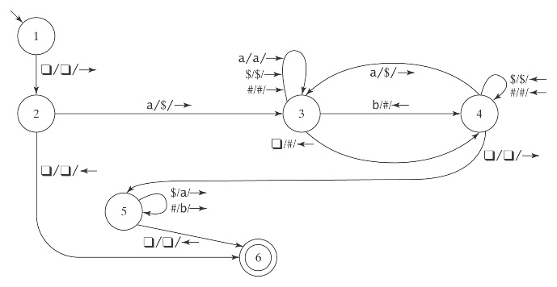
- Example: M takes as input a string in the language: {a^{i}b^{j}, 0 ≤ j ≤ i}, and adds b’s as required to make the number of b’s equal the number of a’s.
- Trace its action on aab:

