MA/CSSE 474 Day 26 Summary
- Context-free pumping theorem:
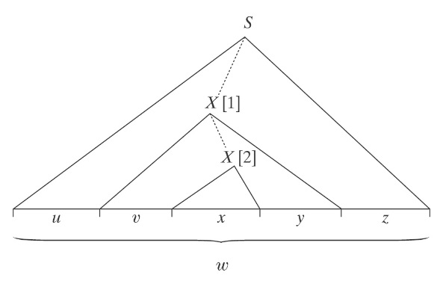
If L is a context-free language, then
∃k ≥ 1 (∀ strings w ∈ L, where |w| ≥ k
(∃u, v, x, y, z (w = uvxyz, vy ≠ ε, |vxy| ≤ k,
and
∀q ≥ 0 (uv^{q}xy^{q}z is in L)))).

- As with the reg.-lang. pumping theorem, to show a language is not CF, we use the contrapositive. We do not get to choose the k or the breakdown into uvxyz. We choose the wεL, and for each breakdown, q a such that uv^{q}xy^{q}z∉L.
- Make note of the slide on similarities and differences between the two pumping theorems.
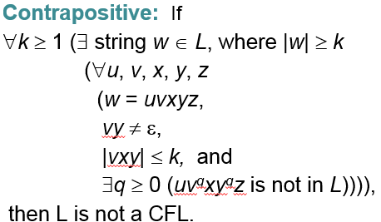
- A^{n}B^{n}C^{n} = {a^{n}b^{n}c^{n}, n ≥0} Three regions (1: all a’s, 2: all b’s, 3: all c’s)

- { $a^{n^{2}}$ : n ≥ 0}
- L = {a^{n}b^{m}a^{n}, n, m ≥ 0 and n ≥ m}.
Let w = a^{k}b^{k}a^{k}
aaa … aaabbb … bbbaaa … aaa
| 1 | 2 | 3 |

- WcW = {wcw : w ∈ {a, b}*}
- {(ab)^{n}a^{n}b^{n} : n > 0}

- {xcy : x, y ∈ {0, 1}* and x ≠ y}

- A PDA may never halt or never finish reading its input.
- Nondeterminism can lead to exponential running time.
- CFL closure:
  - Union. New start symbol: add productions S → S₁, S → S₂
  - Concatenation. New start symbol: add production S → S₁S₂
  - Kleene Star. New start symbol: add productions S → ε, S → S S₁
  - Reverse. Transform grammar to Chomsky Normal form. Replace each production A→BC by A→CB

