MA/CSSE 474 Day 25 Summary (and probably Day 26 also)
- Theorem from last class: The class of languages accepted by PDAs is exactly the class of context-free languages.
Recall: context-free languages are languages that can be defined by context-free grammars.
  - CFG → PDA is the easy direction, and the one with the most practical use
    - Two approaches: Top-down parser and Bottom-up parser
- Top-down parser PDA M from CFG G. Discovers a rightmost derivation from beginning to end.
  - Mirror the productions: Production A → XYZ becomes (q, ε, A) → (q, XYZ)
  - Match terminal symbols: (q, a, a) → (q, ε)
  - Get the process started: (s, ε, ε) → (q, S) [s is the start state of M, different from q] [S is start symbol of G]
  - The stack holds unmatched terminals and unexpanded nonterminals.
- Bottom-up parser PDA M from CFG G. Discovers a leftmost derivation from end to beginning.
  - Mirror the productions: Production A → XYZ becomes (p, ε, ZYX) → (p, A) [p is the start state of M]
  - Shift terminal symbols from input to stack: (p, a, ε) → (p, a)
  - Get the process started: (p, ε, S) → (q, ε) [q is accepting state of M, different from q] [S is start symbol of G]
  - The stack holds prefixes of right sides of rules.

- Show the transitions as the parser from the "bottom-up" slide parses "id + id * id" (write small or use two colmns)
state stack unread input transition to use next

- The number of languages over alphabet Σ is uncountable; number of context-free languages is countably infinite.
- How to show that a language is context-free:

- Context-free pumping theorem:
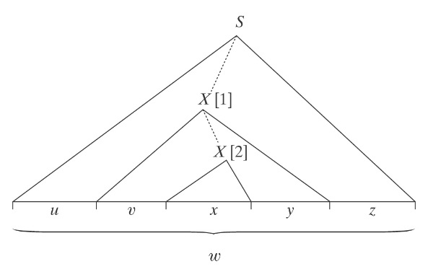
If L is a context-free language, then
∃k ≥ 1 (∀ strings w ∈ L, where |w| ≥ k
(∃u, v, x, y, z (w = uvxyz, vy ≠ ε, |vxy| ≤ k,
and
∀q ≥ 0 (uv^{q}xy^{q}z is in L)))).

- As with the reg.-lang. pumping theorem, to show a language is not CF, we use the contrapositive. We do not get to choose the k or the breakdown into uvxyz. We choose the wεL, and for each breakdown, q a such that uv^{q}xy^{q}z∉L.
- Make note of the slide on similarities and differences between the two pumping theorems.
- A^{n}B^{n}C^{n} = {a^{n}b^{n}c^{n}, n ≥0} Three regions, two cases, details on slides.

- { $a^{n^{2}}$ : n ≥ 0}
- L = {a^{n}b^{m}a^{n}, n, m ≥ 0 and n ≥ m}.
Let w = a^{k}b^{k}a^{k}
aaa … aaabbb … bbbaaa … aaa
| 1 | 2 | 3 |

- WcW = {wcw : w ∈ {a, b}*} (details on slide)
- {(ab)^{n}a^{n}b^{n} : n > 0}

- {x#y : x, y ∈ {0, 1}* and x ≠ y}

