MA/CSSE 474 Day 16 Summary
- L = {a^{n}: n is prime} . For a given k, let w =
  - If w = xyz, then y =
  - It L is regular, then ∀q ≥ 0 (a must be in L).
  - Choose q = Then
  - |x| + |z| +q⋅|y| =
  - How do we know that this is composite (non-prime)?

- L = {a^{i}b^{j}: i, j ≥ 0 and i ≠ j} See slides for difficulty with using the pumping theorem for L.
Don’t try to copy what’s there. Use this space for notes and questions.

- L = { a^{i}b^{j}c^{k} : i, j, k ≥ 0 and (if i=1 then j=k) } . This is example 8.16 in the textbook. Be sure to look at it.
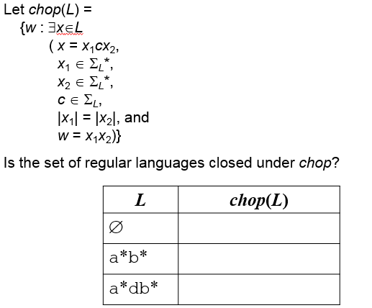
- Also see example 8.20, 8.22, 8.23 in the textbook.
Is the set of regular languages closed chop?
What do we need to do
  - If the answer is yes?
  - If the answer is no?

- What is a decision procedure? (we’ll do as many examples as we have time for today. All are in the textbook.
- Given a DFSM M=(Κ,Σ, δ, s, A) and a string w ∊ Σ*, is w ∊ L(M)?
  - boolean decideFSM(FSMdescription <M>, string w) { // is w in L(M)?
}
  - decideregex(regex α, string w){
}
- Given an FSM M, is L(M) empty?
  - Graph analysis approach:
  - Simulation approach:
  - Minimal DFSM approach

- Totality: Given an FSM M, is L(M) = Σ_{M}*?

- Given an FSM M, is L(M) finite?
  - Graph analysis approach:
  - Simulation approach:
- Equivalence: Given FSMs M1 and M2, is L(M1) = L(M2)?
- Minimality: Given a DFSM M, is it minimal?

