MA/CSSE 474 Day 13 Summary
- Recap: For Every DFSM, there is an equivalent regular expression:
  - Number the states q₁, …, q_{n}.
  - Define R_{ijk} to be the set of all strings x ∈ Σ* such that
(q_{i},x) |-_{M}* (q_{j}, ε), and
if (q_{i},y) |-_{M}* (q_{𝓁}, ε), for any prefix y of x (except y=ε and y=x), then 𝓁 ≤ k
  - That is, R_{ijk} is the set of all strings that take us from q_{i} to q_{j} without passing through any intermediate states numbered higher than k.
    - In this case, "passing through" means both entering and leaving.
    - Note that either i or j (or both) may be greater than k.
- Formulas for R_{ijk}:
  - Base cases (k = 0):
    - If i ≠ j, R_{ij0} = {a∈Σ : δ(q_{i}, a) = q_{j}}
    - If i = j, R_{ii0} = {a∈Σ : δ(q_{i}, a) = q_{i}} ∪ {ε}
  - Recursive case (k > 0):
R_{ijk} is R_{ij(k-1)} ∪ R_{ik(k-1)}(R_{kk(k-1)})*R_{kj(k-1)}
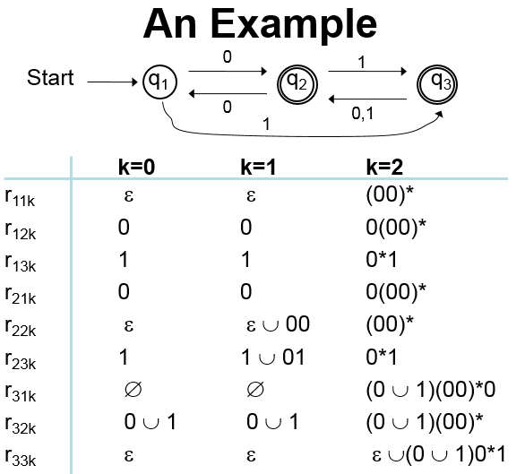
- In the DFSMtoRegExp example machine M from the slides, show how to get
r₂₂₁
r₁₃₂
r₁₂₃

r₁₃₃
A regular expression r such that L(R) = L(M)
- Many programming languages include regular-expression processing. Examples we will look at are from Perl. Most other programming languages have very similar notation.
  - The number of operators is extended significantly.
  - The addition of variables enables the recognition of some languages that are not regular.
  - Examples:
    - \b[A-Za-z0-9_%-]+@[A-Za-z0-9_%-]+(\.[A-Za-z]+){1,4}\b
    - ^([ab]*)\1$
    - \b([A-Za-z]+)\s+\1\b
    - $text =~ s/\b([A-Za-z]+)\s+\1\b/\1/g;
- Rich pages 150-151 has a list of rules for simplifying REs, but you can also use "what language is this?".
- The number of languages over any nonempty alphabet Σ is uncountable.
  - Suppose we could enumerate all languages over Σ={a} as L₀, L₁, …
  - Consider L_{d} = {a^{i} : i ≥ 0 and a^{i} ∉ L_{i}}. Is there a j such that L_{d} = L_{j} ?
- The number of regular languages over any nonempty alphabet Σ is countable. How do we know?
- Are there more regular languages or non-regular ones?
- Finite languages are regular, but not necessarily tractable.
- What are the approaches that we have seen so far for showing that a language is/isn't regular?
is: is not:
Closure properties of regular languages: closed under union, concatenation, Kleene star, complement, difference, reverse, letter substitution (a function that maps each letter in Σ to a string in Σ').
- In the homework you showed closure under intersection by construction. We can also do it using some other closure properties and DeMorgan's laws:
Using closure backwards: If L₁ ∩ L₂ is regular, what can we say about L₁ and L₂?
If L₁ L₂ is regular, what can we say about L₁ and L₂?
- Showing that a language is not regular.
  - All non-regular languages are infinite.
  - Where does "infiniteness" come from in a regular language?
    - Regular expression approach:
    - DFSM approach:
  - If a DFSM has k states and a string whose length is at least k …
  - This is the basis for the "pumping theorem" (also known as the "pumping lemma") for regular languages.
- Pumping theorem: Informally: If L is regular, then every long string in L is "infinitely pumpable (in and out)".
The contrapositive form:
(

)
)
)
)
)
→ L is not regular

Formally, if L is regular, then
∃k ≥ 1 such that
(∀ strings w ∈ L,
(|w| ≥ k →
(∃ x, y, z (w = xyz,
|xy| ≤ k,
y ≠ ε, and
∀q ≥ 0 (xy^{q}z is in L)))))
- Example: {a^{n}b^{n}: n ≥ 0}

