MA/CSSE 474 Day 12 Summary
- For Every DFSM, there is an equivalent regular expression:
  - Number the states q₁, …, q_{n}.
  - Define R_{ijk} to be the set of all strings x ∈ Σ* such that
(q_{i},x) |-_{M}* (q_{j}, ε), and
if (q_{i},y) |-_{M}* (q_{𝓁}, ε), for any prefix y of x (except y= ε and y=x), then 𝓁 ≤ k
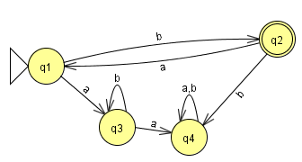
  - That is, R_{ijk} is the set of all strings that take us from q_{i} to q_{j} without passing through any intermediate states numbered higher than k.
    - In this case, "passing through"
means both entering and leaving.
    - Note that either i or j (or both)
may be greater than k.

- Formulas for R_{ijk}:
  - Base cases (k = 0):
    - If i ≠ j, R_{ij0} = {a∈Σ : δ(q_{i}, a) = q_{j}}
    - If i = j, R_{ii0} = {a∈Σ : δ(q_{i}, a) = q_{i}} ∪ {ε}
  - Recursive case (k > 0):
R_{ijk} is R_{ij(k-1)} ∪ R_{ik(k-1)}(R_{kk(k-1)})*R_{kj(k-1)}

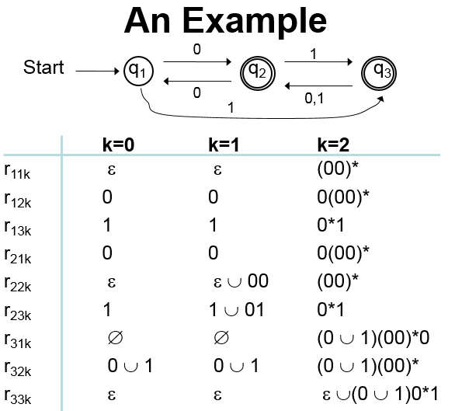
- In the DFSMtoRegExp example machine M
from the slides, show how to get
r₂₂₁
r₁₃₂
r₁₂₃

r₁₃₃
A regular expression r such that L(R) = L(M):

