MA/CSSE 474 Day 09 Summary
- Myhill-Nerode Theorem: A language is regular iff the number of equivalence classes of ≈_{L} is finite.
  - Proof: Show the two directions of the implication:
  - L regular → the number of equivalence classes of ≈_{L} is finite: If L is regular, then
  - The number of equivalence classes of ≈_{L} is finite → L regular: If the cardinality of ≈_{L} is finite, then
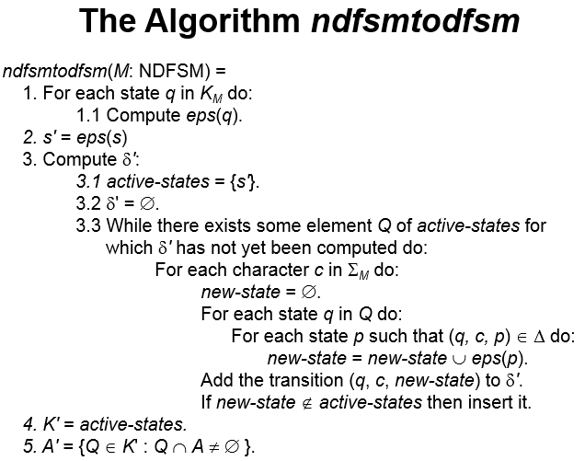
NDFSM->FSM algorithm proof.
- Statement: From any NDFSM M = (K, Σ, Δ, s, A), ndfsmtodfsm constructs a DFSM
M'= (K', Σ, δ', s', A'), which is equivalent to M.
  - K' ⊆ 𝒫(K) (power set of K)
  - s' = eps(s)
  - A' = {Q ⊆ K : Q ∩ A ≠ ∅}
  - δ'(Q, a) = ∪ {eps(p): p ∈ K and
(q, a, p)∈Δ for some q∈Q}
- M' is deterministic. δ' is defined for each reachable state of K' and for each alphabet symbol. And for each state q and symbol a, step 3.3 assigns only one value to δ'(q, a).
- The hard part is showing that L(M') = L(M).
- A useful Lemma: (If this is all we get to today, it's okay, because this is good practice for the exam).
  - Let w be any string in Σ*, let p and q be any states in K, and let P be any state in K'. Then:
(q, w) |-_{M}* (p, ε) iff ((eps(q), w) |-_{M}' * (P, ε) where p ∈ P) .
  - We will only need this lemma for the case q=s, but the more general statement is easier to prove by induction.
  - Informal restatement of the lemma: If the original NDFSM M starts in state q and, after reading the string w, can land in state p ( along at least one of its paths), then the new DFSM M' must behave as follows:
The only-if part implies:

- The lemma: (q, w) |-_{M}* (p, ε) iff ((eps(q), w) |-_{M}' * (P, ε) and p ∈ P) Proof: induction on |w|.
- Base case: w = ε
  - if part: (eps(q), ε) |-_{M}' * (P, ε) ∧ p ∈ P → (q, ε) |-_{M}*(p, ε)
  - only if part: (q, ε) |-_{M}* (p, ε) → (eps(q), ε) |-_{M}'* (P, ε) and p ∈ P
- Induction step: Let w have length k + 1. Then w = zc where z∈Σ* has length k, and c∈Σ.
I.e. Assume that M and M' "behave identically" for the first k input characters; show for k+1 characters.
  - Induction assumption. The lemma is true for z.
  - To show: The lemma is true for w.
- This boils down to showing:
(q, zc) |-_{M}* (s_{i}, c) |-_{M}* (p, ε) iff (eps(q), zc) |-_{M'}* (Q, x) |-_{M'} (P, ε) and p ∈ P
  - If part: (eps(q), zc) |-_{M'}* (Q, c) |-_{M'} (P, ε) and p ∈ P → (q, zc) |-_{M}* (s_{i}, c) |-_{M}* (p, ε)
  - Only if part: (q, zc) |-_{M}* (s_{i}, c) |-_{M}* (p, ε) → (eps(q), zc) |-_{M'}* (Q, c) |-_{M'} (P, ε) and p ∈ P
- Using the lemma to prove the theorem is straightforward.
Recall the theorem: L(M')=L(M). There are two things to show (details are on the last two slides, in case there is not time to write them down before class ends)
  - L(M) ⊆ L(M'). Suppose that w ∈ L(M) (original machine M accepts w):
  - L(M') ⊆ L(M). Prove the contrapositive. Suppose that w ∉ L(M) (i.e. the original NDFSM does not accept w):

