MA/CSSE 474 Day 08 Summary
Recall
- x ≈_{L} y iff ∀z ∈ Σ* (xz ∈ L iff yz ∈ L)
Main ideas from today:
- If L = {aa}{b}*{a}, what are the equivalence classes of ≈_{L}? (Do this one for practice later)
Σ = {a, b}.L = {w ∈ Σ* : |w| is even} (Do this one for practice later)

- L={w ∈ {a, b} *: no two adjacent chars are the same} shows: multiple equivalence classes may be subsets of L.
(equivalence classes are on the slides)
- If L = A^{n}B^{n} = {a^{n}b^{n}: n ≥0 }, what are the equivalence classes of ≈_{L}?
Things that we will state today and probably prove on Monday (4-11 below):
- L regular →, # equivalence classes of ≈_{L} is a lower bound on # states in any DFSM M such that L = L(M).
- Theorem: Let L be a regular language over some alphabetΣ. Then there is a DFSM M that accepts L and that has precisely n states where n is the number of equivalence classes of ≈_{L}. Any other FSM that accepts L must either have more states than M or it must be equivalent to M except for state names.
- Construction: M = (K, Σ, δ, s, A), where:
● K contains n states, one for each equivalence class of ≈_{L}.
● s = [ε], the equivalence classε under ≈_{L} that contains ε.
● A = {[x] : x ∈ L}.
● δ([x], a) = [xa]. In other words, if M is in the state (equiv. class) that contains some string x, then,
after reading the next symbol, a, it will be in the state that contains xa.
- Three things to show (but we won’t show them today):
  - K is finite.
  - δ is a well-defined function. i.e., δ is defined for all (state, input) pairs and produces, for each pair, a unique value.
  - L = L(M). To prove this, we must first show that ∀s,t∊ Σ*( ([ε], st) ⊦_{M}* ([s], t)).
We do this by induction on |s|. The base case is trivial.
- There exists no smaller machine M# that also accepts L.
- There is no different machine M# that also has n states and that also accepts L.
Example:
L = {w ∈ Σ* : no two adjacent characters are the same}

- Myhill-Nerode Theorem: A language is regular iff the number of equivalence classes of ≈_{L} is finite.
- Myhill-Nerode Theorem: A language is regular iff the number of equivalence classes of ≈_{L} is finite.
- Two approaches to minimizing a given DFSM:
  - Start with separate states and merge.
  - Start with overclustering, and then separate distinguishable states. Successively approximate.
- Define ≡ (a relationship on states of a DFSM M) by p≡q iff for every string w ∊ Σ*, either w takes M to an accepting state from both p and q, or w takes M to a rejecting state from both p and q.
- We construct ≡ as the limit of a sequence of approximating equivalence Relations ≡^{n}
  - p ≡⁰ q iff configurations (p, ε) and (q, ε) either both lead to accepting states or both lead to non-accepting states. I.e., ________________________________________'
  - For all k >= 0, p ≡^{k+1} q iff both of the following are true:
p ≡^{k} q
For all a ∊ Σ, δ(p, a) ≡^{k} δ(q, a)
Can you express the meaning of ≡^{n} non-recursively in concise English?

- Example:
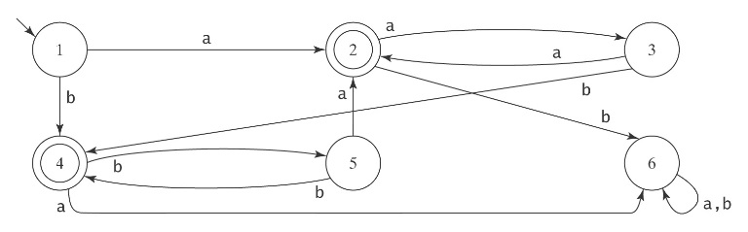

- We can put any DFSM into a canonical form that makes it easy for us to tell whether two machines are "the same". Canonical form. Given a connected DFSM, we can systematically number the states in such a way that any other equivalent machine will have the same numbering and thus be identical. If we apply this to a minimal-state DFSM for language L, we see that there is a unique canonical minimal machine for each regular language.
