MA/CSSE 474 Day 06 Summary
- We look at several DFSMs on the slides. This space is for any notes that you may want to write about them.

- A DFSM for the "missing letter language" is difficult to construct! How many states are needed?

.
- Nondeterminism. Machine may have "transition choices".
  - If one choice leads to acceptance, accept
  - Else if all choices lead to halting and rejecting, reject
  - Else run forever
- Why is nondeterminism necessary for a PDA that accepts PalEven?

- In terms of the formal definitions, what is the major difference between the five components of a DFSM and a NDFSM?
- The two main sources of nondeterminism in an NDFSM:
  - Transitions labeled by _______
  - Multiple transitions out of the same state labeled by _______________________________

- Some uses of Nondeterminism in FSM design:
  - Optional substrings
  - Matching a pattern in the middle of a string
  - Matching any of several possible patterns
  - Matching "from the end of the string"
- Example: A NDFSM for
L = {w ∈ {0, 1}* : w is the binary encoding of a positive integer that is divisible by 16 or is odd}
- For practice later:
L₁= {w ∈ {a, b}*: aa occurs in w}, L₂= {x ∈ {a, b}*: bb occurs in x}, L₃= L₁ ∪ L₂
Design NDFSMs for these languages.
- Know how to compute the epsilon-closures of the states of a NDFSM.
Example:
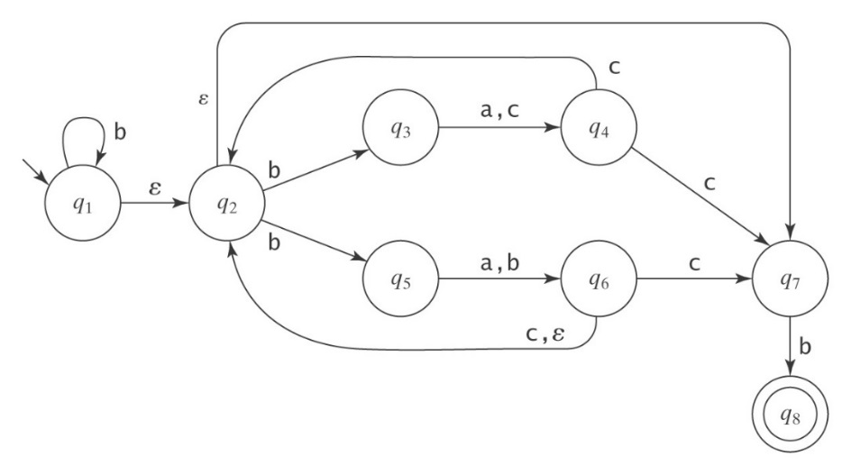
- You should understand and be able to apply the algorithm ndfsmtodfsm. You will get practice with this in HW3.

