MA/CSSE 474 Day 05 Summary
- Constructing one machine based on another machine. Consider the multiplication language:
INTEGERPROD = {w of the form: <int₁>x<int₂>=<int₃>, where each <int_{n}> is an
encoding (decimal in this case) of an integer, and int₃ == int₁ ∗ int₂}

Given a multiplication procedure for integers, we can build a procedure that recognizes the INTEGERPROD language:
This is easy; we did it on Friday.
Suppose we have a machine M(x,y) that multiplies two integers.
Given a string w, if it is not in the form <int1>*<int2>=<int3>, reject. If it is in that form,
X = convertToInt(<int1>)
Y = convertToInt(<int2>)
Z = convertToInt(<int3>)
If z = M(x,y) then accept. Else reject.
Given function R(w) that recognizes INTEGERPROD, build function Mult(m,n) that computes the product of two integers:

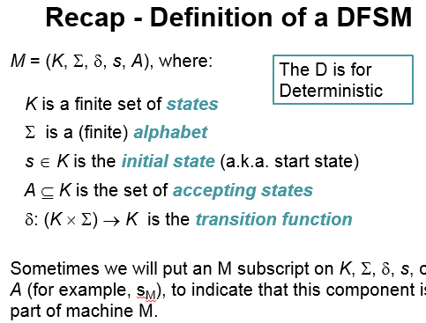
- A configuration of a DFSM M is an element of K × Σ*.
Contains all info needed to complete the computation.
Initial configuration of M: (s_{M}, w), Where s_{M} is the
start state of M.
- The yields-in-one-step relation: |-_{M} :
(q, w) |-_{M} (q', w') iff
• w = a w' for some symbol a ∈ Σ, and
• δ (q, a) = q'
- The yields-in-zero-or-more-steps relation: |-_{M}*
|-_{M}* is the reflexive, transitive closure of |-_{M} .
- A computation by M is a finite sequence of
configurations C₀, C₁, …, C_{n} for some n ≥ 0 such that:
• C₀ is an initial configuration,
• C_{n} is of the form (q, ε), for some state q ∈ K_{M},
• ∀i∈{0, 1, …, n-1} (C_{i} |-_{M} C_{i+1})

- A DFSM M accepts a string w iff (s_{M}, w) |-_{M}* (q, ε), for some q ∈ A_{M}
rejects w iff (s_{M}, w) |-_{M}* (q, ε), for some q ∉ A_{M.} The language accepted by M, denoted L(M), is the set of all strings accepted by M. A language is regular if it is L(M) for dome DFSM M.
- Theorem: Every DFSM M, in configuration (q, w), halts after |w| steps.
DFSM exercises:
- L = {w ∈ {0, 1}* : w has odd parity}. I.e. an odd number of 1's.
- L = {w ∈ {a, b}* : no two consecutive characters in w are the same}.
- L = {w ∈ {a, b}* : #_{a}(w) >= #_{b}(w) } .
- L = {w ∈ {a, b}* : ∀x,y∈{a, b}* (w=xy → | #_{a}(x) - #_{b}(x)| <= 2 ) } Vertical bars mean "absolute value" here.
- DFSM programming techniques
  - States remember info relevant to the goal of the machine (e.g., odd/even).
  - Feel free to label states by "everything from Σ except …"
  - Can make a DFSM for the negation of the desired condition, then ______________________________.
  - A DFSM for the "missing letter language" is difficult to construct! Try it.

- Nondeterminism. Machine may have "transition choices".
  - If one choice leads to acceptance, accept
  - Else if all choices lead to halting and rejecting, reject
  - Else run forever
- Why is nondeterminism necessary for any PDA that accepts PalEven?

