MA/CSSE 474 Day 04 Summary
- Show that ≡₃ is an equivalence relation. (a ≡₃ b iff b-a = 3k for some integer k).
reflexive:
symmetric:
transitive:
- Can a language be uncountable? Is the set of languages over a specific alphabet uncountable?
- Questions about maxstring function:
maxstring( A^{n}B^{n} ) = maxstring({a}*) = (later, to check your understanding): maxstring({b^{n}a: n≥0}) =
Let INF be the set of infinite languages. Let FIN be the set of finite languages.
Are the language classes FIN and INF closed under maxstring?
- Questions about chop function:
What is chop(A^{n}B^{n})? What is chop(A^{n}B^{n}C^{n})?
Are FIN and INF closed under chop?
- Questions about firstchars function:
What is firstchars(A^{n}B^{n})? What is firstchars({a, b}*)?
Are FIN and INF closed under firstchars?
- A decision problem is a problem whose answer is _____________.
- What does <x> mean? <x, y>?
- Some decision problems:

  - Consecutive pair of factors
  - Halting problem
  - Web pattern matching
  - Primality testing
  - Graph connectivity
  - Multiplication as decision problem
  - Sorting as decision problem

- Constructing one machine based on another machine
Consider the multiplication language:
INTEGERPROD = {w of the form <integer₁>x<integer₂>=<integer₃>, where:
<integer_{n}> is any well-formed integer representation and integer₃ = integer₁ ∗ integer₂}
Given a multiplication procedure, we can build a language recognition procedure?
Given the language recognition procedure, we can build a multiplication procedure:

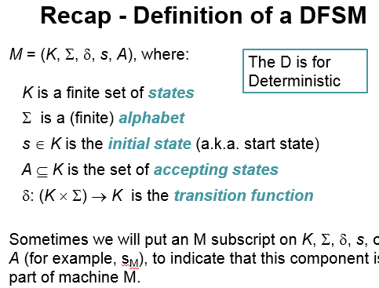
- A configuration of a DFSM M is an element of K × Σ*.
Contains all info needed to complete the computation.
Initial configuration of M: (s_{M}, w), Where s_{M} is the
start state of M.
- The yields-in-one-step relation: |-_{M} :
(q, w) |-_{M} (q', w') iff
• w = a w' for some symbol a ∈ Σ, and
• δ (q, a) = q'
- The yields-in-zero-or-more-steps relation: |-_{M}*
|-_{M}* is the reflexive, transitive closure of |-_{M} .
- A computation by M is a finite sequence of
configurations C₀, C₁, …, C_{n} for some n ≥ 0 such that:
• C₀ is an initial configuration,
• C_{n} is of the form (q, ε), for some state q ∈ K_{M},
• ∀i∈{0, 1, …, n-1} (C_{i} |-_{M} C_{i+1})

- A DFSM M accepts a string w iff (s_{M}, w) |-_{M}* (q, ε), for some q ∈ A_{M}
rejects w iff (s_{M}, w) |-_{M}* (q, ε), for some q ∉ A_{M.} The language accepted by M, denoted L(M), is the set of all strings accepted by M. A language is regular if it is L(M) for dome DFSM M.
- Theorem: Every DFSM M, in configuration (q, w), halts after |w| steps.
- L = {w ∈ {0, 1}* : w has odd parity}. I.e. an odd number of 1's.
- L = {w ∈ {a, b}* : no two consecutive characters are the same}.
- L = {w ∈ {a, b}* : #_{a}(w) >= #_{b}(w) } .
- L = {w ∈ {a, b}* : ∀x,y∈{a, b}* (w=xy → | _{#a}(w) - #_{b}(w)| <= 2 ) }

