474 HW 15 problems (highlighted problems are the ones to turn in)
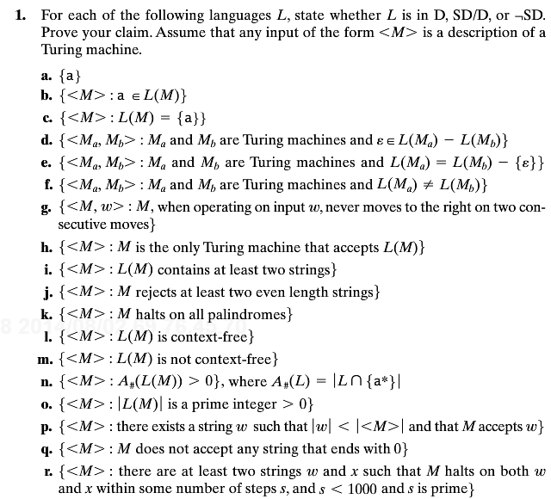
21.1g
(1) 9
21.1h
(2)
21.1k
(3) 9
21.1p
(4)
21.1r
(5)

21.4
(6) 9
21.5b
(7)
21.5d
(8) 9
21.6
(9) 12

21.9b
(10)
21.9c
(11) 9
21.9f
(12) 9
21.14
(13)

20.7
20.8

20.13

21.1a
21.1b
21.1c

