474 HW 13 problems (highlighted problems are the ones to turn in)
17.4
(1) 9
17.6
(2) 3
17.11
(3) 6-3
17.12
(4) 9-9-9

17.13
(5) 3
18.1a
(6) 9

18.1b
(7) 9

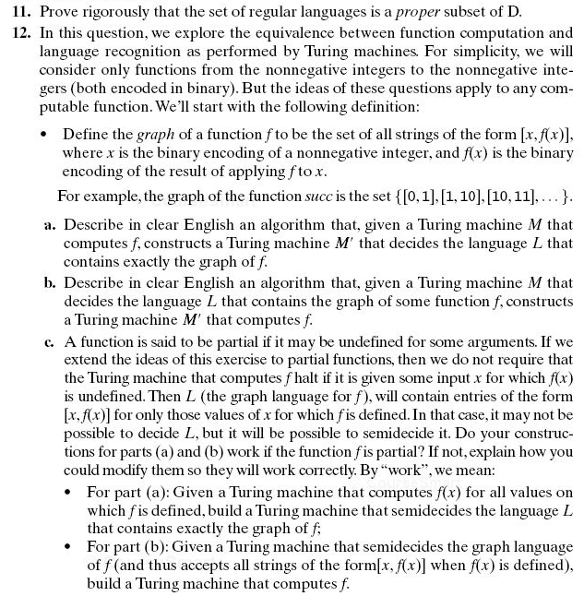
Note on 17.12a:
L = { [<x>, <f(x)>], x∈ℕ}, where <x> means "the binary encoding of x" and <f(x)> means "the binary encoding of f(x)"
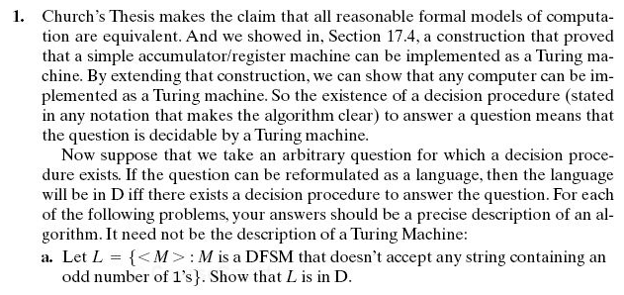

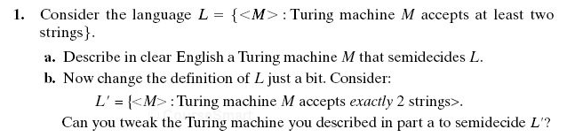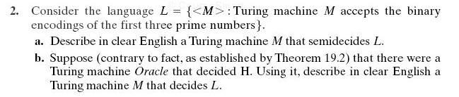
19.1
(8) 6

19.2
(9) 6

