474 HW 12 problems (highlighted problems are the ones to turn in)

12.1b
(#1) 6

12.1c
(#2) 6

12.1d
(#3) 6

12.1j
(#4)

12.3
(#5) 6+6+6

12.4
(#6) 3 for each part

12.5a
(#7) 9

12.6
(#8) 6

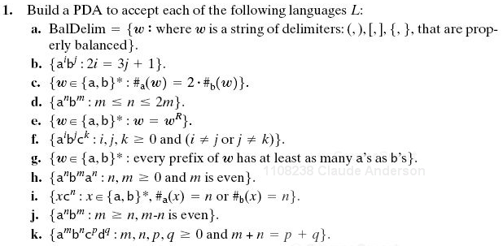
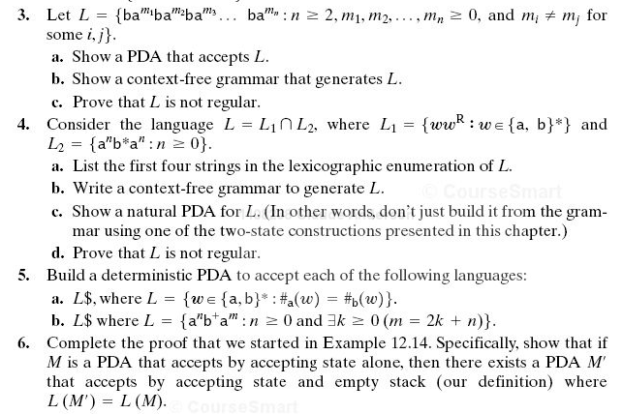
See hint below
See hint below
12.5a Hint: In order to be deterministic, the first thing your PDA should do, before it adds any input, is to push a special "bottom of stack" marker

12.3 Hints (a) Have states and transitions to handle the "don't care" sections where we aren't worried about the number of b's. (b) One nonterminal for when the m_{i}>m_{j}, and one for when m_{i}<m_{j}. (c) Pumping theorem alone probably won't do it; also use closure property.

