474 HW 6 problems (highlighted problems are the ones to turn in)
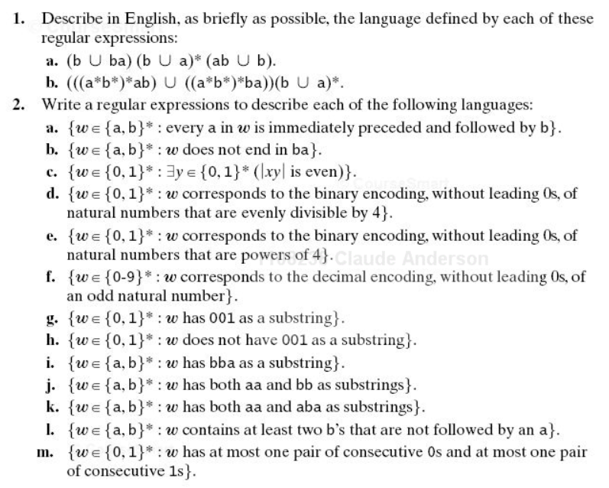

6.2e
2 (3)

6.2h
3 (3)

6.3abe
4 (3)

6.4abd
5 (6)

6.2: For the "to-turn-in" parts of 6.2, aim for as simple a regular expression as you can come up with. Some of the credit may be for simplicity. If your expression is very complicated, some annotation may help the grader to know whether it is correct. The "burden of correctness" is on you. I did not require some of the more complex parts of this problem due to difficulties with grading, but you should try some of them.
Note for part c: The x is a typo, should be w.
|wy| means "the length of string wy"

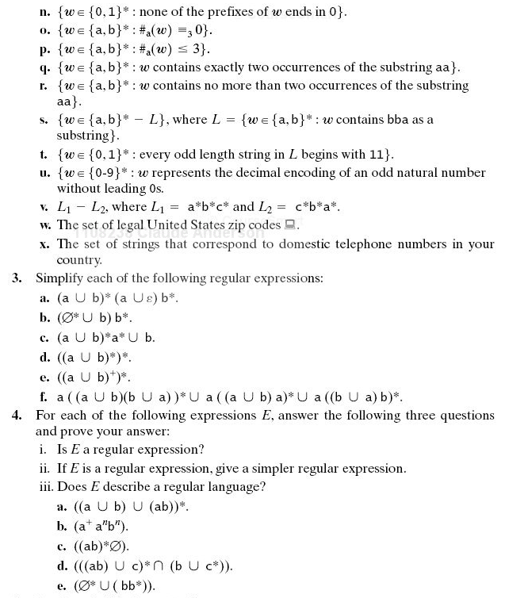

Problem 6 not from textbook
(equiv. classes for a^{p})
(18)
6.5
7 (9)

6.7a
8 (6)

6.8 (#9)

DFSM to Reg expression problem
10 (18)

- (t-12) This could have been on the previous assignment, but I wanted you to have some time to think about it.
Use the Myhill-Nerode theorem (instead of the pumping theorem, which we will study later) to show that the language
Σ = {a}, L= {a^{p} : p is a positive prime integer }
is not regular. In particular, show that for any pair of positive prime integers p and q, the
strings a^{p} and a^{q} are in different equivalence classes of ≈_{L}. I.e., for any p and q, find a non-negative integer t such concatenating a^{r} onto a^{p} and a^{q} produces one string of prime length and one whose length is composite. This is not trivial. Your proof should not mention the word "state"; it should directly use the definition of ≈_{L}.

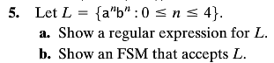
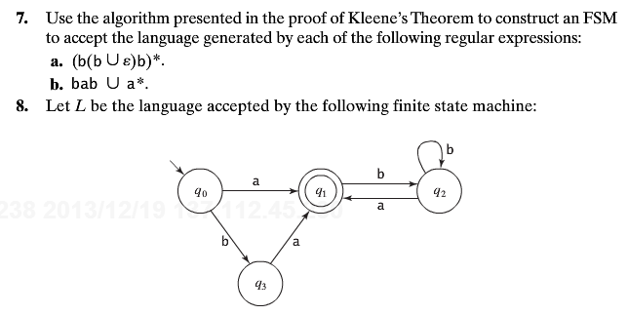
(t-18) Consider the DFSM M below. Use the algorithm from class to find a regular expression r such that L(R) = L(M). You should calculate all of the r_{ijk} for k=0 and k=1. For k>1, you are only required to calculate as many of the r_{ijk} as needed to do the recursive steps that the algorithm actually needs to get the answer. Be explicit about the ones that you do calculate. [This link is primarily for summer students for which there is no “in-class”, but it may be helpful to winter term students as well. The proof of the “in-class” algorithm and a complete example are given in the proof of Theorem 3.4 on the bottom of p33 and on pages 34-35 from this document, taken from “introduction to Automata Theory, Languages, and Computation by Hopcroft and Ullman (Addison-Wesley, 1979). ]
1
0
0, 1
1
1
0
0
Start q₁ q₂

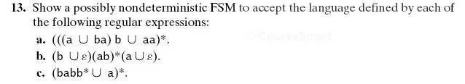
6.13d
(#11)

6.15
(#12)

6.18
13 (6)

6.20
(#14)
Good practice problems for exams (no proof necessary)

8.2ac

8.3
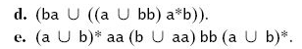
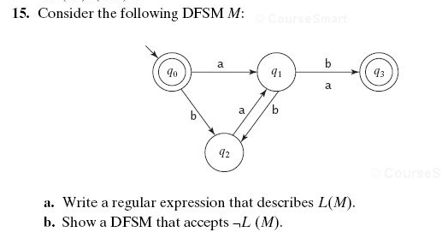
There is an error in this diagram in the book. The b-transition from q₁ to q₃ should not be there. Remove it before doing the problem.
18. Let Σ = {a, b}. Let L = {ε, a, b}. Let R be a relation defined on Σ* as follows: ∀xy (xRy iff y = xb). Let R′ be the reflexive, transitive closure of R. Let L′ = {x : ∃y ∈ L (yR′x)}. Write a regular expression for L′.
Note on 6.18 Transitive and reflexive closures are introduced in Section A.5 Closures under various operations are also mentioned on pages 17, 57, and 72.

