474 HW 5 problems (highlighted problems are the ones to turn in)
Problems 1 (9 points) and 2 (18 points) are not from the textbook. Their problem statements are also on page 2 of this document.
6.1a (3)
6.1b

6.2 a-k, n-p
6.2 See the note on the right side of this page
6.2a (3)
6.2c (3)

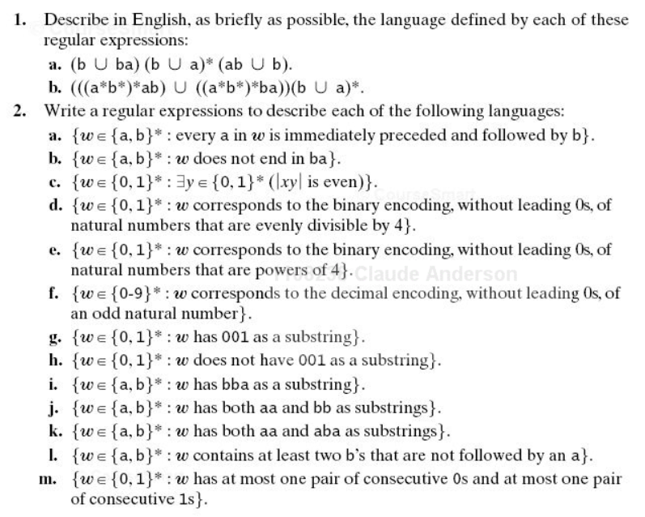
6.2: aim for as simple a regular expression as you can come up with. Some of the credit may be for simplicity. If your expression is very complicated, some commentary will help the grader to know whether it is correct. The "burden of correctness" is on you. I did not require some of the more complex ones due to difficulties with grading, but you should try some of them.
Note for 6.2 part c: The x is a typo, should be w.
|wy| means "the length of string wy"

