Exam 2

Name:____________________________________________ CM _________________

Instructions:
- Write all answers on these pages.
- Skim the entire examination before starting, and then budget your time.

Authorized resources: You may use a 8.5’ x 11’ sheet of paper with hand-written notes on both sides. You may NOT borrow another person’s notes.

Unauthorized resources: You are NOT permitted to use any resources other than those identified above. In particular, you may NOT use books, electronic files, PDAs, or computers.
Good luck!

Problem | Maximum Points | Points Earned
1 | 4
2 | 4
3 | 8
4 | 4
5 | 4
6 | 5
7 | 4
8 | 5
9 | 24
Total | 62

- [4 points] Explain why there in only one standard Inter-Domain Routing protocol (BGP4) and several standard Intra-Domain Routing protocols (like RIP and OSPF).

- [4 points] Comment on this statement:
“The advantage of datagram routing in the Internet is that it allows each IP packet to reach its destination over the shortest path available at the time the packet is sent out.”
Is this true or false and why?

- a. [4 points] The figure below shows a network with a NAT router. In step 1, host 10.0.0.1 sends a datagram from its port 3345 to host 128.119.40.186’s port 80. The router will use the NAT translation table to determine the source and destination IP addresses and port numbers of the datagram it will forward. In step 2, the destination IP address and port number of the outgoing datagram are provided for you. Determine the source IP address and port number of this datagram.

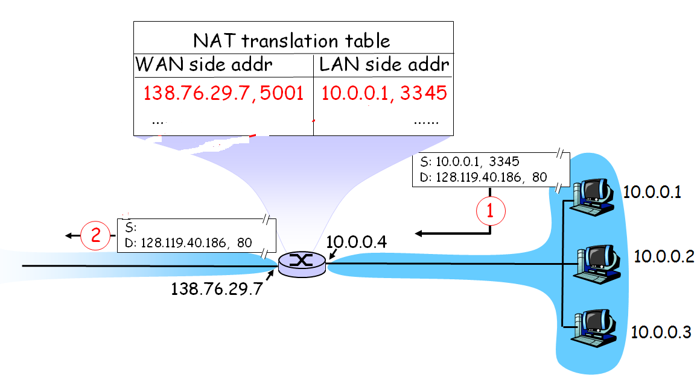

Source IP address = ______________________
Source port number = ___________________

b. [4 points] Why is there a need for Network Address Translation?

- [4 points] Briefly explain two ways in which the ICMP protocol is used in detecting errors in the network.

- [4 points] In IPv4, as shown below, a datagram is fragmented by a router when it determines that the outgoing link’s Maximum Transmission Unit (MTU) is smaller than that of the incoming link. How is the problem of non-uniform MTUs handled in IPv6?

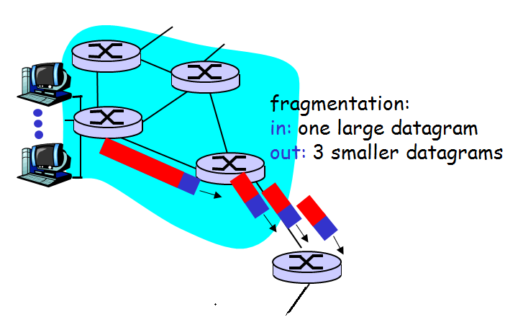

- [5 points] Why does the Ethernet’s CSMA/CD protocol use a random exponential backoff after a collision is detected?

- [4 points] Suppose that my Ethernet card’s collision detection capability is not functioning but its carrier sensing capability (and other functionality) are intact. What would be the effect of this malfunction – would I be able to receive and/or send messages using this card? Explain.

- [5 points] Consider three LANs interconnected by two routers, as shown in the figure below. Answer any ONE of the following two questions:

  - [5 points] Assume all of the ARP tables are up to date. Now, consider sending an IP datagram from host A to host F. Enumerate all the steps involved. Indicate all the hosts, routers, and interfaces involved. Where relevant specify MAC addresses and IP addresses (destination and/or source).
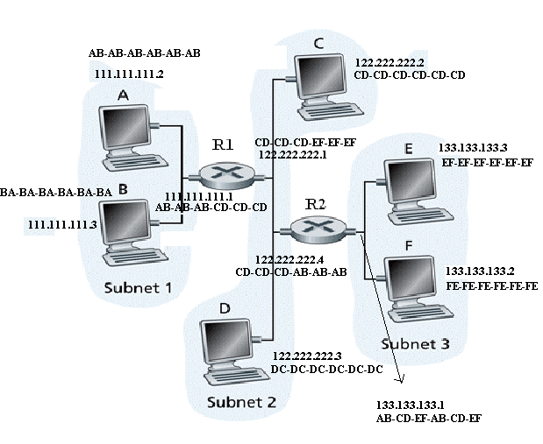

  - [5 points] Assume that host A’s ARP table is empty. Now, consider sending an IP datagram from host A to B. Enumerate all the steps involved. Indicate all the hosts, routers, and interfaces involved. Where relevant specify MAC addresses and IP addresses (destination and/or source).

9. [24 points] Vocabulary
You are given a list of 15 terms and 12 definitions. All of the definitions have matching terms. You need to match terms with definitions. You do NOT have to define the three remaining terms.

Here are the definitions. Fill in the number of the matching term.

a computer network that covers a broad area across metropolitan, regional, or national boundaries [
a computer network that is concentrated in a geographical area, such as a university or corporate campus.
a link layer device that stores and forwards Ethernet frames
a link-layer protocol where the a node that has possession of the token can send data over the shared medium
a physical layer device that amplifies and forwards packets
a technique used to ensure that no bit-patterns are forbidden from part of the packet payload.
encapsulating a packet; including all of its headers; inside another packet
information consisting of a list of all known nodes in an autonomous system(AS) and the estimate of the cost to each node that is sent to all neighbors of a node.
information consisting of list of neighboring nodes and the links costs that is broadcast to all nodes in a autonomous system(AS) by a node in the AS.
layer of the Internet Protocol Stack that routes frames from one node
to adjacent node over a link
layer of the Internet Protocol Stack that routes segments from one process on a host to a process on another host
the sequence of 32 bits typically consisting of a sequence of 1s followed by 0s that help determine if an IP address belongs to a particular subnet.
Here are the terms: (You may detach this sheet for your convenience. Remember to turn it in with the rest of the exam.)

1 | Byte-stuffing
2 | Data link layer (medium access layer)
3 | Distance vector
4 | Hub
5 | IP address
6 | LAN (local area network)
7 | Link state
8 | Network layer
9 | Router
10 | Subnet mask
11 | Switch
12 | Token-passing
13 | Transport layer
14 | Tunneling
15 | WAN (wide area network)

