CSSE 374 – Software Architecture and Design I

Homework 2

Objective
To apply what you have learned about UML Logical Architecture by:
- Complete a preliminary Logical Architecture for the BrickBuster Video System (BBVS), and
- Detailing selected portions of BBVS with Sequence Diagrams and Design Class Diagrams.
As with the other homeworks, this is an individual assignment.

Due Date
See course schedule.

Tasks
- Review the attached Domain Model, SSDs, Use Cases, OC's, and partial package diagram for BBVS. While these are not complete, they should supply the necessary information to complete the assignment.
- Let's now consider the specific application of interest, in the BBVS domain, to be the one that sells videos to customers - as in, the new online system that BBVS wants. (There would be other apps, like an application for provisioning the online inventory.) Develop a preliminary Logical Architecture that allocates the packages to appropriate layers and partitions for the customer application. Be sure to indicate dependencies between packages.
- Choose two system operations from the provided SSDs that would benefit from further interaction analysis. For each, draw a sequence diagram showing the detailed messages and objects involved in implementing the operation. Hint: These interaction diagrams likely represent some subset of the action within one of the provided SSDs.
- Extending what you did in HW 1, draw a design class diagram for the domain layer of BBVS following the guidelines in the book (Chapter 16) and discussed in class. This layer should be general enough to be useful for multiple BBVS applications. Our partial domain diagram, which has its own comments, can be used to get ideas, but we hope you put your own thoughts into the overall organization, and justify those in your comments to accompany your figure.
Per the suggestion in section 16.21 of the book, you should work on tasks 3 and 4 simultaneously. Also, recall that scans of neatly drawn pen and paper sketches are adequate for homework (though not for projects). There is a scanner in F217.

Submitting Your Work
Please submit your BBVS Logical Architecture as a single document to the appropriate Moodle Homework dropbox.
- See the problem domain description, and other artifacts, below.
- Scope (same as for Homework 1, but extended to show example answers for that HW):
The BrickBuster Video System (BBVS) they want will provide a streaming video-on-demand service for Internet customers, available on PC's, iPhones, XBOX's and other devices. Frankly, the client doesn't know a lot about how such systems work.
This new system will replace the company's previous brick-and-mortar video store system - hence the name of the new system ("BrickBuster")!
The client wants their new system to compete with iTunes' video delivery, especially. For a look at other competition, see the web sites for Netflix online, and for Blockbuster online.
All these systems stream videos almost immediately to the customer, after accepting payment. But there's a lot more to them. For example, an issue in all these services is not only how to deliver video feeds for a price, but also helping the consumer make the service work well for them, like how they can attach their computer to their big screen TV to watch the videos!
- BrickBuster's Existing, Store-based System
Your client does know their existing business well, delivering videos on DVD's and Blu-Ray disks from brick-and-mortar stores. To understand how to build the new system, you need first to create a domain model that covers, abstractly but in sufficient detail, the whole competitive sphere of online and brick-and-mortar stores. The best knowledge we have toward that end is a combination of snooping those online competitors noted above, and our knowledge of BrickBuster's existing, store-based system. You want to extract from the latter description a domain model that documents how video rental operations do business generally, apart from either this old system, or its electronic replacement. Keep in mind that not everything in the existing operation will be a part of what's online, etc.
Here's how the business works now:
Customers: The customers at present come to their local store to browse for videos and for related services, such as ordering a video that's not in the store. They pay a rental fee for each video, take it home, watch it as many times as they like over a period of a few days, then return it on time to avoid paying a late fee. Each customer has a name, address, and phone number. They must show a photo ID to get a free membership with the store. They then get a membership card, which they present with their payment when they rent videos. Payments can be made using cash, debit card, or credit card. If a video is returned late, or is lost, the extra fee for this is assessed the next time the customer rents a video.
Video store: Has the videos to be rented, as well as the records of each local customer-member. The store includes retail terminals for ringing-up sales. Each video has a title and a unique ID that is scanned during the sales transaction.
Shelves: Each video in the store has one or more copies, all conveniently located together on a shelf area designated for that particular video. The shelf actually has just the cases, and the customers bring the cases to the checkout counter, where they are filled with the proper DVD's. Each store has a recommended shelf layout, showing the store personnel where the videos are supposed to be, for efficient stocking.
Provisioning: The store gets regular deliveries of new videos, via trucks from the warehouses or directly from DVD suppliers. The store system has information about each shipment, showing where the new DVD's are supposed to go, and what they replace.
Unprovisioning: The old DVD's that the store wants to get rid of are largely sold to customers, and removed from inventory as they are sold. Annually the store does a physical inventory that removes stolen or lost videos from the headquarters system.
Headquarters servers: The store inventory is kept remotely, and indicates which actual copies of which videos are supposed to be in-store, and which are checked-out to which customer. Periodic inventory checks are made to determine shrinkage.
Kiosk: The store also has a kiosk from which customers can order videos to be delivered later. This kiosk has access to a remote database of all available videos.
Store employees: Include a store manager and store associates. The manager has access to employee records and store financial data. All employees can ring-up sales at the counter, and do inventory operations.
- Existing System Use Cases
In getting these use cases form the customer, we tried to make them separate from the way the customer now does business. That is, we wanted them to be "how they wanted the new system to work." At the same time, we wanted to keep the use cases general enough that they might apply to more than one way of running a video business.

UC1: Customer rents videos

Preconditions: Customer has a membership, has selected videos they want to rent, and made the system aware of their choices.

Actor: Customer (if self-service or remote), or store associate (if in a store).

Main flow:

- Actor indicates to rent first item (e.g., clicking "rent" on a networked device, or scanning it physically in a store).
- System verifies immediate availability, waits for actor to make next option.
- Actor indicates they are done selecting.
- System shows total, prompts for payment.
- Actor selects method of payment, entering additional data if needed (e.g., credit card number).
- System verifies the payment has gone through, schedules the goods for rental (e.g., sets up a window to click on to view the video remotely, or tells the store clerk where to find the DVD).

Alternate flows (among many):

2a. System tells actor that the video is not currently available, and provides information on when it will be.
3a. Actor buys additional items, in the same way, if desired, returning to step 3 after each.
6a. System rejects method of payment, asks actor for alternative.

Postcondition: Rental transaction is complete.

UC2: System lets customer select videos to rent

Preconditions: None

Actor: Customer

Main flow:

- "Store" shows videos and other merchandise available for rental. (This could be in stages, such as indicating areas of the store for customer to browse, or responding to a search request. Categories in the store are like "latest hits" and "action/adventure")
- Customer browses by video category, looking at the cases for the videos, and picking a video to rent.
- System shows items in "basket," suggests checkout.

Alternate flows:

1a. Item is not in stock. "Store" shows when it is available, if possible.
2a. Customer continues in this loop, selecting multiple videos.
2b. Customer is a game player, and picks one or more games to rent instead of videos.
2c. Customer picks candy or popcorn at front counter, to eat while watching their video.

Postconditon: Customer has products ready to rent.

UC3: Customer returns videos to store

Preconditions: Customer has a membership, and Video(s) rented within last 30 days (assumption that after that, the customer has been billed).

Actors: Customer (if self-service or remote), or store associate (if in a store).

Main flow:
- Customer provides video(s) for return.
- System provides indicator of each video returned, and any accumulated late fees.
- System acknowledges the return of all the videos returned this time and provides a receipt. A “thank you” message concludes the transaction.

Alternate flows:

2a. Late return: System shows late fee total, prompts for payment.
2b. Actor selects method of payment, entering additional data if needed (e.g., credit card number).
2c. System verifies the payment has gone through, and a payment receipt is provided.
2c.1. Payment not approved: Customer is alerted that the payment was not approved and

Postconditions: Return transaction recorded, and customer gets receipt. Video return transaction complete.

UC4: Videos returned to stock

Preconditions: Returned videos have accumulated behind counter at front of store.

Actors: Store associate.

Main flow:
- Actor asks system for map of how to return videos to proper places in store.
- System prints a map for each video returned, showing path to follow and shelf location of each video.
- Actor takes map and box of videos around the store, returning to the places shown, following the map.
- Actor returns to tell system that this was completed as directed.

Alternate flows:

3a. Missing videos: Actor indicates which ones are missing or surplus, on paper map. Then,
4a. Actor tells system about which videos turned up missing or surplus.

Postconditions: Videos are back in proper places for re-rental.

Note on use cases:

There are additional use cases for BrickBuster's existing system, many of which you should be able to imagine! For example, the store associates need to stock the shelves with new merchandise, removing the actual videos from the cases and storing those in the front of the store; and remove old merchandise; both of which actions would alter the layout of the shelves. And someone needs to do the periodic inventory checks to determine shrinkage. And the store system needs to be updated from the servers at headquarters, in line with these known changes to the store inventory.

Again, as you consider changing this whole operation to being online video streaming, you have to think about which of the store operations still need to be considered at all, which ones will still be there in a very similar form, and which ones will be there but in some altered form. And some parts of both the existing functions and the new ones should be represented in your abstract model. For instance, even an online delivery system requires some kind of "provisioning" to maintain the database of videos being delivered to remote customers.

- Domain model

Here's a sample domain model which has most of the desired features, common across online/streaming and brick-and-mortar versions of a video store:

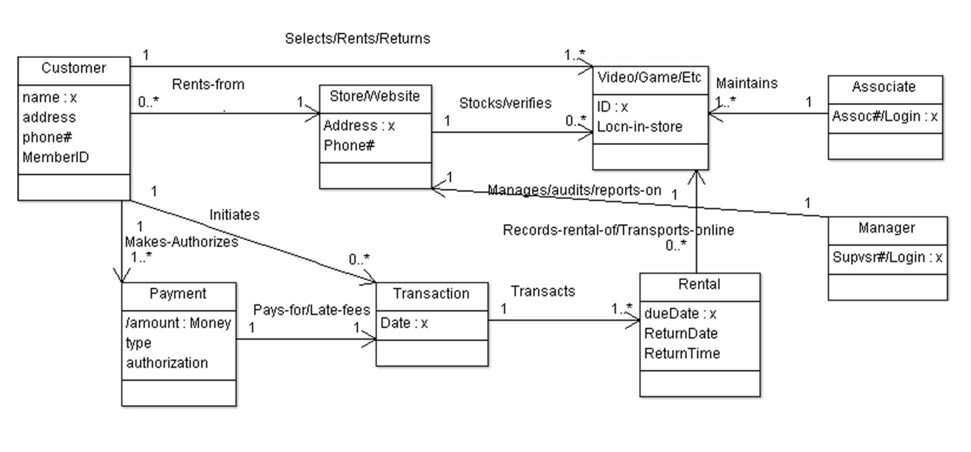
The figure shows the major classes, their attributes and associations from the above explanations and use cases. For example, the customer "Rents-from" a Store or Website, as the case may be. The "Store/Website" has to stock Videos, games and other merchandise / data to stream. The operation is staffed by Associates and Managers who have different tasks. The sales Transaction involves the Customer doing the Rentals, which are either recorded from a physical video or else made available by being Transported online to the customer.

- SSD's and OC's

1 & 2. Here are samples of some SSD's, common across online/streaming and brick-and-mortar versions of a video store, with OC's:

These SSDs and OCs represent key areas of the application of interest, within the domain.
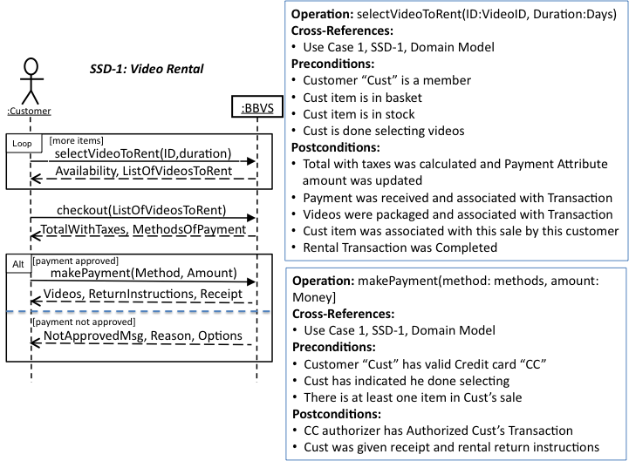

From Use Case 1, we have the typical scenario where a customer rents multiple videos, and the box around that part is to indicate this loop. The OC's detail two important parts of the transaction, the renting of individual items (videos), and the acceptance of payment, after which the customer can watch their videos.
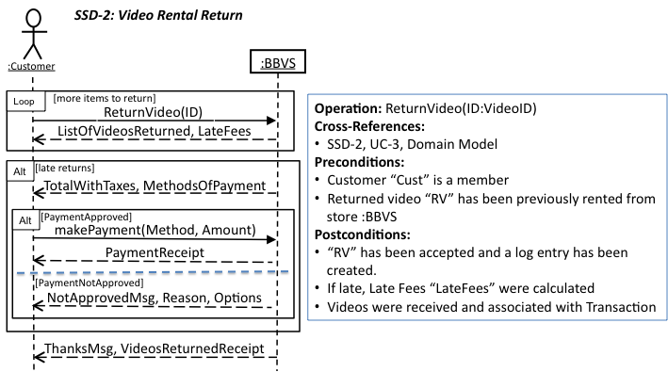

From Use Case 3, we have the scenario where a customer returns multiple videos, and the box around that part is to indicate this loop. The OC details when the video is returned, it is logged, and if it is late, late fees are tallied. The rest represents the alternatives of if there is a late fee assessed, how that fee is collected.

3. Here are some application domain classes that would translate to an application domain layer. With a paragraph showing organization and justification for these choices.

This is the start of a package diagram, which, of course, you can diverge from as desired in your own depiction of layers, packages and classes. As with all figures, you should include a paragraph or two describing (and justifying your design choices).

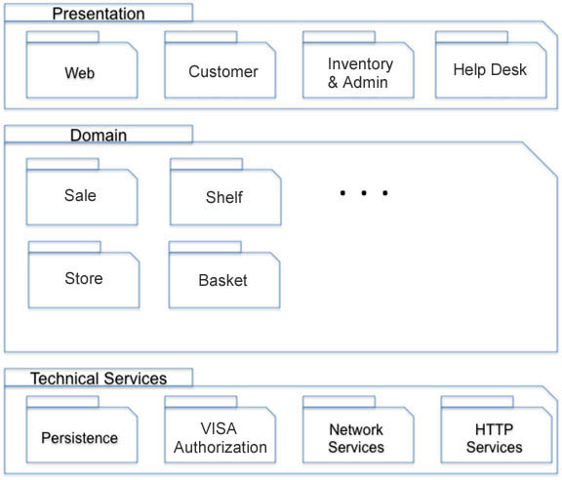

In this example, we presumed that there would be a general web interface provided for web-based services. Perhaps "customer" should appear within that? However, we do have other ways of communicating with the customer, say, by email. You may want to make your own choice as to how these parts of the presentation layer should be packaged!

In many customer service systems like this, the help desk has its own specialized interface for these representatives to be most productive. And people changing the inventory or doing other admin activities would need their own interface, too.

We only hinted at the domain layer! So, you should very much make this into something better. And, don't forget, you really have just a particular application within that domain, as your initial focus.

The technical services, or other layers supporting the domain and the applications, would similarly have additional components we didn't list.

Note that this is actually an ArgoUML class diagram, so it has a few artifacts of that, like a mysterious attribute type "x" on the first attribute of each class.

