CSSE 374 – Software Design

Homework 1

Objective
To apply what you have learned about UML domain modeling by producing a set of system sequence diagrams and requisite operations contracts, and by beginning a preliminary Logical Architecture for the BrickBuster Video System (BBVS).
Tools
Note that you can do these by hand and scan them, to save time, or you can try using any of the tools listed at the course web site. (Visio, for example, is available from the Microsoft development tools web site.) If you use a tool, please explain any issues you may have had which limited the format of your figures!

Due Date
See course schedule.

Tasks
- Read through the project scope statement with its requirements and use cases. There is an attached Domain Model at the end. As a review from 371, develop the system sequence diagrams (SSD) for the relevant elements in the Domain Model. While there are no detailed Use Cases for the new system, use your creative imagination to come up with reasonable sequences of interaction for your SSDs. The objective of this exercise is to give you exposure to the process of reasoning about behavior at the analysis level.
- From the SSDs you produce, identify at least three operations (methods) that need some level of detail to ensure constraints are met or rules are followed. For each operation that you identify, give a sentence or two describing why it warrants additional detail. Write the operations contracts for each of these.
- In preparation for creating a Logical Architecture in Homework 3, begin choosing application domain classes. From the Domain Model, SSDs, and Operations contracts, identify key classes from the application domain layer and organize them into packages. Give a UML Package Diagram showing the organization and a paragraph or two justifying it. You do not need to show dependencies between packages at this time.
- Note that every figure should have an associated explanation!

Submitting Your Work
Please submit your SSDs, Operations Contracts, and Package Diagram as a single document to the appropriate Moodle dropbox.

You can submit either a pdf file or a Word document.

Please include your name on the first page of the document.
Scope (from Homework 1):
BrickBuster is the last remaining holdout video store, but they see the need to move online! The BrickBuster Video System (BBVS) they want will provide a streaming video-on-demand service for Internet customers, available on PC's, iPhones, XBOX's and other devices. Frankly, the client doesn't know a lot about how such systems work.
This new system will replace the company's previous brick-and-mortar video store system - hence the name of the new system ("BrickBuster")!
The client wants their new system to compete with iTunes' video delivery, especially. For a look at other competition, see the web sites for Netflix online, and for Blockbuster online.
All these systems stream videos almost immediately to the customer, after accepting payment. But there's a lot more to them. For example, an issue in all these services is not only how to deliver video feeds for a price, but also helping the consumer make the service work well for them, like how they can attach their computer to their big screen TV to watch the videos!

BrickBuster's Existing, Store-based System
Your client does know their existing business well, delivering videos on DVD's and Blu-Ray disks from brick-and-mortar stores. To understand how to build the new system, you need first to create a domain model that covers, abstractly but in sufficient detail, the whole competitive sphere of online and brick-and-mortar stores. The best knowledge we have toward that end is a combination of snooping those online competitors noted above, and our knowledge of BrickBuster's existing, store-based system. You want to extract from the latter description a domain model that documents how video rental operations do business generally, apart from either this old system, or its electronic replacement. Keep in mind that not everything in the existing operation will be a part of what's online, etc.
Here's how the business works now:
Customers: The customers at present come to their local store to browse for videos and for related services, such as ordering a video that's not in the store. They pay a rental fee for each video, take it home, watch it as many times as they like over a period of a few days, then return it on time to avoid paying a late fee. Each customer has a name, address, and phone number. They must show a photo ID to get a free membership with the store. They then get a membership card, which they present with their payment when they rent videos. Payments can be made using cash, debit card, or credit card. If a video is returned late, or is lost, the extra fee for this is assessed the next time the customer rents a video.
Video store: Has the videos to be rented, as well as the records of each local customer-member. The store includes retail terminals for ringing-up sales. Each video has a title and a unique ID that is scanned during the sales transaction.
Shelves: Each video in the store has one or more copies, all conveniently located together on a shelf area designated for that particular video. The shelf actually has just the cases, and the customers bring the cases to the checkout counter, where they are filled with the proper DVD's. Each store has a recommended shelf layout, showing the store personnel where the videos are supposed to be, for efficient stocking.
Provisioning: The store gets regular deliveries of new videos, via trucks from the warehouses or directly from DVD suppliers. The store system has information about each shipment, showing where the new DVD's are supposed to go, and what they replace.
Unprovisioning: The old DVD's that the store wants to get rid of are largely sold to customers, and removed from inventory as they are sold. Annually the store does a physical inventory that removes stolen or lost videos from the headquarters system.
Headquarters servers: The store inventory is kept remotely, and indicates which actual copies of which videos are supposed to be in-store, and which are checked-out to which customer. Periodic inventory checks are made to determine shrinkage.
Kiosk: The store also has a kiosk from which customers can order videos to be delivered later. This kiosk has access to a remote database of all available videos.
Store employees: Include a store manager and store associates. The manager has access to employee records and store financial data. All employees can ring-up sales at the counter, and do inventory operations.

Existing System Use Cases
In getting these use cases form the customer, we tried to make them separate from the way the customer now does business. That is, we wanted them to be "how they wanted the new system to work." At the same time, we wanted to keep the use cases general enough that they might apply to more than one way of running a video business.

UC1: Customer rents videos

Preconditions: Customer has a membership, has selected videos they want to rent, and made the system aware of their choices.

Actor: Customer (if self-service or remote), or store associate (if in a store).

Main flow:

- Actor indicates to rent first item (e.g., clicking "rent" on a networked device, or scanning it physically in a store).
- System verifies immediate availability, waits for actor to make next option.
- Actor indicates they are done selecting.
- System shows total, prompts for payment.
- Actor selects method of payment, entering additional data if needed (e.g., credit card number).
- System verifies the payment has gone through, schedules the goods for rental (e.g., sets up a window to click on to view the video remotely, or tells the store clerk where to find the DVD).

Alternate flows (among many):

2a. System tells actor that the video is not currently available, and provides information on when it will be.
3a. Actor buys additional items, in the same way, if desired, returning to step 3 after each.
6a. System rejects method of payment, asks actor for alternative.

Postcondition: Rental transaction is complete.

UC2: System lets customer select videos to rent

Preconditions: None

Actor: Customer

Main flow:

- "Store" shows videos and other merchandise available for rental. (This could be in stages, such as indicating areas of the store for customer to browse, or responding to a search request. Categories in the store are like "latest hits" and "action/adventure")
- Customer browses by video category, looking at the cases for the videos, and picking a video to rent.
- System shows items in "basket," suggests checkout.

Alternate flows:

1a. Item is not in stock. "Store" shows when it is available, if possible.
2a. Customer continues in this loop, selecting multiple videos.
2b. Customer is a game player, and picks one or more games to rent instead of videos.
2c. Customer picks candy or popcorn at front counter, to eat while watching their video.

Postconditon: Customer has products ready to rent.

UC3: Customer returns videos to store

Preconditions: Customer has a membership, and Video(s) rented within last 30 days (assumption that after that, the customer has been billed).

Actors: Customer (if self-service or remote), or store associate (if in a store).

Main flow:
- Customer provides video(s) for return.
- System provides indicator of each video returned, and any accumulated late fees.
- System acknowledges the return of all the videos returned this time and provides a receipt. A “thank you” message concludes the transaction.

Alternate flows:

2a. Late return: System shows late fee total, prompts for payment.
2b. Actor selects method of payment, entering additional data if needed (e.g., credit card number).
2c. System verifies the payment has gone through, and a payment receipt is provided.
2c.1. Payment not approved: Customer is alerted that the payment was not approved and

Postconditions: Return transaction recorded, and customer gets receipt. Video return transaction complete.

UC4: Videos returned to stock

Preconditions: Returned videos have accumulated behind counter at front of store.

Actors: Store associate.

Main flow:
- Actor asks system for map of how to return videos to proper places in store.
- System prints a map for each video returned, showing path to follow and shelf location of each video.
- Actor takes map and box of videos around the store, returning to the places shown, following the map.
- Actor returns to tell system that this was completed as directed.

Alternate flows:

3a. Missing videos: Actor indicates which ones are missing or surplus, on paper map. Then,
4a. Actor tells system about which videos turned up missing or surplus.

Postconditions: Videos are back in proper places for re-rental.

Note on use cases:

There are additional use cases for BrickBuster's existing system, many of which you should be able to imagine! For example, the store associates need to stock the shelves with new merchandise, removing the actual videos from the cases and storing those in the front of the store; and remove old merchandise; both of which actions would alter the layout of the shelves. And someone needs to do the periodic inventory checks to determine shrinkage. And the store system needs to be updated from the servers at headquarters, in line with these known changes to the store inventory.

Again, as you consider changing this whole operation to being online video streaming, you have to think about which of the store operations still need to be considered at all, which ones will still be there in a very similar form, and which ones will be there but in some altered form. And some parts of both the existing functions and the new ones should be represented in your abstract model. For instance, even an online delivery system requires some kind of "provisioning" to maintain the database of videos being delivered to remote customers.

- Domain model

Here's a sample domain model which has most of the desired features, common across online/streaming and brick-and-mortar versions of a video store:

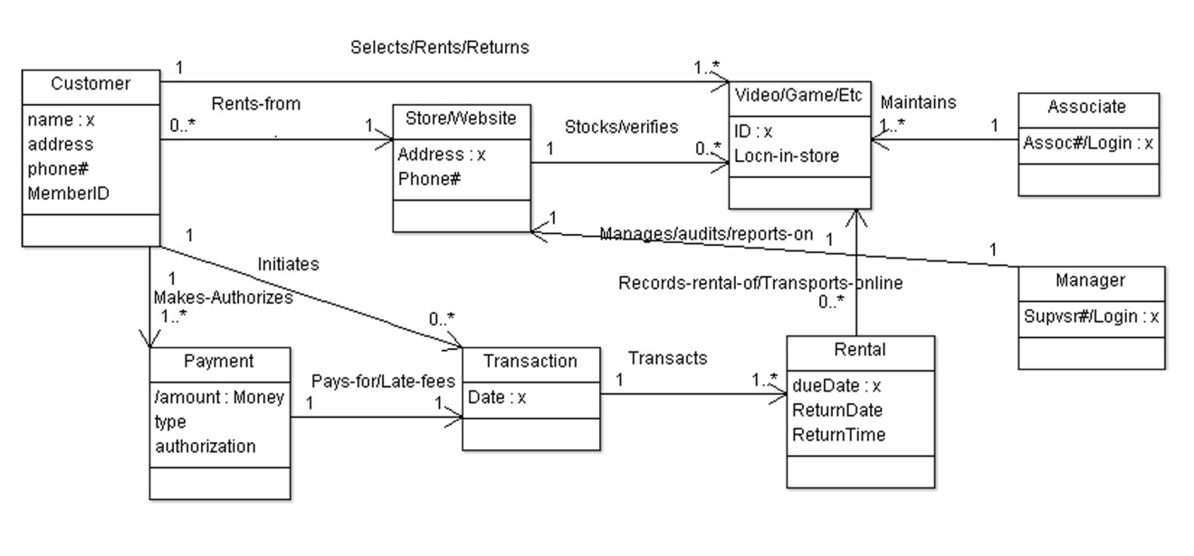
The figure shows the major classes, their attributes and associations from the above explanations and use cases. For example, the customer "Rents-from" a Store or Website, as the case may be. The "Store/Website" has to stock Videos, games and other merchandise / data to stream. The operation is staffed by Associates and Managers who have different tasks. The sales Transaction involves the Customer doing the Rentals, which are either recorded from a physical video or else made available by being Transported online to the customer.

Note that this is actually an ArgoUML class diagram, so it has a few artifacts of that, like a mysterious attribute type "x" on the first attribute of each class.

