CSSE374 Winter 2012-2013
Exam 1
Thurs, 1/9/2013, in class

Instructions:

- You may use one page of hand-written notes, both sides, during the exam. You will get a fresh copy of this pre-test information, to use during the exam, in place of this one.
- Collaboration is not allowed about the exam, including discussing what you can see of this before it! That includes, of course, showing this document to anyone else, in any way.
- You will have both hours of Thursday’s class to take the exam. Chandan and I believe you will have enough time.
- We must be able to read your answers.

Case study for the exam – The Rose eResume System
All the problems will use the following problem statement as background:
Rose students need help producing resumes. For one thing, they tend to forget, till later, to add different kinds of information that belongs on resumes. Some of this info is available on the Rose Banner network supported by IAIT. Some may be better remembered if students had a single tool for keeping this info, like a diary of key activities they did. The system should remind them at key times, however, like at the end of the summer.
There also is a capability for Rose to keep samples of student work via the Rose-ePortfolio, which students might maintain for employers if they choose. Students also are not experts at making the resumes look effective, and some tool would help for this. There should be a large number of formats for them to choose from. However, a system will not be perfect in making such a personalized document, so the result has to be something editable and formattable by the student as a final step. And, once the student has edited it, the automated system should now highlight anything new, so that the student can add that to their final, custom version if they choose, instead of starting over to make those final changes.
The system should be able to handle the fact that, if introduced in College and Life Skills, every student will start using it; but some will continue and others will not. There is a good chance, however, that many will try to re-start using the system as their senior year and its job interviews approach.
Students would be able to select or “ok” what interested parties saw their finished resume on file.
The system will be owned and maintained by Rose’s Career Services. Since it is not an IAIT system, students will need to access related info themselves, and import it into the system. The client thinks this will be an app that students run, but it could end up that the client is web pages, too.
This is the problem statement for the Rose eResume System.
Below we see the domain model developed with the help of the client, and two SSD’s for this system. Each of the latter has an OC explaining further a complex part of is sequence:

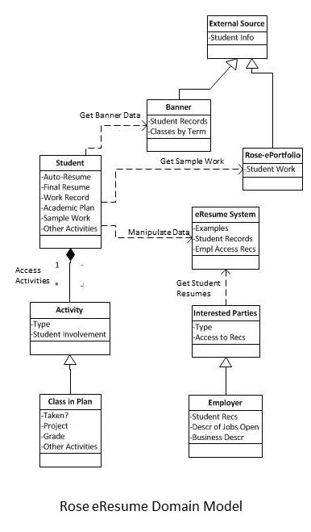

Explanation: Student is connected to the external sources, not the eResume System itself, because the system is not allowed access to these systems. The main interaction is between Student and eResume System, and actually includes multiple activities, like working on their resume itself, building information that they might want to put on the resume, and authorizing what Interested Parties can access a particular resume version they wrote. The Employer is just an example of one of these Interested Parties. And Class In Plan is an prime example of an Activity that a student might want to talk about on their resume.

Here’s an SSD that goes with this domain model:
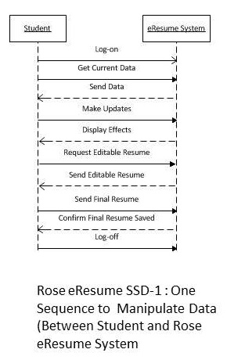
Explanation: Here we’ve shown what a student might want to do in a sequence of editing their resume. They first look at the Current Data in the system, and then make updates to that data. This might be based on the fact the eResume System is out of date, or the student is using it for the first time. The Display Effects reply assumes that the student put this data onto the resume itself, rather than just saving it for reference.
When the student does Request Editable Resume, they have decided that the system has done all it can, and they want to fix the final version themselves.

An Operations Contract for this SSD (OC is shown below):
Explanation: In this OC, we see just a part of the SSD, above, detailed, as to what has to happen. This is, what happens once the eResume System sends the Student its best guess of what the resume should look like, in a form the student can edit. We included this latter requirement as a post-condition. The confirmation step is a common requirement when documents are transmitted – the Student gets one last chance to see their Final Resume in the form the eResume System got it.
Contract 01: Finalize Resume
Operation: | Send Editable Resume, and remaining steps
Cross Refs: | Student, eResume System, Interested Parties
Preconditions: | Student has her Current Data from the eResume System.  Student has necessary data gathered from other sources, or she can provide it herself (e.g., Banner data, Rose ePortfolio data, internship data).  Student has desktop tools with which to make editable resume into final resume.
Post-conditions: | - A working copy of Editable Resume, eRes, was created on the desktop  - eRes was edited into final version, fRes, by one of Student’s desktop tools.  - This included both changing data and reformatting, as desired.  - Formatting may have included altering which template from the eResume System is used.  - Student uploaded fRes to the eResume System. (The Send Final Resume step shown in the SSD.)  - “Confirm Final Resume Saved” included these steps:  - Student has seen how fRes looks, displayed from the server.  - Student has seen redisplayed the list of Interested Parties who can access fRes.  - Student has had a chance to select other operations to do before logging off.

Here’s another SSD that goes with the Domain Model:
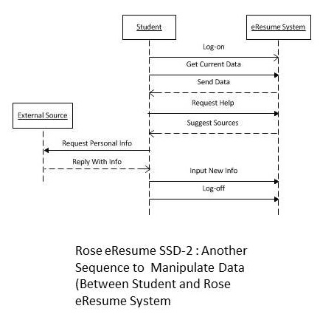
Explanation: This sequence shows how the student accesses data from an External Source which the eResume System itself cannot access directly. The eResume System has sent the Student its Current Data, and the Student has noticed that things are missing. The Student asks for Help. The Suggest Sources response includes help on how to access a desired source, such as Banner. Left unresolved is the question of whether both the Student and the eResume System need to be able to see the data returned, in an understandable way. As it is shown, the Student simply Inputs New Info to the eResume System in some fashion to be decided later.

An Operations Contract for this SSD (OC is shown below):
Explanation: In this OC, once again we see just a part of the SSD, above, detailed for further clarification. The student is looking at the Working Copy of their Resume, as part of the Current Data sent, and she is able to detect that some data, likely new data, is missing. The Student requests help from the eResume System. While the system itself cannot access these sources, it can provide help / reminders about how the Student can access the data. The rest of the OC details how that exchange with the External Source might go. It suggests that the student might need to Format the data returned, to make it acceptable to the eResume System, but this requirement is speculative.
Contract 02: Request Help
Operation: | Request Help from eResume System, then use this help to add information.
Cross Refs: | Student, eResume System, External Source
Preconditions: | Student has her Current Data from the eResume System.  A Working Copy of the Student’s Current Data, curData, was created on the desktop  Student does not have needed data that exists on External Sources.
Post-conditions: | - curData was analyzed by the student, who decided to check for additional data.  - This could be recently updated Banner data.  - It also could be data saved by the student or by instructors on Rose ePortfolio.  - Student Requested Help from the eResume System.  - eResume System sent instructions for how to access the External Sources.  - Student accessed one of the External Sources.  - The External Source responded by providing the requested data.  - The Student had the data formatted and sent as New Info to the eResume System.  - Student has had a chance to select other operations to do before logging off.

That’s the end of the pre-test info!
You have to imagine what the actual problems look like.
The exam will try to cover everything we have studied in 374, so far.
NAME: _____________________________ SECTION:_______ CM: ________ SCORE: ______

This exam is worth a total of 80 points. But there are 11 questions each worth 10 points. So, you need to do 8 of the 11 problems, not more than 8. Circle the ones you want to be graded, if you try more than 8 of them!
Note: Problem 3 is highly recommended, because you can use what you did there in 3 other problems!
Problem | Value | Score
1 | 10
2 | 10
3 | 10
4 | 10
5 | 10
6 | 10
7 | 10
8 | 10
9 | 10
10 | 10
11 | 10
Total | 80

- (10 points) In SSD-1, above, the message “Make Updates” and the response “Show Effects” are probably really a loop of these. → On the right of the existing figure, above, redraw what this loop should look like.

The loop box with proper identifier could also have just been added around the repeated part of the sequence.
- (10 points) In Contract 02, we see the following sequence:
- Student Requested Help from the eResume System.
- eResume System sent instructions for how to access the External Sources.
Suppose you are designing the software classes that will make this domain model exchange happen. You will need to describe what data gets sent in the method call from, say, the software Student class to the Help class in the eResume application. And similarly for the reply back to Student. → Describe, as precisely as you can, what the data would look like, in the signature of these two method calls. That is, describe what is being passed, in addition to naming the parameters:
The student request needs to ask for a specific type of help, either a description or an enumerated value. The help system probably returns a string and/or associated images or links, in some object called helpResults.

- (10 points) Suppose that the system ends up as web pages with JavaScript, and everything else running on the server. → Draw an appropriate Design Class Diagram (DCD), based on what was given for this system. Be sure to include a 1-paragraph explanation, like we did for the figures already given in the exam. Hint: It’s necessary to use your imagination to expand the one domain class called eResume System into multiple software classes in the application:
The image could vary depending on what you added as internal classes. Something like this image, done by one student, who also added the Graduate School as part of the answer to question 10:
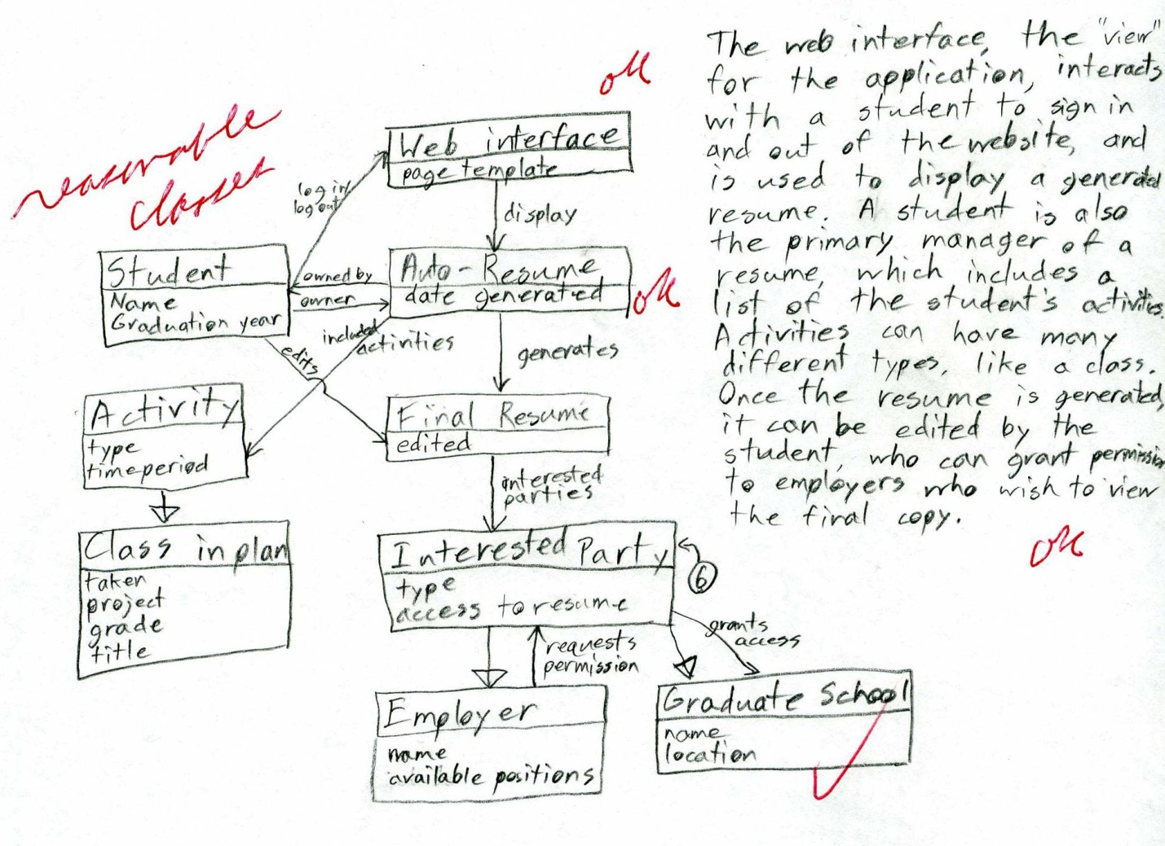

- (10 points) → Create a picture showing the layers and packages of the system, based on your DCD, above, and be sure to show dependencies among these: Include a 1-paragraph explanation, like we did for the figures already given in the exam. Note – If you elected not to do problem 2, invent a similar level of detail in the classes for this problem:
Full credit required that you had both multiple layers that made sense, and some packaging of the DCD classes, with more than a single arrow between layers, and a reasonable, short explanation.
- (10 points) In the Domain Model given, the authors had a domain class to represent Class in Plan, whether the student had taken it yet, or not. But they did not explicitly show other activities which the student may want to put on their resume, besides classes. → Add, to the domain model already shown, above, how it would look if you added two more domain classes, for activities that logically would be on a student’s resume.
This was a simple addition of two reasonable classes like Employment, Internships, Projects, or Service Activities, under Activity, on the existing DM.
- (10 points) → Describe the most important place where you would use the GoF Adapter pattern in this design, explain why this would be valuable, and point to it on your DCD, above. Note – If you elected not to do problem 3, draw just the part of it that would pertain to this problem:
Adapters convert interfaces. Any place where some outside system is attached would be a good place for an Adapter, even when this is fixed. Technically, Banner and Rose-ePortfolio don’t count, because they are attached to the Student, not directly to the eResume System! They would otherwise be good choices, because they could change, for example. An adapter for the DB is very popular, because it gives one consistent way of dealing with a messy interface.
- (10 points) → Describe the most obvious place to use a GoF Factory in this system, explain the value, and describe how the factory would work:
Either creating the Editable Resume, which would be messy and variable, or creating the Activities, especially if you added different types to these in question 5! The factory would account for the variations and deliver to the Student class an object with appropriate data in the attributes, etc.
- (10 points) → What part of this system already looks like a GoF Façade, and why? And how would you implement this to make it an effective façade?
This is almost the same answer as for question 6, above, because Façades also substitute an interface. The difference is that Façades give a unified, higher-level interface for a set of interfaces. I disagree that Student is or needs a Façade, which some people said. More likely, something like the class data coming via Banner is more complex than needed for a resume, and, as represented in Class in Plan, has more to it than we really need to show it on a resume, thus there would be a Façade to simplify it.

- (10 points) One place to use either GoF Composite or Strategy would be in having the system give “smart” recommendations to a student, regarding how to describe the student’s areas of technical expertise. → Explain which of these patterns you would use for that advice-giving, and why?
Strategy is really a way to pick an algorithm, and it tends to be a stable choice for a given situation, often loaded at run-time, like the Accounting System example in the Larman’s book. Composite has the advantage that it is a momentary decision for a situation in a running program, which fits this need better. It also can be invoked recursively, which does fit the problem-solving situation of giving recommendations.
In your answer, you should at least have said why your choice was better. If you had a good reason, I accepted Strategy as the answer.
- (10 points) Right away, Career Services has realized that the “Interested Parties” should include graduate schools as well as employers. → Add these to your DCD. Suppose that these were different in that we had to initiate sending them information, instead of waiting for them to request it. Draw what the sequence diagram would look like to accomplish this interaction, using your DCD as the reference. Note – If you elected not to do problem 3, draw just the part of the DCD that would pertain to this problem:
This asked for two figures, or an addition to the DCD along with the SD. The latter should have shown our system initiating the resume transmission to the other school.
- (10 points) For security, there really are certain things that ought to be GoF Singleton’s in this system. → Identify two such classes, and explain why:
The most likely are the representation of outside entities requiring security, like Banner. Also, answers about security handling and the database were good guesses! Not acceptable was that something like Student should be a Singleton. It’s true there should be only one object for a given student, at any given time, but that’s not the same as a Singleton, which is one object (or a static one) for everybody!

