CSSE374 Winter 2011-2012
Exam 1 Part 1
1/12/2012

Instructions: You may use your notes and the book. This test is time bound so do not read the book too much. Collaboration is not allowed.

Problem | Score
1 | Out of 30
2 | Out of 25

- GRASP problem
The game of “craps” is an exciting casino game played with two dice. Basically, the “shooter” rolls both dice at once, one or more times. The outcome can be decided on the first roll of the two dice, or in subsequent rolls. If the shooter wins, he or she continues to roll. The “betters” bet on the outcome (for or against the shooter).
This domain class diagram for this game was created without concern for Larman’s GRASP principles. Your goal is to critique it in that regard, and describe what GRASP principles you would use to make your recommended improvements.
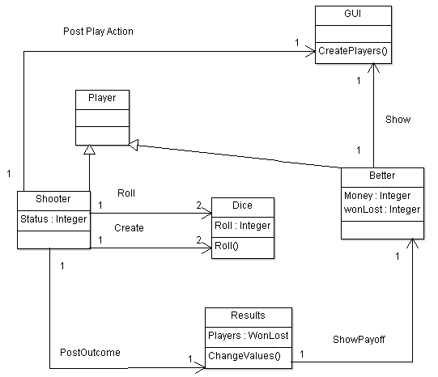

Rubric and Answers:
Largely I graded this question based on your discovering things in the figure that disagreed with GRASP principles we've studied. For full credit, you had to mention multiple instances of GRASP violations by name, in situations that sounded plausible to me (and I was flexible in considering your interpretation). Here's the rough rubric I used in weighting these:
15 of the 30 points: A big part of the answer is saying “There needs to be a Controller class other than the GUI, which is what’s suggested by the figure.” Otherwise, too much for the GUI to do - it's not cohesive (or, I’d accept saying this doesn’t follow good MVC practice, though that’s not in GRASP per se).
If you said that the shooter or some other class already there should be the controller, I tried to see that as a possibility, although it's almost surely not as good as having a "Game" controller class.
If you saw problems with the permanence of some of the objects, in terms like what logically should be an information expert on what, I gave credit for that. E.g.,:
- 5 of the 30 points: The permanence of Shooter, Better, and Dice is murky and coupled more than it should be. In particular, the roles of Shooter and Better would vary as the game progresses. And, do separate Dice need to be created for each new Shooter?
- 5 of the 30 points: The Results need to be semi-permanent over the course of the game, so they almost surely need to be related to the non-existent Controller ("Game" or whatever), and not just to the players. Probably destroys the cohesiveness of the Controller to put all the scorekeeping there, as well.
I also gave 5-10 points or more (for a total of 30 or less) given for other observations taken from the points below that aren't already covered:
- Need a controller of some kind identified or suggested in the figure. The most logical would be for this controller to be a Game class, which is not shown.
- Unlikely therefore that the GUI should create the players.
- Also possible to have the Player as the controller, though this could lead to issues because the GUI needs then to interact with both a Player and multiple Better controllers during any part of the game.
- The Shooter should be the info expert on the results of the dice throws, because it does those. This is suggested by the diagram, but not clear because Results has the WonLost attribute.
- Many more detailed issues can be addressed:
  - The Shooter and Player roles will vary as the game progresses, so making them subclasses as shown is questionable, unless these are temporary entities. Then where does their information as Players generally go? (Like their scores.) The overall scores management should be somewhere in the model - putting this in the Controller probably gives it too many tasks (reducing cohesion).
  - Controller could show the results, not Better and Shooter, but the MVC model does allow this to stay as shown. And the above comment suggests this is too much.
  - There's a question of whether or not Results should be a permanent, singleton object started by the Controller. Probably so, to avoid a lot of coupling as the game progresses and the role of Shooter changes.
  - Having the Shooter create the Dice also is questionable. The dice remain over the course of the game. This creates unnecessary coupling of Shooter and Dice.

- Domain Model Question
Domain description: This problem relates to the domain of customers ordering merchandise from a company. The domain includes the customer’s acts of finding merchandise by category, checking merchandise for availability and price, placing an order, and checking on their order status.
Below is a proposed domain model for the domain. As you can see, a Customer places an order, which can have one or more products included in it. Each different product is an “OrderLine” on the Order. The OrderLines are from a catalog of Product(s), that are grouped into Category(s).
Critique this domain model, identifying as many things as possible that you would do to improve it and to bring it in line with the above domain description.
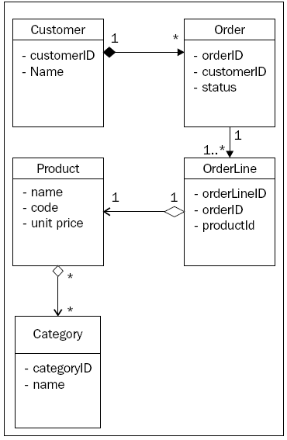
Rubric and Answers:
This is an interesting exam question because it requires you to think on multiple levels about what's given:
- There are details that are wrong about the format of the picture, like it shows privacy of attributes and does not label the dependencies.
- There are (perhaps arguably) things wrong with the figure as it stands, in terms of supporting a sale.
- The figure does not represent all of the domain as it is described.
I gave up to 10 of the 25 points for noticing that the whole domain isn’t represented by the picture.
I gave 5 of the 25 points for pointing out things in A, above, like that the connections should be labeled.
I gave 10-15 points (for a total of 25 or less) given for other observations taken from the points below that aren't already covered:
- The model shown only works for placing orders. The domain described also includes finding merchandise, checking on its availability and price, and checking on order status. E.g., the Customer needs to be able to access Product and Category, as well, without an order.
- Having the stars on both ends of the Product to Category line is confusing, even if it is sometimes true that a product is in multiple categories, because a Category is shown as being composed of the Products.
- The Order to OrderLine arrow should show that the Order has a composition of OrderLines.
- It's questionable that OrderLine is a composition of Products, since it's 1 to 1.
- Customer to Order isn't a 1 to many during the scenario that is described verbally for the domain. (Though it would be in general, because a customer could have many orders.)
- The domain model doesn't need to show visibility of the attributes.
- The relationships should be identified to clarify the dependency.
- Some additional classes may be needed - like an information expert class to go with each product, so that this product info doesn't disappear if we sell-out of the items.
- The foreign keys shown in places should be taken off. (Like orderID in OrderLine.)
- Product attributes should include availability, since that's something important to the domain.

This should have been the word "design." Only one person read the problem as asking for a domain diagram, and I graded theirs accordingly.

