374 take home final part 2
Instructions
This is an individual test. You may not consult with anyone except either of the class instructors. You may use your text (digital or analog), your notes/quizzes, emails from the instructors, and any materials under http://www.rose-hulman.edu/class/cs/csse374 website. No internet or internet searches.
In all solutions: please keep in mind the design principles from class. Solutions that conform to GRASP/GoF patterns are preferred of course.
Submit your solution as a PDT (parts 1 and 2) to the ANGEL drop boxes.
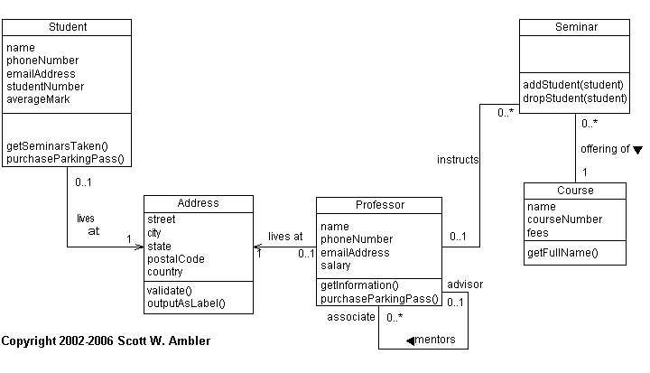
(This is a slightly modified version of Scott W. Ambler’s UML Diagram)
This system is only partially functional and might have some problems.

- (20 pts) There is some duplicate data/functionality between the Professor and Student objects, what might we do to reduce this duplication? Please present relevant design artifacts (probably including a class diagram and an interaction diagram showing how external clients of those classes would use them, in light of the new entities). There are at least two ways of doing this, can you discuss why your solution is superior to another way?

- (20 pts) Given this activity diagram:
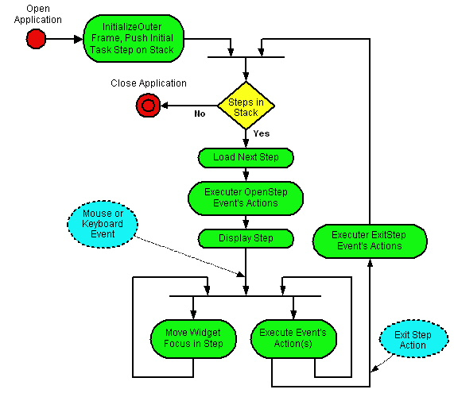
from: http://www.classle.net/faq/what-activity-diagram
This activity diagram shows how users interact with an application.
- Under what conditions would the application NOT exit after the user completes the first step?
- Suppose you had to build this system with only FOUR classes. Draw the DCD showing how those classes would relate.

