374 take home final part 1
Instructions
This is an individual test. You may not consult with anyone except either of the class instructors. You may use your text (digital or analog), your notes/quizzes, emails from the instructors, and any materials under http://www.rose-hulman.edu/class/cs/csse374 website. No internet or internet searches.
In all solutions: please keep in mind the design principles from class. Solutions that conform to GRASP/GoF patterns are preferred of course.
Submit your solution as a PDT (parts 1 and 2) to the ANGEL drop boxes.
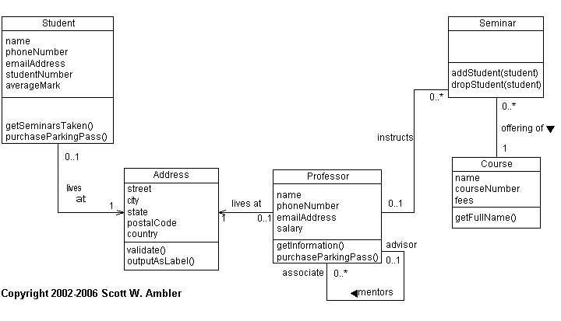
(This is a slightly modified version of Scott W. Ambler’s UML Diagram)
This system is only partially functional and might have some problems.
- (40 pts) We’d like this system to support students signing up for seminars that have a limited number of spots. The workflow is this: a professor is teaching a course and will periodically offer seminars. Once the seminar is listed, students may sign up for them. If the seminar limit is exceeded, the student ought to be added to the wait list – if another student drops in the meantime, a student at the top of the wait list will be automatically entered into the seminar.

How might we support the following?
  - Seminar.addStudent()
  - Seminar.dropStudent()
  - Student.getSeminarsTaken() [this ought to work for historical data]
What other functions and classes might we need to add?
Please show interaction diagrams to support the changes you will make to the class diagram. Give us a high degree of confidence that your solution will be complete.

- (20 pts) The “create seminar” use case is:
Given a professor (who is teaching a course), create a new course as a seminar. This seminar gets added to the global “SeminarsCollection”. As a post-condition, students can now sign-up.
What object ought create the Seminar object? Please work through the relevant diagrams to determine how this use case ought to flow, step by step. There ought to be more than one diagram.

