Team Biohazard

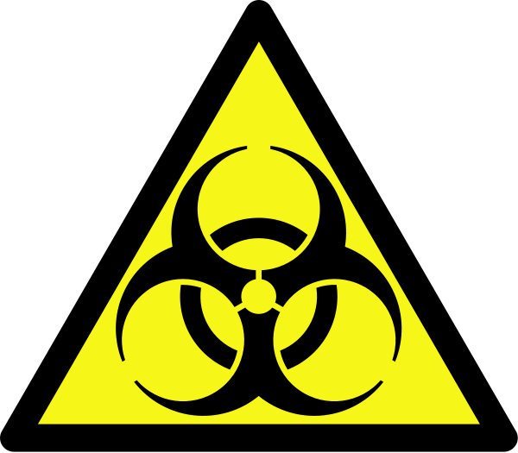

CSSE 371 Milestone Two

Chris Hoorn,
Vismay Modi,
Spencer Murphy,
Zhengyu(Daniel) Qin

Table of Contents
Table of Contents
1. Executive Summary 3
2. Introduction 3
3. Project Content 4
3.1 Project Background: 4
3.2 Features Table: 4
3.3 Use Cases: 6
3.4 Feature Mapping: 15
3.5 Data Flow Diagrams: 16
Context 17
Level 0 18
Level 1 19
Level 2 19
4. References 20
5. Index 21
6. Glossary 22

1. Executive Summary
This document will elicit further details about the development of the BioHazard project, the game BioPioneer. Our project will be a fun and educative introduction for young adults into the diverse field of Synthetic Biology. Most tablet games currently do not present the users with the unique opportunity to learn something while playing, however BioPioneer would be an ideal candidate to meet that challenge. Through its innovative in-game tutorials and its detailed Learning Center, BioPioneer retains the fun of game-play and combines it with multiple styles of education in order to meet the varied needs of our users. Future milestones will describe in more details the inner workings of the game. We will also develop test cases, and prototypes for the game.

2. Introduction
The document for this milestone will expand upon previous installments by describing use cases that demonstrate the functional requirements of our system. The features presented in previous milestones will be clarified through in-depth scenarios contained within the use cases’ main and alternate flows.
In addition to detailed use cases, data flow diagrams will be developed to illustrate certain requirements of the system. A context level diagram showing the application environment, as well as lower level diagrams are included to reveal deeper data flows within the system.
This document shows the client and stakeholder more details about this document will elicit further details about the development of the BioHazard project, the game BioPioneer and understand each use cases and its contents.

3. Project Content

3.1 Project Background:
Our client is Mr. Ben Deschaine, a current Rose-Hulman senior majoring in Biomedical Engineering and a Resident Advisor in the Apartments West Residence Hall. Over the summer of 2012, Ben designed and created the BioPioneer board game as an entry in the IGEM competition. Ben decided to commercialize his game by selling it as a tablet application. In order to do this, he approached Dr. Chenoweth and asked the app to be designed as part of the CS/SE Junior project. Ben is the sole owner of the Intellectual Property rights of this game. Currently, BioPioneer is a board game that is still in beta testing with is only one tangible copy of the game. As this is a new game that our client Ben and the IGEM group have made, there is no existing software system.
We are making a mobile version of the game that will be played on iPads by our target customers, who, according to the client, are students and young adults. Its purpose is to interest students or other users in synthetic biology and bioengineering as career choices. The product, BioPioneer, is likely to provide a very general understanding of the equipment and methods used in synthetic biology while giving the users a fun platform to learn from. It will also be able to show the users the interdependencies between labs, equipment and access to resources and how these nuanced interconnected relationships affect the final product of the lab. Our product stands apart from other games on the market because it is both a multiplayer and single player game that mixes education with fun.

3.2 Features Table:

ID | Feature | Reason
1 | Touch Graphical User Interface | The game is going to be played on portable device as a native application.
2 | Background Music | Most modern games have background music. This feature can be turned off or on depends on user's need.
3 | Player Profiles | It is important for a user to be able to customize their game play to their personality.
4 | 2-4 Multiplayer | It is essential to meet client’s request to make the game playable with friends.
5 | Single Player vs. AI | The game will also be playable even with single player.
6 | Educational Popups | Matches the educational purpose of this app.
7 | Short and Long Games | Allow different level player playing have different game experiences.
8 | Variations for Different Numbers of Players | Game won’t need exactly 4 players to start, which conveniences everyone.
9 | Die Rolling | Randomly decide a dice roll to make the event fair and exciting.
10 | Token/Avatar Selection | Player can choose what game token their character will represent.
11 | Sound Effects | Sound effects for actions in the game.
12 | Tutorials for different features | Tutorials that explain how the game is played.
13 | Help/Instructions | The rulebook and instructions on how to play
14 | View Other Labs | The player can view their lab and other players’ labs.
15 | Board Representation | A representation of the board.
16 | Random Initialization of Cards | All shape, lab event, world problem, and DNA sequence cards need to be shuffled at the beginning of each game
17 | Ability to Choose a Lab | Players are able to choose the lab they want to use.
18 | Turn Clock | Clock each turn will make the game more fair, but also will be bad if player is facing some connectivity issues.
19 | Welcome Screen | A welcome screen.
20 | Card Selection | Every turn players must select at least one card. A method of simulating cards in the application.

3.3 Use Cases:
Name: Starting a Game
ID: 1
Brief Description: The player sets up a new game by selecting the players, labs, tokens, and length of the game to be played. They will also use a generated profile for themselves.
Actors: User, other players
Preconditions:
- ->The Welcome Screen has displayed and the main menu is currently displayed.
- The user has created a profile.
Basic Flow:
- User presses “New Game” button.
- -> The screen prompts the user for the amount of players.
- User chooses how many players that will play.
- -> The screen asks the user if they want to use their profile.
- The user selects yes.
- -> The screen prompts the user to choose a profile of the second player, enter the name of the second player, or choose to make them be controlled by the computer.
- The user enters the second player’s name
- The rest of the users names are entered.
- The user presses the “Next button”
- -> Die rolls are cast to determine the order of play and are shown on the screen.
- The person with the highest roll is prompted to choose a token.
- The user presses the button corresponding to the token they want.
- -> The screen prompts the same user to choose which lab they want.
- The user chooses the lab they want.
- -> The screen prompts the second user to choose their token and then lab.
- The rest of the users choose their labs and tokens.
- -> The screen prompts the user if you want to play a short or long game.
- The user chooses short or long game.
- -> A random world problem is chosen and displayed on the screen with the requirements.
- -> Random DNA sequences are assigned to each user.
- The user taps anywhere on the screen to start the game.
- -> The board is initialized and the first player is ready to start their turn.
Alternate Flows:
3.a. The user can choose different numbers of players.
5.a.1 The user selects no.
5.a.2 -> The screen prompts the user for their name.
5.a.3 The user enters their name.
7.a. The user chooses to make the second player be played by the computer.
7.b The second player chooses a profile.
8.a. The amount of users to do this will change depending on the amount of players and how many are human players.
9.a. The user can edit the other player’s names or profile selection.
11.a. If the highest roll is assigned to a computer player, it will automatically choose a token and lab at random.
16.a. This will change depending on the number of players and if they are human (computer players’ items are chosen at random).
18.a. The user chooses a long game
a. The user closes the app at any time.
b. The user cancels the new game at any time.
c. The user goes back a step at any time.
d. The game has an error at any time.
e. The iPad battery dies.

Post conditions:
- The game is ready to play.
- All labs have been chosen and DNA strands are initialized.
- The world problem has been determined.
- The play order is determined.
- The board is initialized.
- Screen displays the board and prompts first user to start turn.

Name: Creating user profile
ID:2
Brief Description: Before start of the game, players have to create their user profiles so that each of the players can have a graphical token in the game, and also their profiles can be stored into memory play history and games.
Actors: User, and other players
Preconditions:
♦ Users have chosen to enter game
♦ .User is a new player or returning player
♦ User willing to use tokens or pictures to represent him/her
Basic Flow:
1. User tap on the “User Profile” button on the iPad screen
2. -> Enter profile management interfaces
3. User is a new player, tap the “Create” button
4: -> Enter create interface, ask user to choose a picture from library or choose a token to represent him/her
5: User done creating, tap on “Done” and then tap the “Back” buttons
6: -> Back to profile management interface, show current user’s profile and game history
7: Each new player can do the same flow to create their profiles, when done, tap on the “Back” button back to main menu.
Alternate Flow:
3.a User is a return player, tap on the “Load Profile” button
4.a.1-> Enter load profile interface, all the player data stored will be displayed
4.a.2 -> Users can take pictures via iPad’s camera and use the picture as his/her profile picture
5.a.1 Users choose one existing profile and load it as his/her profile, and tap “Back” button

Post condition:
♦ The profiles for each player are set up
♦ The tokens and pictures loaded to the game
♦ The game is ready to start, users can skip the setup screen and jump to game interface.

Name: Playing a turn
ID: 3
Brief Description: Once the game has started, users take turns rolling the dice, moving, selecting DNA, using abilities, obtaining resources, and completing actions.
Actors: User, Other players
Precondition:
- Players have started a game
- It is the beginning of a turn
Basic Flow:
- User taps on the die
- -> Display die with random number between 1 and 6 inclusive
- User presses ‘Move’
- -> Move user’s piece the number of spaces indicated by the die
- -> The DNA shape is revealed to the user
- User taps on shape card
- -> The DNA attaches itself to the player’s DNA strand
- User taps ‘continue’
- -> Present options to user
- User taps the person option
- -> Display the new person screen
- User taps the die
- -> Display die with random number between 1 and 6 inclusive
- -> Decrement user’s action counter
- User taps ‘accept’
- -> Add person to the lab
- User taps ‘continue’
- -> Display game board
- User taps ‘end turn’
- -> Recalculate the user’s action counter
- -> Pass control to next player
- User passes the iPad
Alternate Flow:
Random Events
a. The user closes the app at any time.
b. The game has an error at any time.
c. The iPad battery dies.
d.1. The User clicks on a lab at any time
d.2. -> Display selected player’s lab
e.1. The user taps ‘main menu’ at any time
e.2. -> Switch to main menu
f. Step 10 and its alternates may be repeated as long as the user has actions
g.1 User tries to use an equipment for the second time that turn
g.2 -> Indicate item has been used up
User wants to adjust their die roll
3.a.1. User taps ‘Take Action’
3.a.2. -> Present options to user
3.a.3. User selects the pipette action
3.a.4. -> Display info about pipette
3.a.5. User taps ‘use’
3.a.6.a.1 User taps the up arrow
3.a.6.a.2 -> Die number increments
3.a.6.b.1 User taps the down arrow
3.a.6.b.2 -> Die number decrements
3.a.7. User taps ‘accept’’
3.b. User may press back during steps 3.a.3 or 3.a.5
The user lands on a lab event square
4.a.1 -> User’s piece stops when it reaches a lab event space
4.a.2 -> Present user with lab event
4.a.3 User taps ‘accept’
4.a.4 -> Apply penalty or benefit to user
4.a.5 -> Continue to step 9

User lands on a star space
5.a -> Present shape options when user lands on star space
User wishes to use a piece of equipment
6.a.1 User taps ‘take action’
6.a.2. -> Present options to user
6.a.3. User taps on an option
6.a.4. -> Show info about option
6.a.5. User taps ‘use’
6.a.6. -> Apply effects of option
6.b. User may tap ‘back’ during steps 6.a.3 and 6.a.5
User wants to go for a paper (a), go for equipment (b), use an ability (c.) or win the game (d)
10.a.1 User taps the ‘paper’ option
10.a.2 -> Display list of papers
10.a.3 User taps on a paper
10.a.4 -> Display info about selected paper
10.b.1 User taps the ‘equipment’ option
10.b.2 -> Display equipment tree
10.b.3 User taps on an item
10.b.4 -> Display detailed equipment information
10.c.1 User taps the ‘abilities’ option
10.c.2 -> Display user’s abilities
10.c.3 User selects an ability
10.c.4 -> Display detailed ability information
10.c.5 User taps ‘use’
10.c.6 -> Apply the ability and adjust action counter
10.d.1 User taps ‘solve world problem’
10.d.2 -> Display world problem and requirements
10.d.3 User taps the die
10.d.4 -> Generate random number 1-6
10.d.5.a -> Display winning screen
10.d.5.b -> Indicate failure
User cannot roll the die again.
13.a -> Indicate user has no remaining actions
13.b -> Indicate max number of people/turn
13.c -> Indicate max number of equipment/turn
13.d -> Indicate max number of papers/turn
13.e -> Indicate insufficient technology level
A player fails (a), gets a paper (b), or gets a piece of equipment (c.)
16.a -> Display insufficient knowledge pool
16.b -> Add paper to lab
16.c -> Add equipment to lab

Post condition:
- It is no longer the player’s turn

Name: Turn on/off music
ID: 4
Brief Description: There will be background music playing during the game, and it will be controlled by the user.
Actors: User, Other players
Preconditions:
- The game has been started

Basic Flow:
- User taps on the options tab
- -> Options are presented to user on the screen and the game is blacked out
- User taps on the sound options button
- -> A list of sound options appear on screen with on/off options
- User taps ON or OFF on the background music option
- -> Background music turns either on or off depending on its previous state
- User taps EXIT to exit the options tab

Alternate Flow:
a. The user closes the app at any time.
b. The game has an error at any time.
c. The iPad battery dies.
1.a. The enters the options tab
1.b. The user can press the exit button to leave at any time
3.a The user presses some other button by accident and turns on/off some other feature
3.b The user can undo this action by re-tapping the same button
d. The user can also press exit at any time to leave the options tab

Post conditions:
- Board returns to original state

Name: Turn on/off sound effects
ID: 5
Brief Description: There will be background music playing during the game, and it will
Actors: User, Other players
Preconditions:
- The game has been started
Basic Flow:
- User taps on the options tab
- -> Options are presented to user on the screen and the game is blacked out
- User taps on the sound options button
- -> A list of sound options appear on screen with on/off options
- User taps ON or OFF on the sound effects option
- -> Sound effects turns either on or off depending on its previous state
- User taps EXIT to exit the options tab

Alternate Flow:
a. The user closes the app at any time.
b. The game has an error at any time.
c. The iPad battery dies.
1.a. The enters the options tab
1.b. The user can press the exit button to leave at any time
3.a The user presses some other button by accident and turns on/off some other feature
3.b The user can undo this action by re-tapping the same button
d. The user can also press exit at any time to leave the options tab

Post conditions:
- None, the user can do nothing and just exit the options tab and the game will return to the board.
- Board returns to original state

Name: Hints
ID: 6
Brief Description: Beginners will be greeted with helpful hints as to what their options are during different phases of play.
Actors: User, Other players
Preconditions:
- The app has been started
- A game is in progress
Basic Flow:
- User taps on the options tab
- -> Options are presented to user on the screen and the game is blacked out
- User taps on the hints button
- -> The screen displays possible options for the player letting them know what they can do during that turn.
- User views the advice
- User taps EXIT to exit the options tab

Alternate Flow:
a. The user closes the app at any time.
b. The game has an error at any time.
c. The iPad battery dies.
1.a. The enters the options or hints tab
1.b. The user can press the exit button to leave at any time
3.a The user presses some other button by accident and turns on/off some other feature
3.b The user can undo this action by re-tapping the same button
d. The user can also press exit at any time to leave the options tab

Post conditions:
- Board returns to original state

Name: View Other Labs
ID: 7
Brief Description: The player can view any other player’s lab during their turn to view their equipment, papers, and DNA.
Actors: User, Other players
Preconditions:
- The game has been started.
- It is a human player’s turn.
- The lab contains at least one paper.
Basic Flow:
- User touches other person’s corner of the screen
- -> Screen displays overview of other person’s lab.
- User touches the equipment tree.
- -> Screen displays a more detailed view of the equipment tree and the player’s equipment
- User presses the exit button.
- ->Screen displays overview of other person’s lab again.
- User taps a paper.
- ->Screen displays a details about the paper.
- User presses the exit button.
- ->Screen displays overview of other person’s lab again.
- User presses the exit button.
- -> Screen returns to the playing board
Alternate Flow:
a. The user closes the app at any time.
b. The game has an error at any time.
c. The iPad battery dies.
1.a. The user doesn’t touch another person’s lab corner.
3.a. The user doesn’t touch the equipment tree.
3.b. The user taps on a paper instead.
3.c. The user presses the exit button.
7.a. The user doesn’t touch a paper.
7.b. The user taps on the equipment tree instead.
7.c. The user presses the exit button.

Post conditions:
- The screen is back to the game board.

Name: View Tutorials
ID: 8
Brief Description: The player can view tutorials on how to play the game from the main menu.
Actors: User
Preconditions:
- The main menu is displayed.
Basic Flow:
- User touches the tutorial button from the main menu.
- ->The screen displays several different categories.
- User touches a category.
- ->The screen displays a screenshot and/or text describing an aspect of play.
- User presses the “Next” button.
- ->Another screenshot and/or text screen describing more appears.
- User keeps pressing “Next” button until it no longer appears.
- User presses the “Exit” button.
- ->Screen returns to list of categories.
- User presses the “Exit” button.
- ->Screen returns to the main menu.
Alternate Flow:
3.a. The user selects a different category.
3.b The user presses the “Exit” button.
5.a. The user presses the “Exit” button.
7.a. The user presses the “Exit” button.
a. The user closes the app at any time.
b. The game has an error at any time.
c. The iPad battery dies.

Post conditions:
- The screen is back to the main menu.

Name: View Learning Center
ID: 9
Brief Description: The player can educate themselves in various topics concerning synthetic biology through tutorials in the learning center.
Actors: User
Preconditions:
- The main menu is displayed.
Basic Flow:
- User opens game options menu
- ->The screen displays several different options
- User touches the Learning Center Button
- ->The screen displays the learning center menu with a list of topics to choose from
- User clicks on one of the topics
- ->The screen is redirected to the page for that topic, including embedded links to youtube.com videos
- User reads about the topic to learn
- User presses the “BACK” button.
- ->Screen returns to list of topics.
- User presses the “EXIT” button.
- ->Screen returns to the main menu.
Alternate Flow:
1.a. The user exits the Learning Center at any time
1.b. The screen returns to the game
4.a The user clicks the wrong link
4.b Pressing the BACK button will return the user to the Learning Center menu
a. The user closes the app at any time.
b. The game has an error at any time.
c. The iPad battery dies.
Post conditions:
- The screen is back to the main menu.

Name: Ending a Game
ID: 10
Brief Description: After a game has been completed and a player has won, they are greeted with the option to return to the main menu or start a new game.
Actors: User
Preconditions:
- A game has just completed
Basic Flow:
- -> Display end screen
- User taps ‘main menu’ button
Alternate Flow:
2a1. User taps ‘reset’
2a2. -> Reset game based on last game’s settings
Post conditions:
- The ending screen is no longer displayed
- New game is created or Main menu is displayed

3.4 Feature Mapping:

Use Case | Features
1. Starting a Game | (4)2-4 Multiplayer, (5)Single Player vs. AI, (7)Short and Long Games, (10)Token/Avatar Selection, (17)Ability to Choose a Lab,(16)Random Initialization of Cards, (19)Welcome screen
2. Creating a Profile | (3)Player profiles
3. Playing a Turn | (9)Die Rolling, (20)Card Selection, (6)Education Pop-ups, (18)Turn Clock
4. Turning on/off music | (2)Background Music
5. Turn on/off sound effects | (11)Sound Effects
6. Turn on/off hints | (13)Help/Instructions
7. View other labs | (14)View other labs
8. View tutorials | (12)Tutorials
9. Access Learning Center | (13)Help/Instructions
10. Ending a Game

*Features not covered by the above use cases (1,8, and 15) are not functional requirements

3.5 Data Flow Diagrams:
All of these DFD’s are for the proposed system because there is no current software system.

Context
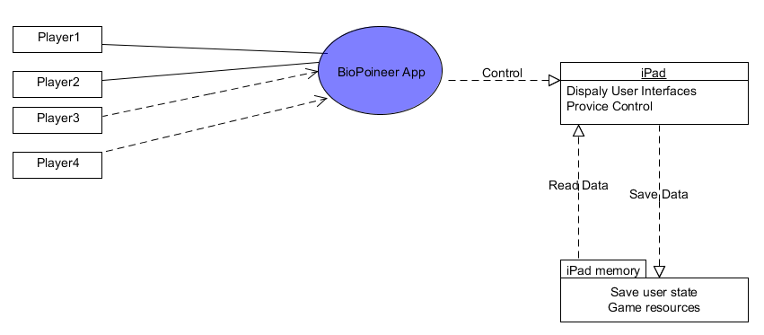

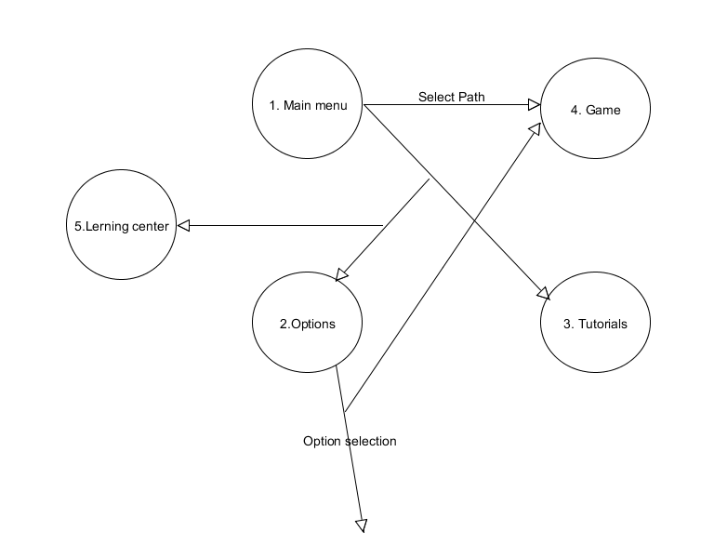
Level 0

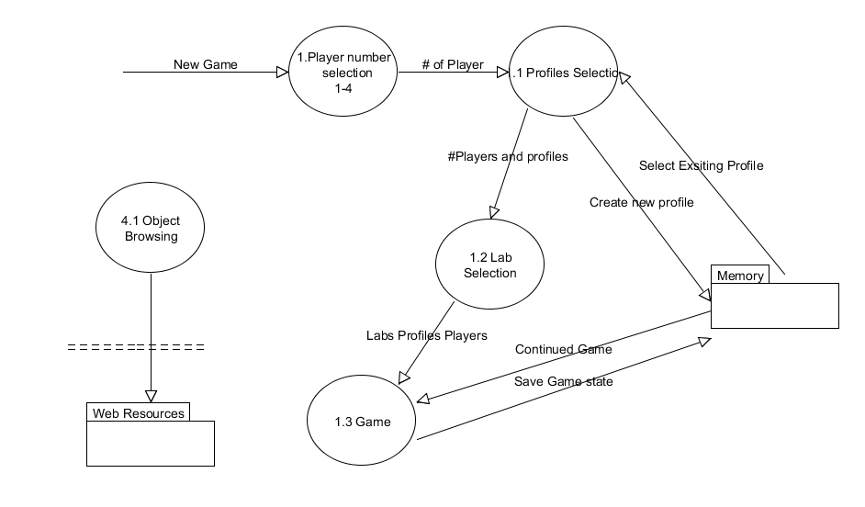
Level 1

Level 2
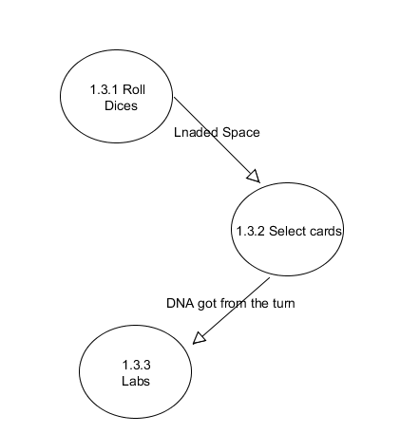

4. References
1: Quality Software Project Management , Robert T. Futrell, Donald F. Shafer, and Linda I. Shafer, Prentice Hall, January 2002
2:Software Project Survival Guide (Pro -- Best Practices)
3:Alkire, Sabina. 2002. "Dimensions of Human Development." World Development 30(2): 181–205.
4:Robeyns, Ingrid. (2005). The Capability Approach: A Theoretical Survey Journal of Human Development 6(1) 93-114.
5: <Data Modeling: A Beginner's Guide> Andy Oppel (Author),Publication Date: December 21, 2009
6: <Writing effective use cases> Alistair Cockburn, Publication Date: October 5, 2000
7: Leffingwell, Dean, and Don Widrig. Managing Software Requirements. 2nd. Boston: Pearson Education, 2003. Print.

5. Index

Apple 22
Equipment 22
IGEM 4, 22
IOS 22
Music 4, 16
Papers 22
Profile 4, 7, 8, 16
Sound Effects 5, 12, 16
Tutorial 5, 14, 16

6. Glossary

Actions - In Biopioneer, the number of activities user may undertake on a given turn.
Deoxyribonucleic acid (DNA) - a nucleic acid containing the genetic instructions used in the development and functioning of all known living organisms.
Equipment - In Biopioneer, items which allow the players to use special abilities during the game.
IGEM - The International Genetically Engineered Machine (IGEM) competition is a worldwide Synthetic Biology competition aimed at undergraduate university students.
IOS - A mobile operating system developed and distributed by Apple Inc. Originally released in 2007 for the iPhone and iPod Touch, it has been extended to support other Apple devices such as the iPad and Apple TV.
Knowledge Pool - In Biopioneer, represents a player’s lab technology level. Used to determine success or failure when performing actions.
Papers - In Biopioneer, game items which allow the players bonuses to their knowledge pool.
Youtube.com - A popular video sharing website.

