- Change the following method into a cps-procedure:
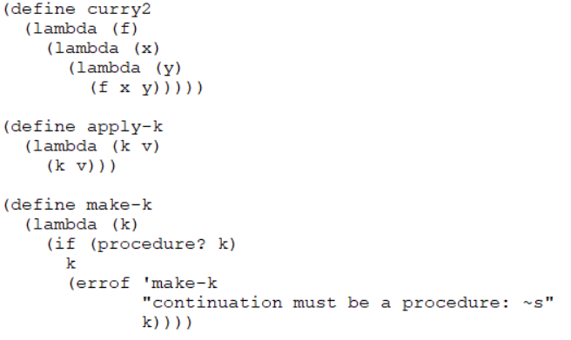
- Now change that method so it is imperative form using datatype for the continuations and an apply-k to evaluate those continuations the following unfinished code may help:
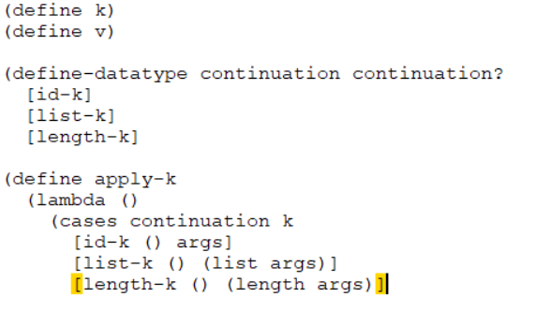
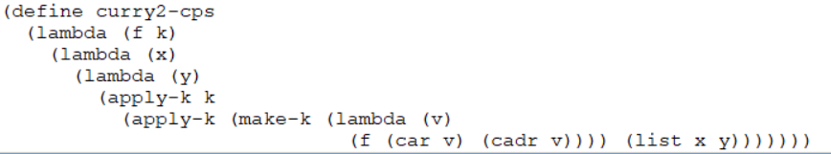
Answers:
1.

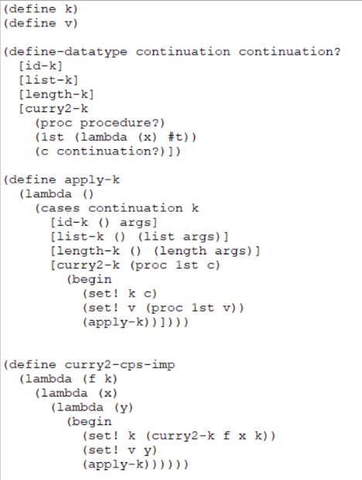
2.

