Written assignment 8, Weiss problems

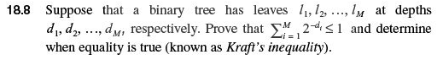
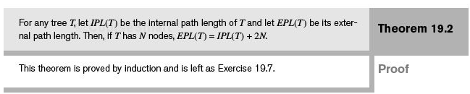
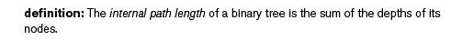
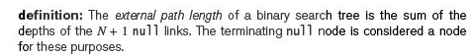
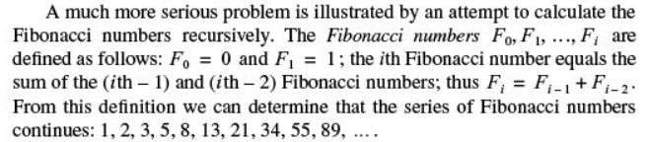
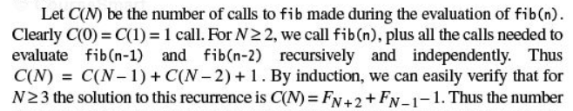

Problem 6:
