Set your Path environment variable in Windows to facilitate compiling and running Java programs fm the command line:
- Open My Computer, and browse to the place where your Java JDK binary files live.
(something like C:\Program Files\Java\jdk1.6.0_01\bin). Select the pathname at the top of the window, and type ctrl-C to copy that path to your clipboard.
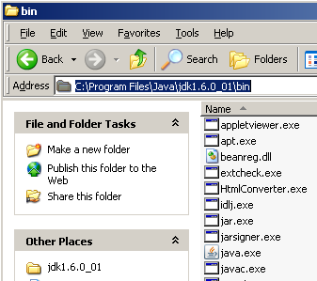
- Log in to an account with administrative rights (localmgr).
- Right-click "My Computer", and choose Properties. Click the Advanced Tab.
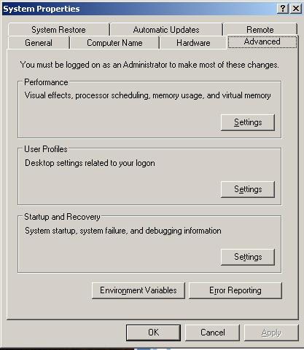

- Click Environment Variables
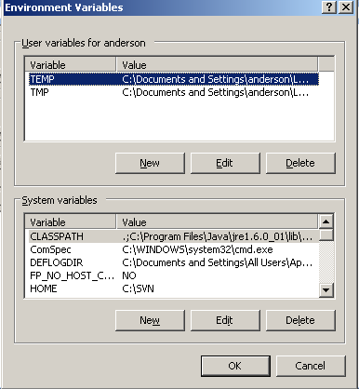
- In the System Variables List, scroll down to find Path. Select it, then then click Edit.
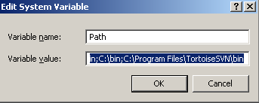
- At this point you want to be careful not to lose what is there. (Single)click in the Variable vaslue field, then press the End key on your keyboard.
- Now use the left arrow key to slowly scroll through the long string, looking for the same pathname as the one that you copied to your clipboard. If it is there, you don't need to do anything. Repeatedly click Cancel to exit all of the dialog boxes.
- If you don't find it, press the End key again. Type a semicolon (;), and then Ctrl-v to paste in that pathname. Press OK repeatedly to Exit the properties dialogs.
- Check it out. Press the Start button and choose Run (a shortcut for this is to hold down the Windows key and press R). Type cmd and press Enter. At the DOS prompt, type javac and press Enter. If you get the
'javac' is not recognized as an internal or external command, operable program or batch file
error, something is wrong. If you get a list of options for the java compiler, everything should be okay.!

