HUX System, Usage Documentation/Speculation

Written By: Jeremy Jarvis
Date: 3-27-03

One note from Jeremy: This is what I have discovered so far in working with the system. These are predominantly my thoughts when using lotus in Windows 2000. There is a section at the bottom dealing with differences in lotus in Windows 2000 and NT. Feel free to edit this document or re-write it however you see fit. It is fairly informal in its current state.

Passwords:
Windows 2000 Login: Userame: administrator
Password: (blank)
Windows NT Login: First check “Workstation only” and then
Userame: rose
Password: rose

To seal/un-seal macro workbooks: Password: HUX
For MUCALC_F.wk4: Password: sEAL
To bring menus in lotus, hidden upon startup: <ctrl>-r

Current Status of Macros (On the E drive, E:\123R5W\MUCALC\):
Currently (3-27-03) all the macros are locked. If a macro is locked, you can run it, but can’t edit it. If a macro is unlocked, you can’t run it, but you can edit it. Brett and Jeremy had unlocked ISO for a period of time to mess with it. It has since been locked back. The only other change to ISOMACRO.wk4 is that its code was changed to look to the E drive instead of the F drive. This is explained later on. The rest of the macros (SSD, OAR, ELE, CHK) are still locked and are as they were when we originally got them. The process of unlocking and locking macro workbooks is explained later on.

Working with the macros:
Start by opening MUCALC_F.wk4. It can be found in the E:\123R5W\MUCALC directory. It seems like NT lotus is supposed to use the MUCALC files on the F drive, while Windows 2000 lotus is supposed to use the MUCACL files on the E drive. You may want to make a copy of whatever files you play with, and mess with the copies instead of screwing up the original. I’m not sure what exactly is our policy is on this. Hertz or someone, please clarify this point.

- When you open MUCALC_F.wk4 it will start up and ask you about printer stuff. Hit Cancel.
- On the toolbar should be 5 icons for the 5 macros (ISO, SSD, OAR, ELE, CHK). The icons are there in Windows 2000 and NT, but if for some reason you don’t have those icons, there is documentation that Mike e-mailed us on how to get them there.
- Click on one of the 5 icons to run a macro. I would suggest ISO because that is the only one that has its paths pointing to the E drive instead of the F drive.
- ISO has three spreadsheet pages labeled A, B, and C. A is the code for the macro. B is the “gui/display” for the macro. C seems to be a table of values that we haven’t yet determined the purpose of.
- PAGE B: There is a display of the test values and a button labeled “MU CALC” to run the macro. As long as the workbook is locked, the macro will run. There are instructions below on how to lock it. If the workbook is unlocked, you will just get the macro code editor when you click on the button.
  - To lock a macro workbook:
  - Press <ctrl>-r to un-hide the lotus menus.
  - Go to File -> Workbook Properties -> Security -> check “Lock workbook”.
  - When it asks you for a password, type in “HUX”.
  - Press Ok.
  - Now the macro should run when you click the “MU CALC” button.
- To unlock a macro workbook:
  - Go through the same process as locking it, except un-check “Lock workbook” and enter in the password “HUX”.

Here is a diagram of the ISO GUI system:
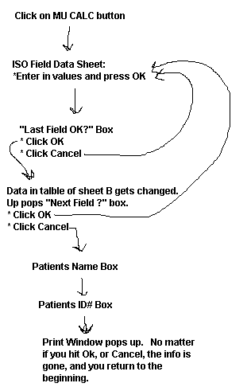

PAGE A: This page contains the code for the ISO macro.
- The way the code seems to be set up is this:
  - Each Column has a label at the top. Each label is some sort of function name. At the top of column B is the title “MUCALC”. I believe that this is what the “MU CALC” button from PAGE B links to.
  - When the “MUCLAC” column is run, the instructions in the column are done in order from top to bottom. Some instructions refer to other columns in the spreadsheet, such as “MAIN”, which in turn refers to other columns. This seems like a weird way to program, but that’s how it seems to work.
  - It has not yet been determined what the section from A17 – B34 is supposed to be. Perhaps they are global variables. That is mere speculation, though.

PAGE C: This page seems to be a table of values. It has not yet been determined what these values are for.

Differences in running lotus software in Windows 2000 vs. NT:

In Windows NT, all the macros work (or at least appear to work) as they should. The macros all point at the F drive, which is ok, because NT can see the MUCALC files that are on the F drive. So, when you are running NT, the files on the F drive that lotus needs are “seeable”, but in Windows 2000, the files aren’t “seeable”. Windows 2000 has it’s own set of files on the E drive. This is why, in Windows 2000, the macros (except ISO) complain because the files that they want on the F drive aren’t there as far as NT is concerned. Like I said earlier, Brett changed the code in ISOMACRO.wk4 to point to the E drive instead of the F drive, so that the macro would work.

