How to configure your laptop for CSSE 120
2010-2011

These instructions explain how to configure your laptop for CSSE 120 in 2010-2011.
- They assume Windows 7 in a configuration similar to that provided by IAIT. However, they work fine for Windows XP or Vista, or your own (non-IAIT) version of Windows 7, with the obvious adjustments.
- If you run the 64-bit version of Windows 7, you can try the 64-bit versions of the installation files where they are provided. However, we have NOT tested these instructions with a 64-bit configuration.
- You’ll need to give administrator privileges if you are not already an administrator, at many points of the configuration.
- The instructions include the configuration necessary for both Robotics and non-Robotics sections.

The configuration requires that you install the following software. Install all the software, in the order listed, even if you believe that you already have it, to be sure that your configuration is right. It is easier to re-install everything (takes about XXX minutes) than to figure out what you need to change/add/fix.
- TortoiseSVN
- Python
- Eclipse
- PyDev plug-in for Eclipse
- Subclipse plug-in for Eclipse
- Preferences file for Java, Python and C in Eclipse

Simply proceed through this document to do the configuration.

Install TortoiseSVN:
FYI: TortoiseSVN is a free, open-source Windows client for the Subversion version control system (also free and open-source). TortoiseSVN lets you access Subversion from the context menu that pops up when you right-click on a file or folder.
How to use it: choose Help when running TortoiseSVN or see: http://tortoisesvn.net/docs/release/TortoiseSVN_en/
FAQ: http://tortoisesvn.tigris.org/faq.html
Home page: http://tortoisesvn.net/

Install a version of TortoiseSVN that matches the version of Subclipse that you will later install, as follows:

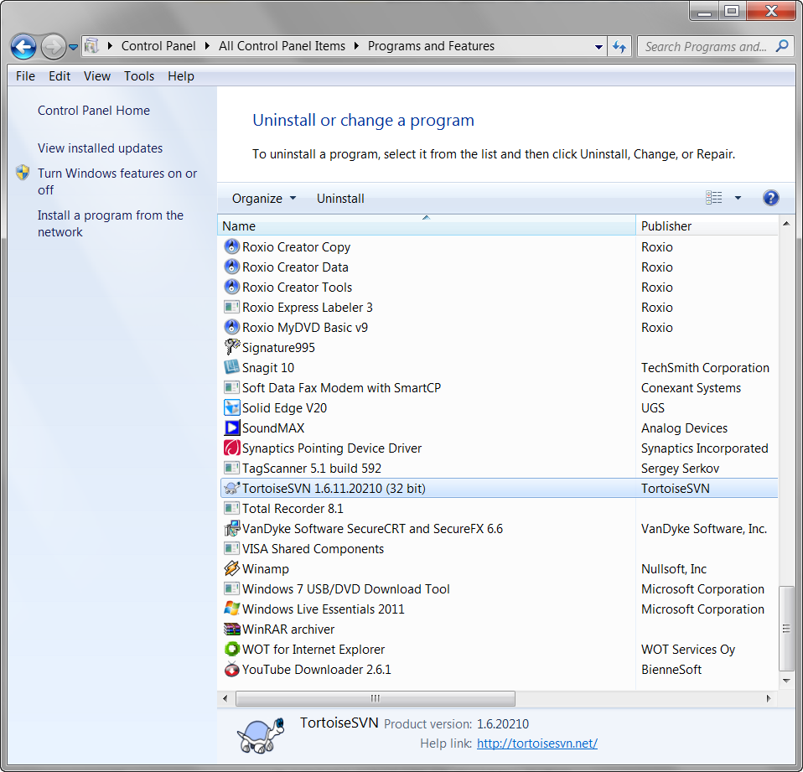
- Open Control Panel and select Programs and Features.

- Look to see if TortoiseSVN is already installed. If you have version 1.6.11 or higher, skip the rest of this installation of TortoiseSVN – your version is fine.
Here is what version 1.6.12 looks like in the list of installed programs, for example:

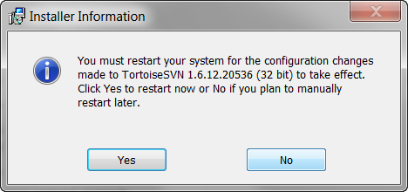
- Uninstall your older version of TortoiseSVN, if you have one installed. Respond No when it asks if you want to restart your system.

- Install version 1.6.12 of TortoiseSVN, as follows:
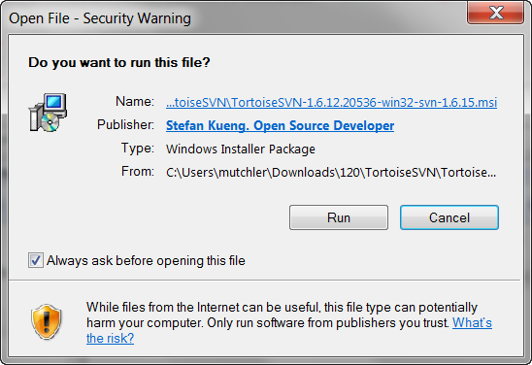
  - Select (click on the link):
- TortoiseSVN-1.6.12.20536-win32-svn-1.6.15.msi
if you have a 32-bit version of Windows (e.g. the version installed by IAIT)
- TortoiseSVN-1.6.12.20536-x64-svn-1.6.15.msi if you have Windows 7 64-bit (that you installed yourself)
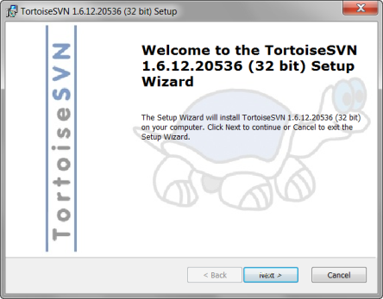
and press Run. Note: the window that pops up may be hidden behind these instructions.
  - Follow the instructions for installation, accepting the terms of the license and otherwise accepting all defaults.
  - Respond Yes when it asks if you want to restart your system.
Install Python:
FYI: Python is a free, open-source programming language.

We use it in CSSE 120 because it:
    - Is powerful: strong programming primitives,
huge set of libraries.
    - Has a gentle learning curve; start using it today!
    - Plays well with others (e.g. COM, .NET, Corba, Java, C)
    - Runs everywhere (Windows, Linux/Unix, OS/2,
Mac, Amiga, some cell phones, …)
    - Is open source.
How to use: start from the CSSE 120 web site
and/or Python’s wiki:
- www.rose-hulman.edu/class/csse/csse120/
- wiki.python.org/moin/BeginnersGuide/
FAQ: http://docs.python.org/py3k/faq/
Home page: http://www.python.org/

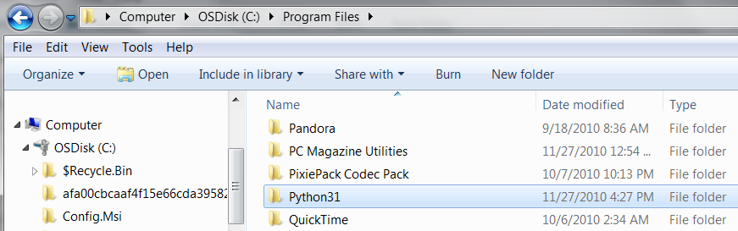
Install the version of Python that we will use, as follows:

- See whether or not you have a folder:
C:\Program Files\Python31
If not, make one.
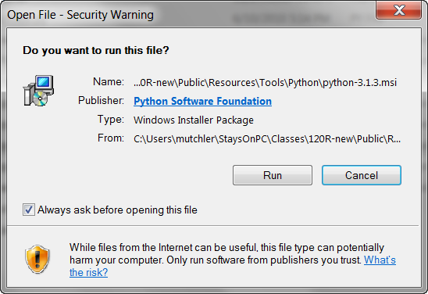
- Select (click on the link):
- python-3.1.3.msi if you have a 32-bit version of Windows (e.g. Windows 7 installed by IAIT, or XP)
- python-3.1.3.amd64.msi if you have Windows 7
64-bit (that you installed yourself)
and press Run. Note: the window that pops up may be hidden behind these instructions.
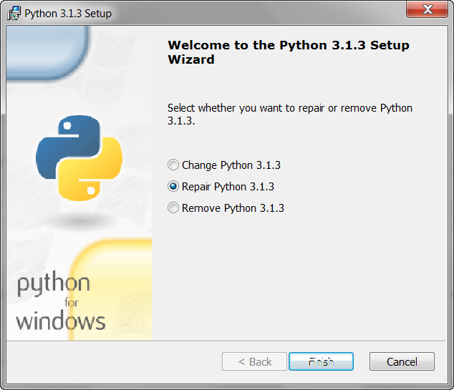
- You will then see one of the two dialog boxes shown to the right:
  - If you see a Repair option in the dialog that appears, as shown to the right, choose it. It will make sure that your Python installation is OK. Accept all its defaults, then continue directly to STEP 4, the configuration of Python.
OR

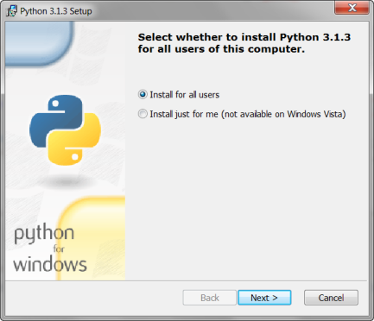
  - Otherwise (i.e., no Repair option), continue as follows:
    - Choose Install for all users and press Next.

Instructions continue on the next page.

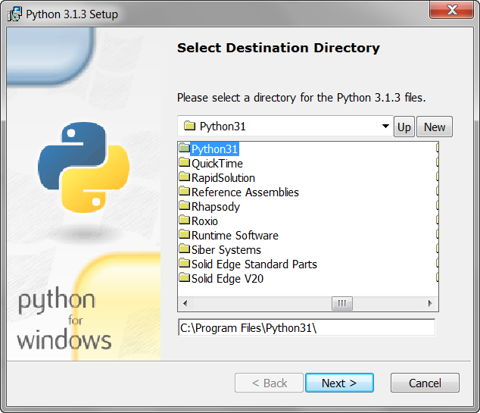
    - Be careful with this step – it is easy to make a mistake here!
Use the Up button to locate your C:\Program Files\Python31 folder. Be sure that the pathname at the bottom is
C:\Program Files\Python31 and NOT C:\Python31. If you SELECT the folder INSTEAD of typing its name, you will be assured of getting the spelling and spaces exactly right.
When you are confident that the pathname is right, press Next.
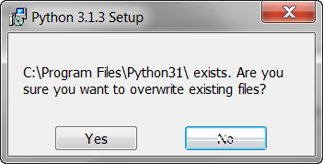
    - If it asks you if you want to overwrite files, respond Yes assuming that the pathname is:
C:\Program Files\Python31
(Else say No and reselect the folder.)

    - Just Next (and Finish) from there on, accepting all defaults.

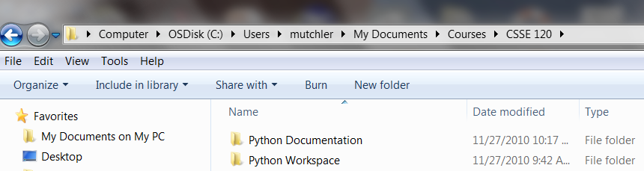
- Configure Python for CSSE 120, as follows:
  - Make folders for your Python work and your Python documentation:
Python Workspace
Python Documentation
It is best if these are under My Documents, e.g. in My Documents/Courses/CSSE 120
If you already have a Python Workspace:
- If it has only a .metadata folder in it, delete that folder.
- If you are retaking CSSE 120, you probably already have a Python Workspace that has your old projects in it. Rename the old one and make a new one; that way, you have all your old work (and can refer/use it) but won’t mix up the new work with the old.
You may also see another Python folder that IAIT created for you (PythonFiles or PythonProjects); you can delete it if it is empty.
  - Unzip this PythonCustomizations.zip file to wherever you want. Move its contents to
C:\Program Files\Python31\Lib\site-packages.

Install Eclipse, as follows:
- If you have a C:\program files\eclipse folder, delete it.
- Unzip this eclipse-java-galileo-SR2-win32.zip file to wherever you want.
- Move the eclipse folder that you got from the zipped file to C:\Program Files. Then delete the zip file.
- Make a shortcut to C:\Program Files\eclipse.exe and put it where you want (e.g on your Start Menu, Desktop and/or Quick Launch menu). If you already have a shortcut to it, it is probably OK.
- Choose a workspace for Eclipse:
  - Open Eclipse as an Administrator. IMPORTANT: open it as an Administrator.
  - Press Browse.
  - Browse for the folder you created: …
And SELECT it. Make sure that it says Python Workspace under Folder.
Press OK.
  - DOUBLE-CHECK that the workspace is right
AND CHECK THE BOX. Click OK.
  - Press the “ribbon” on the far right. It says Workbench when you hover over it.
- Update Eclipse.
  - We call the window that opens the Workbench. In it, select Help ~ Check for Updates.
It will contact the Eclipse site and check things out. Takes a minute or two
You’ll probably end up with a message “There is nothing to update.” That’s OK!
- Add PyDev to Eclipse.
  - Back in the Eclipse Workbench, select Help ~ Install New Software…
  - In the Install (Available Software) dialog that opens, press Add.
  - In Add Site dialog that opens, type http://pydev.org/updates in Location. You can leave the Name blank. Press OK.
  - After a short pause, you should see some additions to the Install (Available Software) dialog, so that it looks as shown.
Check the PyDev box (leave the PyDev Mylyn Integration (optional) box UNchecked) and press Next.
(Sometimes you have to pull down the list of All Available Sites and choose PyDev from it instead of the above.)
  - In the next dialog, verify that PyDev for Eclipse is listed and press Next again.
  - Change to the “I agree…” radio button and press Finish.
  - BE CAREFUL ON THIS STEP: If you get a dialog asking “Do you trust these certificates”, press SELECT ALL and THEN press OK. It is easy to forget the SELECT ALL.
  - If you are asked whether you want to Restart Eclipse, select No.
  - Exit Eclipse.
- Add Subclipse to Eclipse.
  - Open Eclipse as an Administrator. IMPORTANT: open it as an Administrator.
  - If you see a Select Workspace dialog, select the right Workspace as before and CHECK THE BOX this time.
  - Back in the Eclipse Workbench, select Help ~ Install New Software…
  - In the Install (Available Software) dialog that opens, press Add.
  - In Add Site dialog that opens, type http://subclipse.tigris.org/update_1.6.x in Location. You can leave the Name blank. Press OK.
  - After a short pause, you should see some additions to the Install (Available Software) dialog, so that it looks as shown.
Check the Subclipse box (leave the other two UNchecked) and press Next. (You can get away with just some of the subitems, but it is simpler just to take them all.)
  - In the next dialog, verify that several options including Subclipse are listed and press Next again.
  - Change to the “I agree…” radio button and press Finish.
  - If you get a dialog about whether your trust, press OK and if you get another dialog PRESS SELECT ALL then OK. (Easy to forget the SELECT ALL).
  - BE CAREFUL ON THIS STEP: If you get a dialog asking “Do you trust these certificates”, press SELECT ALL if present and THEN press OK. If you get another dialog, press SELECT ALL if present and THEN press OK. It is easy to forget the SELECT ALL.
  - If you are asked whether you want to Restart Eclipse, select Yes. Eclipse will close and then (after a pause) restart.
  - If asked to Please … leave the box checked or not (whichever you choose) and press OK.
  - Exit Eclipse.

