EC581 DSP Projects: Lab Project #6
Dept. of Electrical and Computer Engineering
Rose-Hulman Institute of Technology
Radix 4 FFT and Real-time Spectrum Analyzer
Last Modified on 7/29/00 (KEH)

- Study the radix-4 FFT algorithm explained in Appendix A. Then draw the (much simpler) 16-point radix-4 FFT butterfly pattern, similar to the 64-point radix-4 pattern on p. 3 of the handout. Be sure to indicate the ordering of the resulting transform points on the right.
- Now assume the 16 input points consist of the following (real) values:
{1000 1000 1000 0 0 0 0 0 0 0 0 0 0 0 0 0}
Enter these numbers on the left side of your butterfly pattern, and then indicate the value of each remaining node in the butterfly pattern. Include as Attachment A.
- Now run a MATLAB FFT on this same 16-value input sequence. Show that the two results agree. Include MATLAB results as Attachment B.
- Next, run the radix-4 FFT C62x DSP board demo program that is listed in Appendix B. Note it is already set up to calculate the 16-point FFT of the sequence given above. Show that its results agree also. Include a copy of this output as Attachment C.
- Now, modify this program so that it now calculates a 64-point FFT. (You may want to initialize the twiddle factor array “w[ ]” using a software routine that calculates the sine and cosine values just once, at the beginning of the program. Or you may decide to use a MATLAB M file to help you generate the scaled short-integer values and enter it into a table, as was done in the 16-bit example.) Include your modified program as Attachment D.
- Test your 64-point FFT by comparing its results against a MATLAB FFT for at least 2 test cases. Include copies of the MATLAB FFT output and the DSP program output as Attachment E that prove the 64-point algorithm is working.
- Continuously Updated Audio Spectrum Analyzer
Integrate this 64-point, radix-4 FFT program with your interrupt-driven sampling program. Your program must sample 64 real input values at a sampling rate of 8 kHz. It should place these samples into even-indexed positions of a 128-element global input array (the odd-indexed positions correspond to the imaginary values of the input sequence, and these may be set to zero in the interrupt routine).
When the global index variable used to fill this input array reaches 127, the interrupt routine should stop filling the input array, though it should continue to sample and output the samples to the CODEC. The interrupt routine should wait until the main program sets the index variable back to zero, thereby signaling the interrupt routine that it is time to re-fill the input array. Once the main program sees the global index variable reach 127, it can assume that the input array is full, and it should now call the radix-4 FFT routine to calculate the FFT of these points.
Finally, the squared magnitude of the first half of the transformed complex-valued points (the first 32) must be displayed, using printf( ), by the main DSP program. There is no need to display the remaining 32 points, since the first 32 points correspond to the usable frequency range between 0 Hz to fs/2 = 8000/2 = 4000 Hz. We really don’t care about displaying the second half of the FFT, which corresponds to frequencies above the Nyquist sampling limit, fs/2 .
Once printing is complete, the main program can set the global index variable back to 0 to signal the interrupt routine that it is now time to re-fill the input array.
Demonstrate your working spectrum analyzer program and obtain the signature of the lab instructor on your adequately commented program listing. Include this signed listing as Attachment F.
Appendix A. Radix 4 Decimation-in-Frequency FFT Algorithm Description, from “DSP Applications with TMS320”, Texas Instruments, 1986 (SPRA012A)

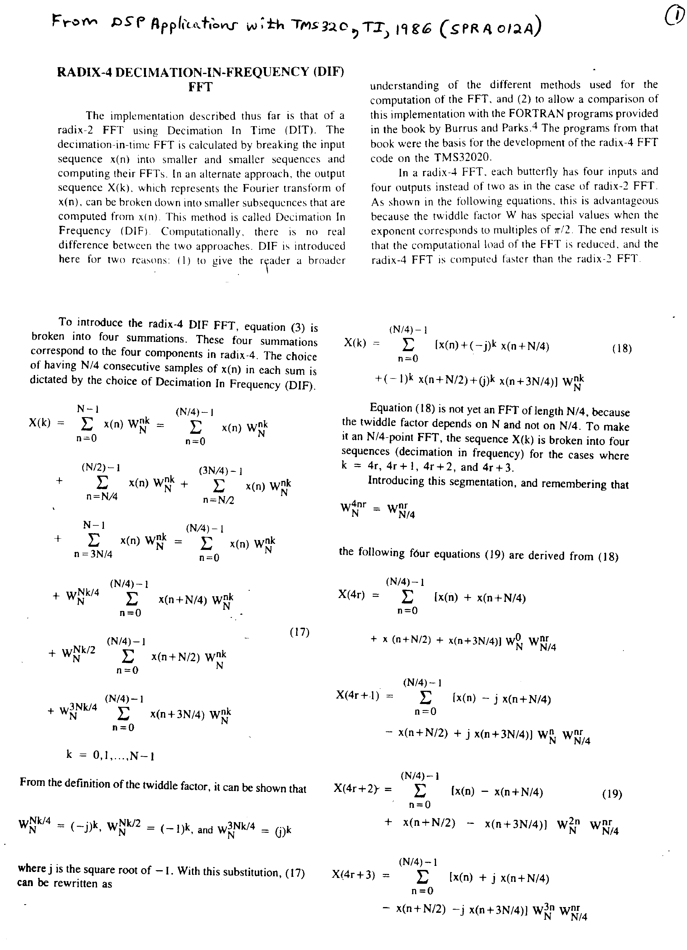
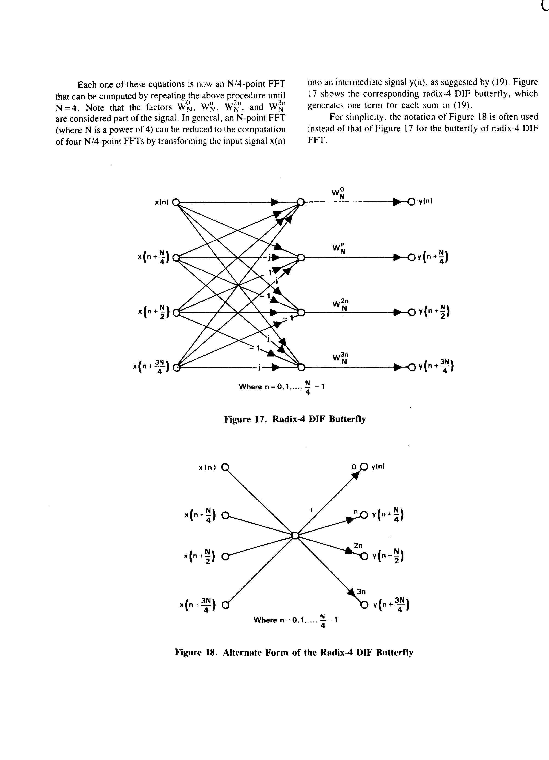

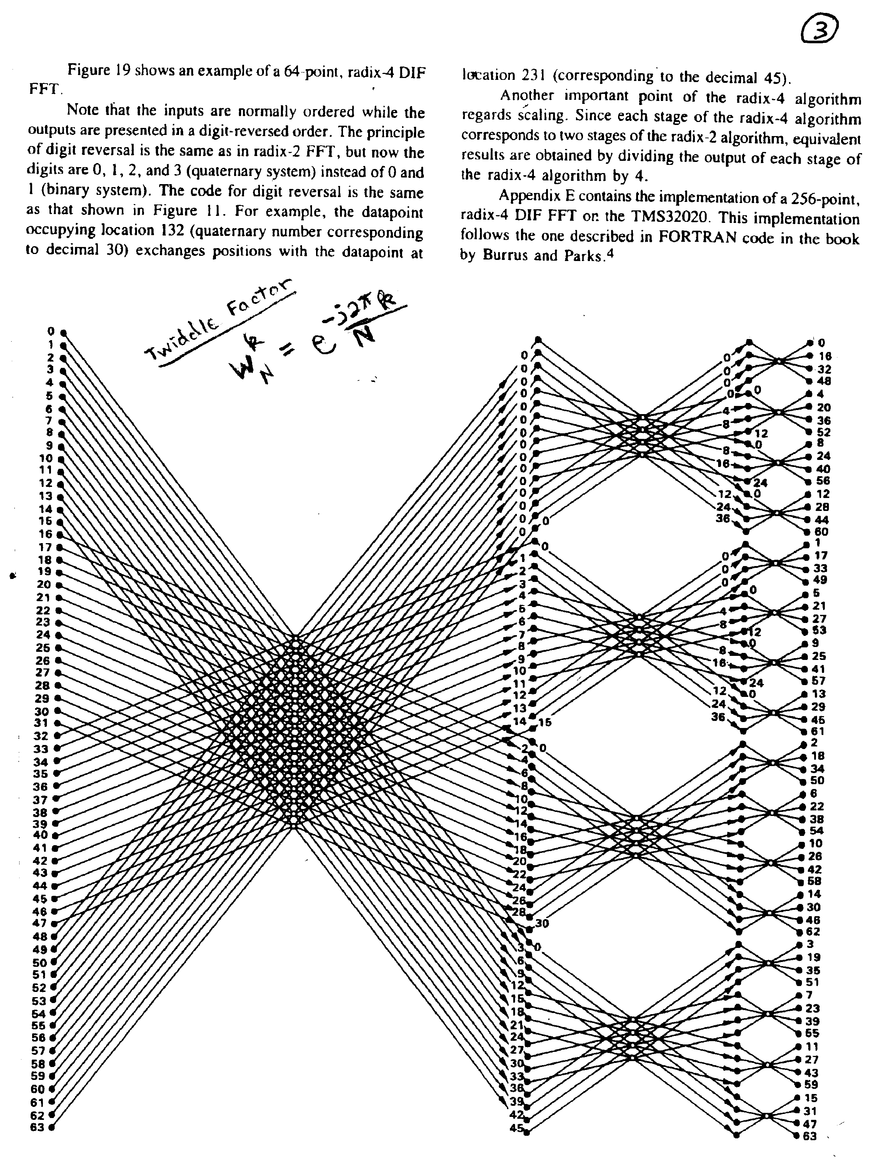

Fig. 19 shows an N=64-point DFT, broken down into a number of radix-4 Butterfly operations. Note that the original input points are listed (in order) on the extreme left, where the points are numbered 0 through 63. Then N/4 = 16 Butterfly operations are used to transform (or decompose) the original 64 input points into FOUR separate sets of N/4 = 16 input points, each of which may be individually transformed. The advantage of this decomposition is apparent when we recall that N2 complex multiplications are required to evaluate an N-point DFT using its definition. Thus the original N = 64-point DFT would require 642 = 4096 complex multiplications, while four N/4 = 16-point DFTs could be evaluated using only 4(162) = 1024 complex multiplications (not counting the Butterfly calculations)! Note from Fig. 19 that the result of applying these 16 Butterfly operations to the original set of input values leaves us with a single 64-node vertical column near the middle of the page that containin four groups of values. If these four groups of points are run through four independent N/4 = 16-point DFT operations, this would yield the desired transformed values X(n) from the original N-point sequence, in the following order (progressing from the top to the bottom of the column), as predicted by Eqns (20):

0, 4, 8, 12, 16, 20, 24, 28, 32, 36, 40, 44, 48, 52, 56, 60
1, 5, 9, 13, 17, 21, 25, 29, 33, 37, 41, 45, 49, 53, 57, 61
2, 7, 10, 14, 18, 22, 26, 30, 34, 38, 42, 46, 50,54, 58, 62
3, 8, 11, 15, 19, 23, 27, 31, 35, 39, 43, 47, 51, 55, 59, 63

However, we can do much better than this! We can reduce the computational burden even further by not simply using the DFT definition to transform the resulting four 16-point subseries, but rather, by applying the radix-4 decomposition once again (in recursive, or hierarchical, fashion) to each of the individual 16-point DFTs.! This second level of decomposition requires 16/4 = 4 Butterfly operations for each of the four separate 16-point decompositions. (See Fig. 19.) This produces 4*4 = 16 groups of 16/4 = 4 points, each of which may be individually transformed. And once they are transformed, the ordering of the desired transform values X(n) from the original N-point sequence (as predicted by Eqns (20) is now found by taking every fourth value from the first row in the previous ordering sequence shown above, first starting at position 0, then starting at position 1, then starting at position 2, and finally starting at position 3. The remaining rows are treated in like fashion. This yields the new (and final ordering!) of:

0, 16, 32, 48, 4, 20, 36, 52, 8, 24, 40, 56, 12, 28, 44, 60
1, 17, 33, 49, 5, 21, 37, 53, 9, 25, 41, 57, 13, 29, 45, 61
2, 18, 34, 50, 7, 22, 38, 54, 10, 26, 42, 58, 14, 30, 46, 62
3, 19, 35, 51, 8, 23, 39, 55, 11, 27, 43, 59, 15, 31, 47, 63

Appendix B. Example C62x Radix-4 FFT Programs (Contained in three files: Radix4.c, Digitgen.c, and Digit.c) Written by Texas Instruments (See Application Report SPRA291, 1997)

File Radix4.c

#include <stdio.h>
#include <math.h>
void R4DigitRevIndexTableGen(int, int *,unsigned short *,unsigned short *);
void radix4(int n, short[], short[]);
void digit_reverse(int *, unsigned short *, unsigned short *, int);
short w[32] = {
32767,
0,
30273,
12539,
23170,
23170,
12539,
30273,
0,
32767,
-12539,
30273,
-23170,
23170,
-30273,
12539,
-32767,
0,
-30273,
-12539,
-23170,
-23170,
-12539,
-30273,
0,
-32767,
12539,
-30273,
23170,
-23170,
30273,
-12539};
short x[64];
int i,count;
unsigned short IndexI[64], IndexJ[64];
void main(void)
{
for(i=0;i<32;i++) x[i]=0;
x[0]=1000;
x[2]=1000;
x[4]=1000;
R4DigitRevIndexTableGen(16, &count,IndexI,IndexJ);
for (i=0;i<count;i++)
printf("IndexI(%d) = %d IndexJ(%d) = %d \n",i,IndexI[i],i,IndexJ[i]);

radix4(16,(short *)x,(short *)w);
digit_reverse((int *)x,IndexI,IndexJ,count);
for(i=0;i<16;i++)
printf("X(%d) = %d + j%d\n",i,x[2*i],x[2*i+1]);
}

/**************************************************************
File: radix4.c FFT function (Based on Burris, Parks p. 113)
radix4(int n; short x[ ], short w[ ]);

Efficiently calculates n-point DFT, defined as

X[m] = SUM(o=0 to o=n-1){x(o)*Wn^(o*m)}

(Where Wn = exp(j*2*Pi/n)

n = number of points in FFT (must be a power of 4)
x[ ] = complex input array of length 2n, where
the kth element = x[2k] + j*x[2k+1]. Upon return
this array holds the DFT result.
w[ ] = complex twiddle factor array of length 2n, where
Wn^k = = (exp(j*2*Pi/n))^k = exp(j*2*Pi*k/n)
the kth complex element Wn^k = w[2k] + j*w[2k+1]

***************************************************************/

void radix4(int n, short x[ ], short w[ ])
{
int n1,n2,ie,ia1,ia2,ia3,i0,i1,i2,i3,j,k;
short t,r1,r2,s1,s2,co1,co2,co3,si1,si2,si3;
n2=n;
ie=1;
for (k=n;k>1;k=k>>2)
{
n1=n2;
n2=n2>>2;
ia1 = 0;
for (j=0; j<n2; j++)
{
ia2=ia1+ia1;
ia3=ia2+ia1;
co1=w[ia1*2];
si1=w[ia1*2+1];
co2=w[ia2*2];
si2=w[ia2*2+1];
co3=w[ia3*2];
si3=w[ia3*2+1];
ia1=ia1+ie;
for (i0=j;i0<n;i0=i0+n1)
{
i1=i0+n2;
i2=i1+n2;
i3=i2+n2;
r1=x[2*i0]+x[2*i2];
r2=x[2*i0]-x[2*i2];
t=x[2*i1]+x[2*i3];
x[2*i0]=r1+t;
r1=r1-t;
s1=x[2*i0+1]+x[2*i2+1];
s2=x[2*i0+1]-x[2*i2+1];
t= x[2*i1+1]+x[2*i3+1];
x[2*i0+1]=s1+t;
s1=s1-t;
x[2*i2] = (r1*co2+s1*si2)>>15;
x[2*i2+1] = (s1*co2-r1*si2)>>15;
t = x[2*i1+1] - x[2*i3+1];
r1=r2+t;
r2=r2-t;
t = x[2*i1]-x[2*i3];
s1=s2-t;
s2=s2+t;
x[2*i1] = (r1*co1+s1*si1)>>15;
x[2*i1+1]= (s1*co1-r1*si1)>>15;
x[2*i3] = (r2*co3+s2*si3)>>15;
x[2*i3+1] = (s2*co3-r2*si3)>>15;
}
}
ie = ie << 2;
}
}

File Digitgen.C

/******************************************************************************
FILE
digitgen.c - This is the C source code for a function used to generate
index tables for a digit reversal function for a radix-4 FFT.

Recall that the DIF Radix 4 method requires the transformed values to be bit
reversed in a "mod-4" fashion. Thus, in a 16-bit transform, element 1001
must be swapped with 0110, and element 1010 would be swapped with
1010 (and hence is not swapped at all). Thus for an transform with
n = 16 points, the following values would be generated by this function:

Iindex[0] = %0001 = 1 Jindex[0] = %0100 = 4
Iindex[1] = %0010 = 2 Jindex[1] = %1000 = 8
Iindex[2] = %0011 = 3 Jindex[2] = %1100 = 12
Iindex[3] = %0110 = 6 Jindex[3] = %1001 = 9
Iindex[4] = %0111 = 7 Jindex[4] = %1101 = 13
Iindex[5] = %1011 = 11 Jindex[5] = %1110 = 14

count = 5 (=> 6 pairs of elements are to be swapped!)
******************************************************************************/

void R4DigitRevIndexTableGen(int n, int *count, unsigned short *IIndex, unsigned short *JIndex)
{
int j, n1, k, i;
j = 1;
n1 = n - 1;
*count = 0;

for(i=1; i<=n1; i++)
{
if(i < j)
{
IIndex[*count] = (unsigned short)(i-1);
JIndex[*count] = (unsigned short)(j-1);
*count = *count + 1;
}

k = n >> 2;

while(k*3 < j)
{
j = j - k*3;
k = k >> 2;

}
j = j + k;
}
}

File Digit.c

/******************************************************************************
FILE
digit.c - This is the C source code for a digit reversal function for
a radix-4 FFT
******************************************************************************/

void digit_reverse(int *yx, unsigned short *JIndex, unsigned short *IIndex, int count)
{ /* NOTE TRICK -- The value pointed at by yx (*yx) is
declared to be of size int... thus both the short int real and imaginary part
of each pair of transformed value are exchanged at the same time! */

int i;
unsigned short I, J;
int YXI, YXJ;

for (i = 0; i<count; i++)
{
I = IIndex[i];
J = JIndex[i];
YXI = yx[I];
YXJ = yx[J];
yx[J] = YXI;
yx[I] = YXJ;
}

}

