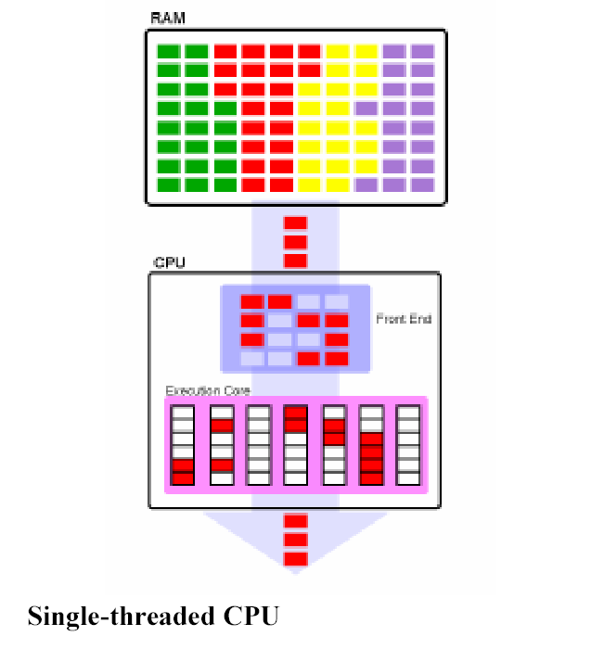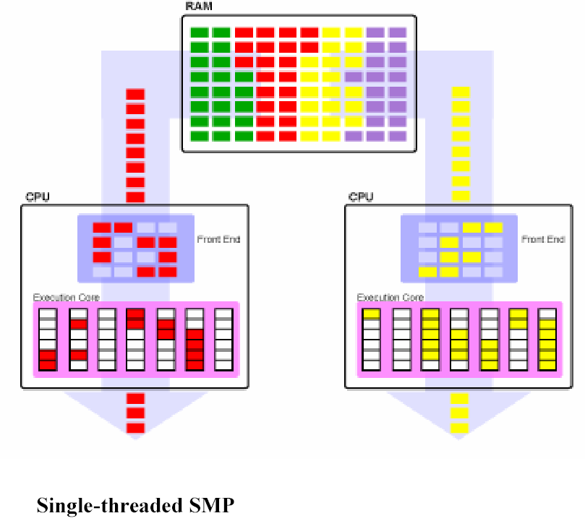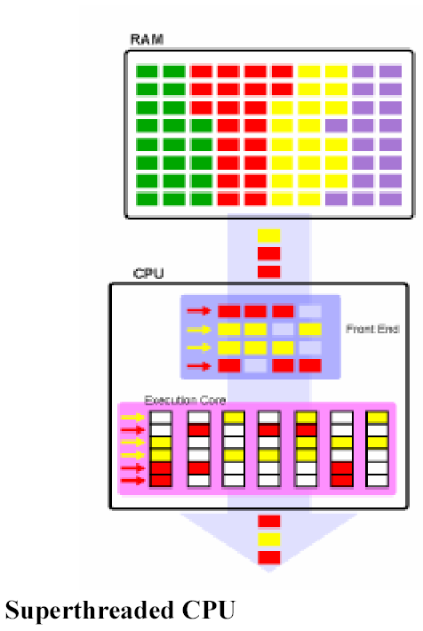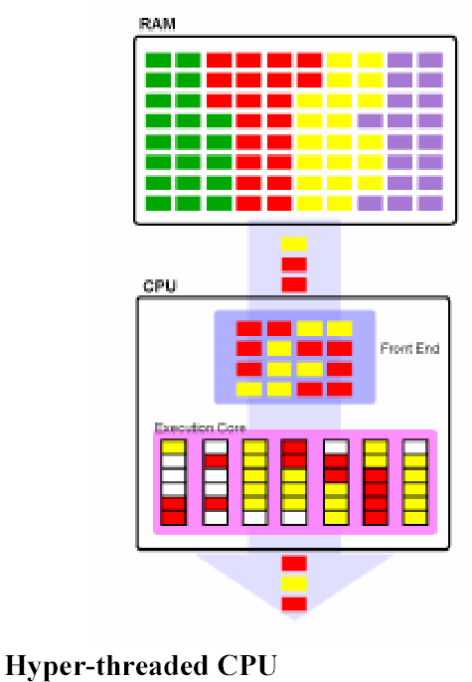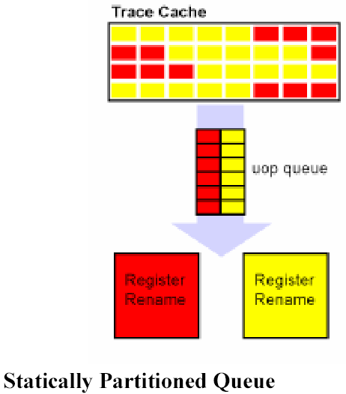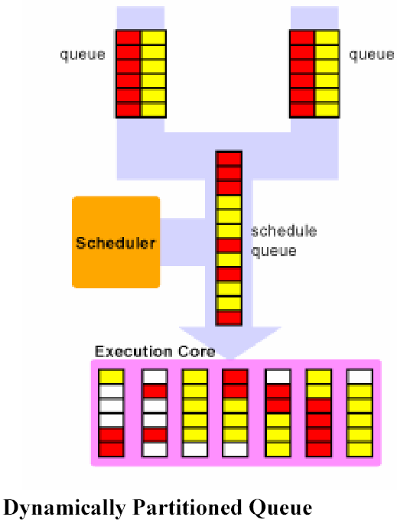

Replicated | - Register renaming logic  - Instruction Pointer  - ITLB  - Return stack predictor  - Various other architectural registers
Partitioned | - Re-order buffers (ROBs)  - Load/Store buffers  - Various queues, like the scheduling queues, uop queue, etc.
Shared | - Caches: trace cache, L1, L2, L3  - Microarchitectural registers  - Execution Units

