"Undergraduate Electromagnetics: Discrete, Numeric, and Continuous"
Professor David R. Voltmer
Rose-Hulman Institute of Technology
5500 Wabash Avenue
Terre Haute, IN 47803
812-877-8289 (Office)
812-877-8895 (FAX)
voltmer@rose-hulman.edu

ABSTRACT - This paper describes a new approach to undergraduate electromagnetics that is based on spatial discretization and numeric computation. The initial coverage is limited to quasi-static, two-dimensional, Cartesian geometries with no leakage flux, descriptive of many ideal lumped circuit elements with which the students are already familiar. The circuit behavior of resistors, capacitors, and inductors motivates the introduction, formulation and interpretation of the behavior of the electric and magnetic fields. The fields within the elements are expressed by Laplace’s equation in discretized form. This formulation provides the basis for numeric computations that exploit the power of modern PCs. In addition, PC-based software provides a rich graphic environment that enables students to display the solutions in a variety of visual modes. The simplicity of this approach allows students to focus upon the electromagnetic principles and to gain valuable experience in solving problems. In the simplest form, classroom and homework activities include spreadsheets, matrix solvers, and circuit analog simulations. More ambitious student activities are realized with a powerful, PC-based, interactive, electromagnetic computation engine that empowers students to experiment with the geometry and material properties of two-dimensional electromagnetic problems. As the students gain experience, the more traditional formulations of continuous differential and integral vector calculus are introduced to complete their preparation for advanced courses. This technologically intensive approach is particularly attractive since all of our students have laptops and most classrooms allow network access to all students. A variety of software packages (including Maple, Mathcad, Matlab, Excel, Pspice and VEM) further enhances this approach. Course details and software demonstrations are included in the presentation.

THE APPROACH

A revolutionary departure from traditional electromagnetics is necessary to strengthen every student’s understanding of electromagnetics. Implicit in this approach is a change in the presentation of electromagnetics to students; learning is focused on the concepts and tools of today's electromagnetic professionals. Two fundamental principles are synergistically combined in the foundation of this approach--spatial discretization and numeric formulation. Without numeric formulations that can exploit computational power and graphics, the concepts of spatial discretization offer an interesting, but limited, alternative to continuous electromagnetics. Without spatial discretization, numeric methods are limited to formula evaluation and plotting of equations.

Spatial Discretization

Traditional electromagnetics textbooks are based upon the vector calculus of continuous mathematics. An alternate perspective considers space to be divided into discrete incremental cells each of which can be modeled as a lumped circuit element. This construct allows the laws of electromagnetics to be cast in terms of lumped element circuit theory--resistance, capacitance, inductance, Ohm's law, Kirchoff's voltage and current laws. Basic field concepts are developed within the familiar framework of the terminal behavior of circuit elements. The axioms of this approach are based in circuit theory rather than in physical observations and vector calculus. The vector description of fields naturally follows from the behavior of incremental circuit elements. Spatial variations of fields are manifest in the geometric arrangement of the incremental cells. Macroscopic element values follow directly from the rules for series and parallel elements of circuits and lead intuitively to the more traditional line and surface integral representation of continuous-variable, vector calculus.

Numeric Formulation

The elegance and rigor of the continuous-variable vector calculus foundations of electromagnetics have great appeal to many professionals (and most textbook writers) and with good reason--they are a necessity for advanced concepts of electromagnetics. On the other hand, spatial discretization, in addition to its basis in circuit theory, allows the use of computer-oriented (and less intimidating) discrete mathematics. Formulation of electromagnetic laws in numeric form leads beginning students directly to computer-based solutions. Real-time, scalar calculations displayed with color graphics provide a powerful learning environment. Using this process, students can understand the basic principles of electromagnetics before they master differential and integral calculus. This numeric foundation makes students aware of the value of vector calculus; moreover, it enables them to grasp more readily its physical underpinnings. An intuitive sense of electromagnetic field behavior can be acquired by computer experimentation. An added benefit is that numeric formulations enable students to obtain computer solutions to practical problems. Students can solve "real world" problems, not just those which satisfy the artificial boundary geometry of infinite planes, infinite circular cylinders, or spheres.

THE DETAILS

Spatial discretization is a powerful method by which the internal electromagnetic details of circuit elements are readily visualized and related to the terminal behavior of lumped circuit elements. Several assumptions are used in this approach in order that the fundamental features of the fields are not hidden by unnecessary, advanced details.
In this approach, a student’s first encounter with electromagnetic fields is limited to quasi-static cases so that the structures are small compared to wavelength. This corresponds to the conditions of electric circuits. But more importantly, the complexities high-frequency, radiating fields are delayed until students have some experience with electromagnetics. The underlying principles are found in circuit theory and elementary concepts of freshman physics. For example, the variation of voltage along a straight wire leads to the slope of voltage with distance V/x to give local variation. In the limit this becomes dV/dx. This is generalized to three dimensions and the definition of the gradient. Another example, the application of KCL in circuits is applied to an incremental cube and leads to the definition of divergence. Physical intuition and generalization leads to conservation of charge. This approach is followed throughout the first electromagnetics course.

Cartesian coordinates are chosen for most of the course in order to minimize the masking of electromagnetic principles by the complexities of new coordinate systems. Most structures are defined by or can be adequately approximated in Cartesian coordinates so that only a limited number of applications in cylindrical and spherical coordinates are included.

Further simplification is gained by considering mainly two-dimensional structures. One-dimensional structures provide a simplistic view of fields limited to only a single spatial variable and vector direction. Two-dimensional structures are adequate to show the variety of basic properties and spatial variations of potentials and vectors; the added complexity of three-dimensional structures is unnecessary. Equally important, two-dimensional electromagnetic fields quite conveniently take advantage of computer graphics displays.

Structures and solution techniques are simplified by assuming that ideal flux-guiding material is present in all devices so that all of the flux is confined to the material, i.e. there is no fringing or leakage flux. The exclusion of fringing flux exactly models the fields of resistors and is a reasonable approximation for most capacitors. However, inductors are limited to closed, magnetic cores with at most a thin air gap. Air core inductors are not covered since the computational complexities associated with leakage flux do not reveal any additional basic principles.

Under these conditions, the behavior of all lumped element devices is governed by ∇²V = 0, Laplace’s equation, where V represents a scalar electric or magnetic potential. The perpendicular nature of equipotential surfaces and flux lines is exploited to describe local behavior in terms of discretized, incremental elements. In this representation, all incremental element values are calculated by the same
l
_{I}
w
h
σ
 V
−
l
_{E}
w
h
ε
 V
−
l
_{M}
w
h
μ
 V_{M}
−

RESISTORS CAPACITORS INDUCTORS

Figure 1 - Incremental Elements

general form, ΔX = ΔΨ/ΔV, that can be specialized to give numeric values of incremental elements as ΔG = σΔa/Δl. ΔC = εΔa/Δl, and ΔL = μΔa/Δl for conductors, capacitors, and magnetic reluctors, respectively. Figure 1 illustrates the relationship of the flux and potential difference of the incremental elements. The incremental elements are combined by the familiar series and parallel procedures of circuit theory to element values for finite structures.

EXCEL – Potential Distirbution in a Corner Resistor

0.32 | 0.33 | 0.37 | 0.42 | 0.5 | 0.6 | 0.72 | 0.86 | 1
0.29 | 0.3 | 0.33 | 0.39 | 0.46 | 0.57 | 0.71 | 0.85 | 1
0.24 | 0.25 | 0.28 | 0.32 | 0.4 | 0.51 | 0.68 | 0.84 | 1
0.17 | 0.18 | 0.2 | 0.24 | 0.3 | 0.41 | 0.65 | 0.83 | 1
0.09 | 0.09 | 0.1 | 0.12 | 0.15 | 0.18
0 | 0 | 0 | 0 | 0 | 0

Figure 1 - Potential Distribution within a Corner Resistor: Numeric Values.

Figure 2 - Potential Distribution within a Corner Resistor: Potential Surface.

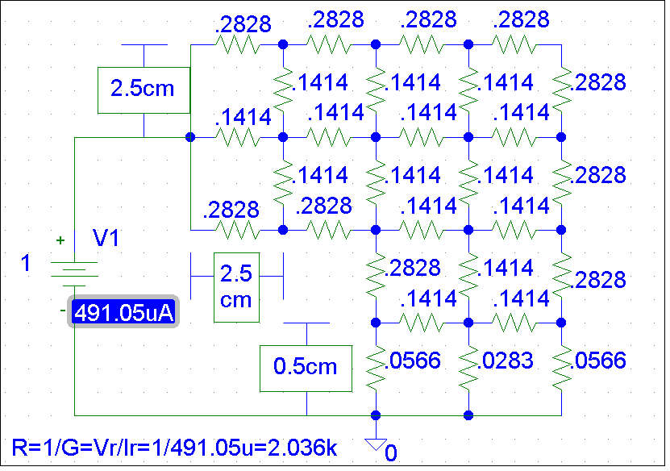PSPICE – Potential Distribution in a Corner Resistor

Figure 3 – PSPICE calculation of Potential Distribution within a Corner Resistor.

MAPLE – Continuous Math toward the end of course after students are familiar with concepts.
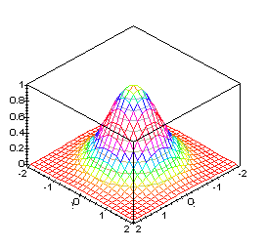
Figure 4 - Electrostatic Field Potential Distribution. Figure 5 - Equipotentials and Electric Field
Vectors of Electrostatic Field.

VEM – Visual Electromagnetics
Visual EMag (VEM) is a two dimensional, electromagnetic simulator designed and developed as a visualization aid for students in undergraduate electromagnetics. VEM utilizes finite difference techniques in electrostatic and magnetostatic environments. The VEM code, written in Matlab 5 for Windows 95, provides a user-friendly graphical interface for which is inexpensive and platform independent. VEM consists of a structure window in which the user enters electromagnetic materials and sources via common drawing tools and pop-up menus. The solver button generates the system matrix, solves it, and activates the solutions window in which the results are displayed in a variety of user-selected viewing modes. Though the solution region is finite in extent, its outer boundaries appear open as if the solution region were of infinite extent. A compact simulation of the open boundaries is implemented via the Transparent Grid Termination (TGT) [3] techniques.

VEM Examples
- 3-charges.vem: 3 charges (+1,+1, -2) in dielectric, Cartesian coordinates.
Increase number of equipotential contours to 15; Flux – add line and surface.
- Cylindrical_resistor.vem: Conductive material in cylindrical coordinates; Vector fields plotted, black, linear current flux vectors; Background potential, 3-D view – spin or sliders for perspective.
- core_small_gap.vem: Magnetics in Cartesian coordinates; flux is along A-vector
equipotentials; fringing seen in gap.

This approach is technologically intensive; analytic tools with a modicum of graphics have been replaced by numeric, highly visual tools. With the ready availability of high-performance computers, today’s students are able to numerically and analytically solve a wide variety of electromagnetic problems. The limited power of the calculator, paper, and pencils are replaced by the powerful tools used by electromagnetics professionals.

