ECE-521 Control Systems II
Homework 1

Due at the beginning of class, Tuesday December 7, 2004

1) Problem B-3-15 from Ogata. Find the equations of motion and a state variable description using Lagrangian dynamics.

2) Problem B-3-17 from Ogata. Find the equation of motion using Lagrangian dynamics. Show that the pendulum will oscillate at frequency

3) Using Lagrangian dynamics, show that the equations of motion for the following system

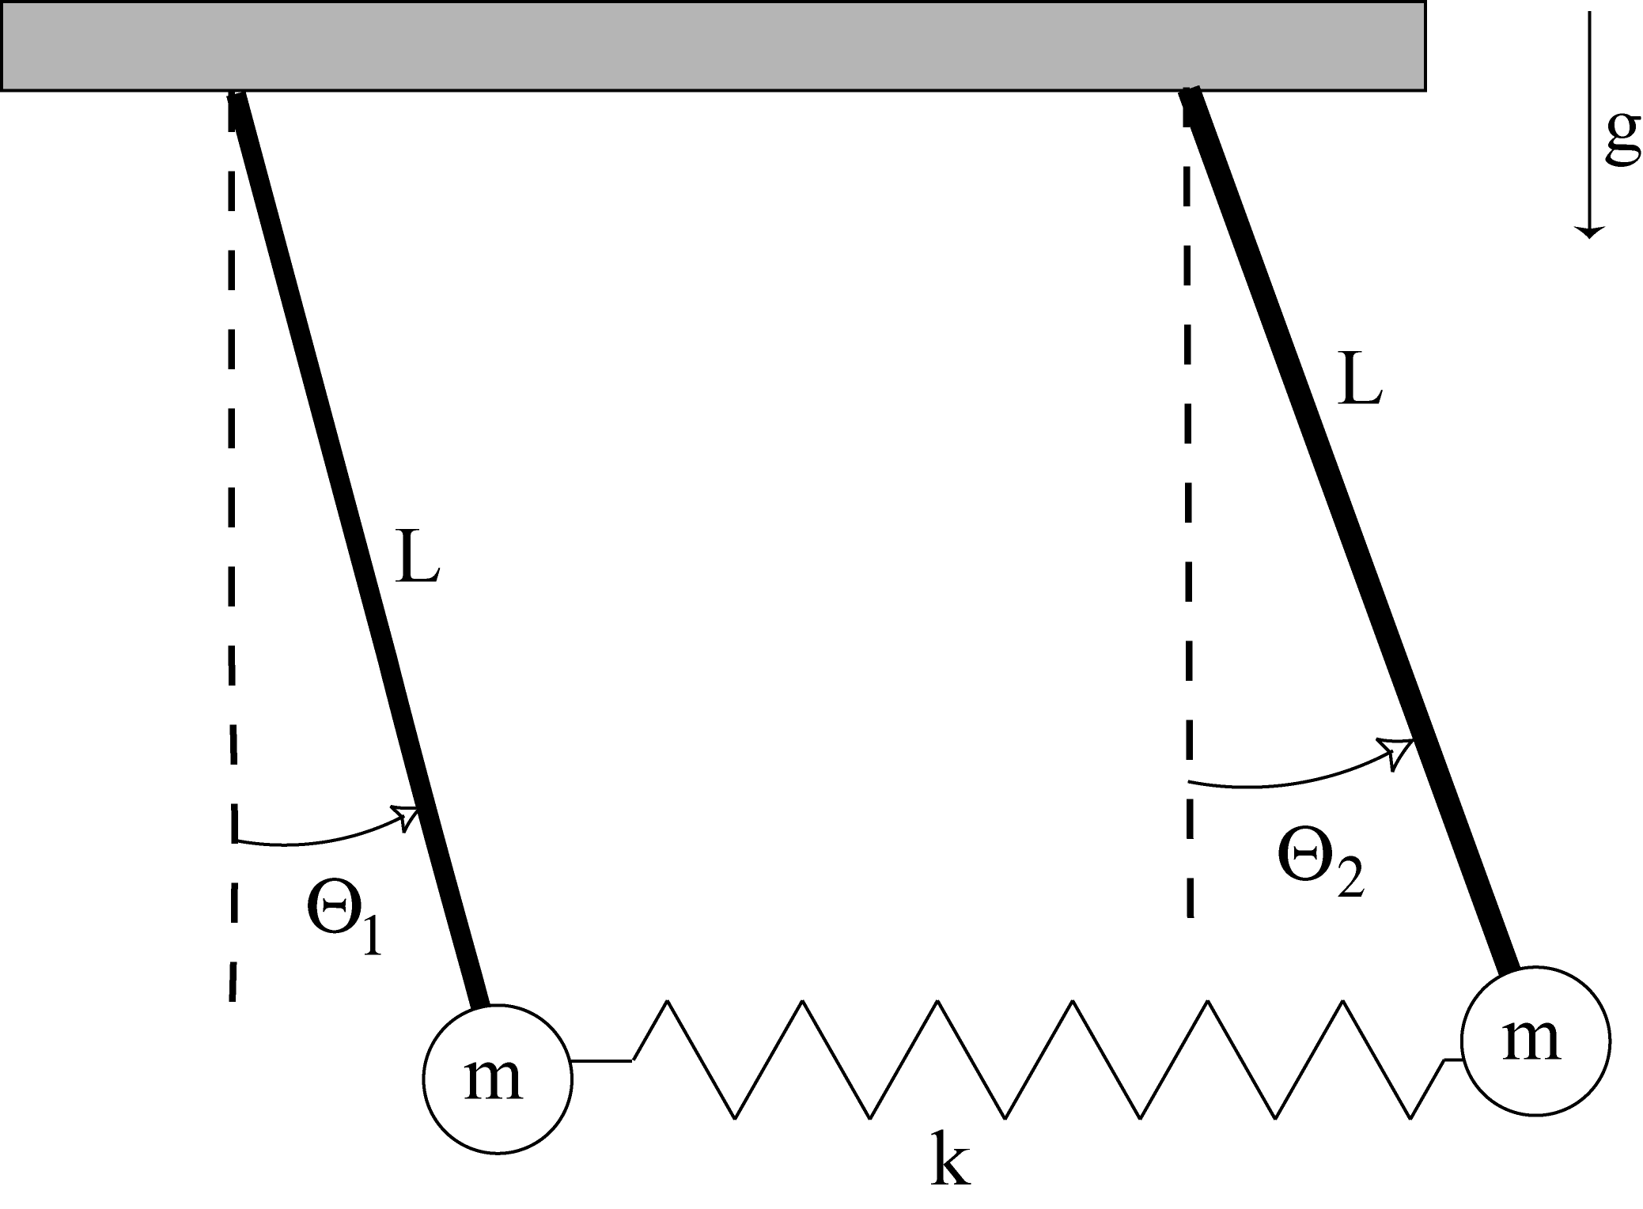

are given by

4) In class we derived the following forms for the kinetic, potential, and dissipative energies for an inverted pendulum:

Find the complete equations of motion, and then the equations of motions for small angles and small velocities .

Preparation for Lab 1 (to be done individually):

5) Consider the following model of the one degree of freedom system we will be using in lab 1.

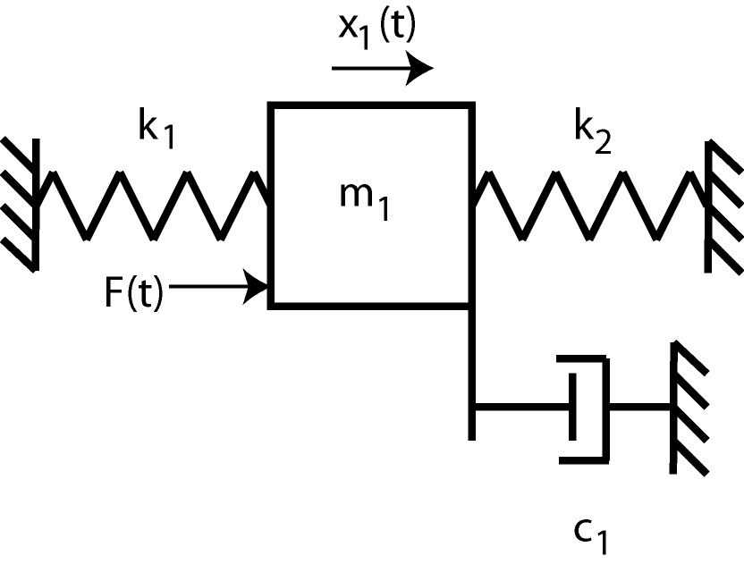

a) Using Lagrangian dyanamics, show that the equations of motion can be written as

b) We can write this as

Determine how we can relate the damping ratio , the natural frequency , and the static gain to
, , , and .

c) Defining , and , show that we get the following state equations

In order to get theand matrices for the state variable model, we need to determine all of the quantities in the above matrices. The matrix will be determined by what we want the output of the system to be.

d) If we want the output to be the position of the first cart, what should be? If we want the output to be the velocity of the first cart what should be?

e) For state variable feedback we have, where is the prefilter gain, is the reference input, and is the state variable feedback gain. This give us the new state equations (assuming)

If the reference input is a step of amplitude , and we want the scalar output in steady state to equal , show that we should choose the prefilter gain as

6) The one degree of freedom Simulink model (Basic_1dof_State_Variable_Model.mdl) implements a state variable model with state feedback for this systesm. This model uses the Matlab code Basic_1dof_State_Variable_Model_Driver.m to drive it. Both of these programs, as well as state_model.mat, which contains a state variable model for a particular cart configuration, are available on the course website.

For this problem you need to run the code as it is, and try to figure out what is going on. You will be modifying this code throughout this course, so the soon you figure it out the better off you'll be.You need to turn in the graph that is generated.

7) Utilizing the Simulink code from part 6, utilize the linear quadratic regulator method for choosing the state feedback gain so that first cart follows a step input of amplitude 1 cm (we are trying to control the position of the first cart so that should be the system output). The control effort must remain below 0.5 and the settling time must be less than 0.3 seconds.

The linear quadratic regulator finds the gain to minimize

where
For this system, is a 2x2 positive definite matrix, and is a scalar. Since we will use a diagonal matrix for and for our system is a scalar, we can rewrite as

A large value of penalizes a large control signal, a large value of will penalize the position of the first cart, while a large value of will penalize a large value of the velocity of the first cart. All of the should be zero or positive.

It's easiest to find using the following command in Matlab:

You will have to try different values of the to find an acceptable controller. Later in the course we will see how Matlab determines these gains. You need to turn in one plot, as well as your Matlab code.

