Name ______________________________ CM_______________

ECE-320, Quiz #2

1) For the function

the final value as is

a) 0 b) 2 c) 10 d) undefined

Problems 2 - 5 refer to the system described by the transfer function:

2) The steady state error for a unit step input for this system is best approximated as

a) 1 b) -1 c) 0 d) 5/6

3) The steady state error for a unit ramp input for this system is best approximated as

a) b) 0 c) 4/6 d) 1

4) The static gain of the system is best approximated as

a) 1 b) 2 c) 3 d) 4

5) If the input to this system is a unit step with amplitude 2, the steady state output will have amplitude

a) 1 b) 2 c) 4 d) 6

6) The unit ramp response (input = ) of a system is given by

The steady state error for this system is best approximated as

a) 0 b) c) 1 d) 2

7) A system has poles at -1, -3, -4+j, and -4-j. Based on these pole locations, the best estimate of the settling time for this system is

a) 4 seconds b) 4/3 seconds c) 1 second d) 1/4 second

Problems 8-10 refer to the step response of a system, shown below

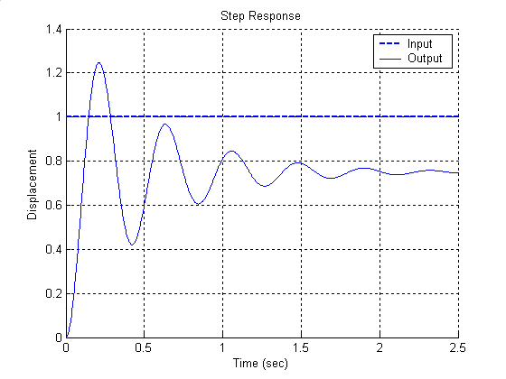

8) The percent overshoot for this system is best approximated as

a) 125% b) 100% c) 66.7% d) 25%

9) The steady state error for this system is best approximated as

a) 0.25 b) -0.25 c) 0.5 d) impossible to determine

10) The steady state error for a unit ramp input for this system is best approximated as

a) b) 0.5 c) 0.0 d) impossible to determine

Problems 11, and 12 refer to the ramp response of a system, shown below

11) The best estimate of the steady state error of this system is

a) -0.3 b) 0.3 c) -0.5 d) 0.5

12) The best estimate of the steady state error for a unit step input for this system is

a) 0 b) 1 c) d) impossible to determine

