Name ______________________________ CM_______________

ECE-320, Quiz #6

P) I) PI) PD)

PID) Lead) ()
For all of these controllers, we assume k, p, and z > 0.

1) For the following plant,

which, if any, of the above controllers cannot be used to make the closed loop system stable?

a) P and PI b) PD c) PID and lead d) I

2) For the following plant,

which, if any, of the above controllers cannot be used so the estimated settling time is 1 second?

a) P and PI b) PD c) lead d) I e) PID

Problems 3-5 refer to the following system
+
-

The closed loop poles of the system are at and -15.2

3) The best estimate of the settling time is

a) seconds b) seconds c) seconds d) seconds

4) The best estimate of the position error is

a) b) c) 0 d)

5) The best estimate of the velocity error is

a) 0 b) c) d)

6) Now we add a lag compensator to change the velocity error, as shown below
+
-

If we want the velocity error to be 0.001 and we choose z = 0.1, what should p be?

a) 1 b) 0.1 c) 0.01 d) 0.001
7) With the lag compensator in the system (as shown in problem 6) do we expect the settling time of the system to

a) increase b) decrease c) remain the same

8) The magnitude of the frequency response of four systems with real poles is shown below. Which system will have the smallest settling time?

a) System A b) System B c) System C d) System D

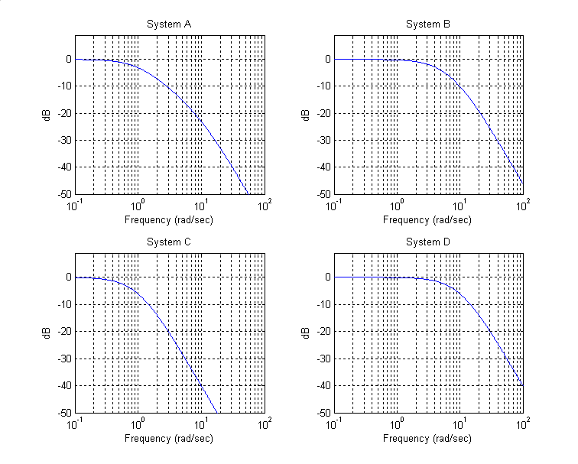
9) The unit step responses of four systems with real poles are shown below. Which system will have the largest bandwidth?

a) System A b) System B c) System C d) System D

