Lab 1: Simulink, Matlab and the ECP Model 205 and 210 Systems

There are three basic goals to this lab:

1) Review (or learn for the first time) some basic Simulink and Matlab commands. Due to the fact the the Simulink drivers for the ECP system are for Matlab 6.5.1, you must use Matlab 6.5.1 in the lab. The Matlab/Simulink files you generate today will be the basis for much of the work we do in lab this quarter, and you will utilize them regularly in your homework.

2) Learn to connect and operate the ECP model 210 rectilinear system

3) Learn to connect and operate the ECP model 205 torsional system

Part 1: Some background Matlab commands::

poly If we want to construct a polynomial with roots at -1 and -2, we type the command

y = poly([-2 -1])

Matlab will respond with the array [1 3 2], which corresponds to the polynomial
tf To construct the transfer function
we type into Matlab:

Gp = tf([1 3 2],[1 0 0 0])

pole and zero To find the poles or zeros of a transfer function, we use the pole or zero command

pole(Gp)

zero(Gp)

minreal This command eliminates common poles and zeros from transfer functions. There is an optional argument (tol) that let's you specify how close the pole/zeros are to each other before you decide they are really equal. To utilize this command, you would type

G = minreal(G);

tfdata Sometimes we need to extract the numerator and denominator from the transfer function. This is particularly true when trying to implement a transfer function in Simulink, which expects a numerator and denominator. To do this we use the tfdata command, as follows:

[num_G,den_G] = tfdata(G,'v');

Sometimes we want to know the value of a transfer function when. To do this in Matlab, and assign the value to a variable value, type

value = num_G(end)/den_G(end);

feedback This is a useful command when we want Matlab to determine the closed loop transfer function for a system with the configuration shown below.
Gpre(s)
Gc(s)
Gp(s)
H(s)
+
-

R(s)
Y(s)

This is the type of configuration we will be utilizing extensively in this class. To find the transfer function from the input R(s) to the output Y(s), we would type

G = Gpre*feedback(Gc*Gp,H);

Note that this command may not clean up pole/zero cancellations, and we may need to utilize minreal after this command. If any of these elements is not present, set that value to a 1.

axis Sometimes we want the axes of one particular graph to be different than the other graphs on a page, or we want to examine something up close. To do this we utilize the axis command as follows:

axis([min_x_value max_x_value min_y_value max_y_value]);

This limits the range of the x-axis from min_x_value to max_x_value, and limits the range of the y-axis from min_y_value to max_y_value.

For you to do: In Matlab, construct a transfer function with zeros at -1, -2, -5 and poles at
-1, -2, -3 using the poly command, then the tf command. Verify the poles and zeros are where you think they should be using the pole and zero commands. Then use the minreal command to eliminate common poles and zeros. Finally, use tfdata to extract the numerator and denominator of the transfer function and find the value of the transfer function as

Part 2 - Open Loop Response

The first thing we will look at in this lab is the open loop response of a system. Here we basically assume we have the transfer function of some type of system. This system is usually referred to as the plant, and we are trying to improve on the response of the plant.

a) Create a folder for your work. I would suggest making a folder in the ECE-320 folder which identifies you and your lab partner, and then within this folder make a folder entitled something creative like Lab 1.

b) Open Matlab (6.5.1) and set the directory to this folder. Do not dump your stuff in the work (default) directory.

c) Go to the class website (~throne) and download openloop_driver.m (Matlab driver file) , openloop.mdl (Simulink model file), and state_model_1dof.mat.

The Simulink file for the open-loop system should look like the following:

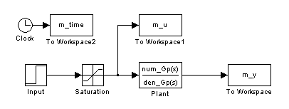
In this case, all of the things we are save (to plot later) have the prefix m, such as m_time, m_u, and m_y. This is so we can (in future labs) compare the response of the model (the m things) with the response of the real system.

Before we go on, we should review a few of the important pieces of the Simulink file.

All of the items begin saved to the workspace that we want to be able to plot later, like m_time, look like the following:

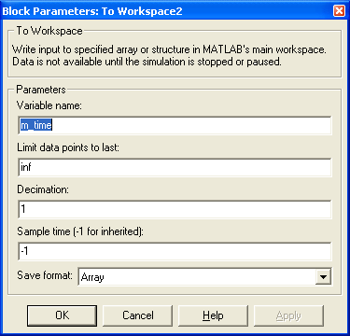
This should say Array

Note in particular that we are saving this data as an array.

The saturation levels are determined by the ECP device, are coded into the Matlab driver, and are set using the following window (you shouldn't have to change this):

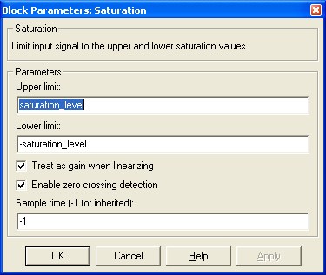

The (plant) transfer function is determined in Matlab, and is entered into the Simulink model as:
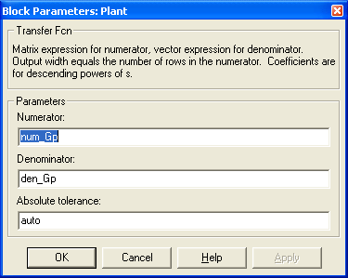

We need tfdata to get these pieces

The system input is determined in Matlab, and is entered into the Simulink model by

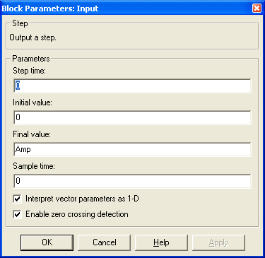

We are controlling the amplitude of the step in Matlab

The length of time to run the simulation is also determined by Matlab, and is set in the Simulation Parameters section
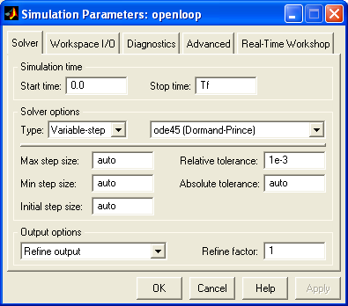
This is the length of time to run the simulation for.

Finally, to run the simulation, open openloop_driver.m and click on the down arrow:
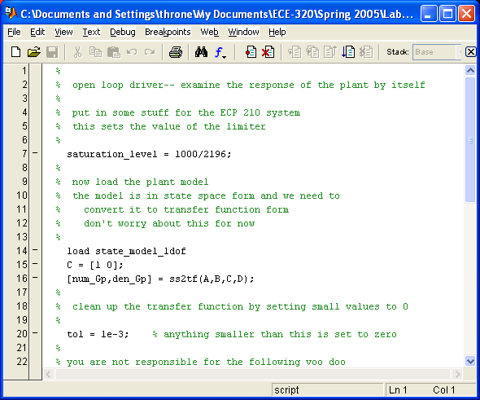

Click here to run Simulink

ulink

If you run the m-file openloop_driver.m, you should get the following plot:

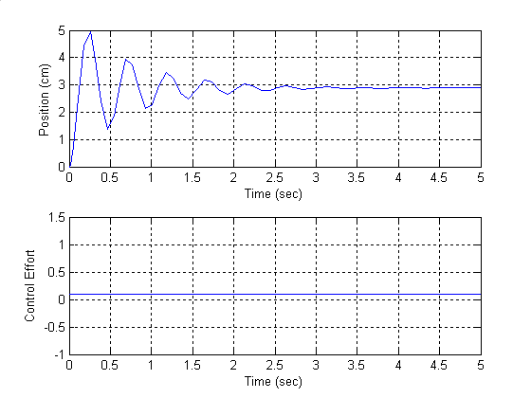

d) Adjust the input amplitude so that position in steady state is 1cm. Include this plot (and the corresponding input amplitudes) in your memo. Be sure to label each figure and provide a caption.

e) By adjusting the input amplitude, can we change the settling time of the system? Can we change the percent overshoot [(peak-steady state)/steady state x 100%]?

This an open loop system, in that the output signal is never compared to the input signal.

Part 3 - Closed Loop Control

a) Save your openloop.mdl file as closedloop.mdl. Save your openloop_driver.m as closedloop_driver.m. Be sure to modify closedloop_driver.m so it runs closedloop.mdl.

b) Modify closedloop.mdl so it looks like the following:

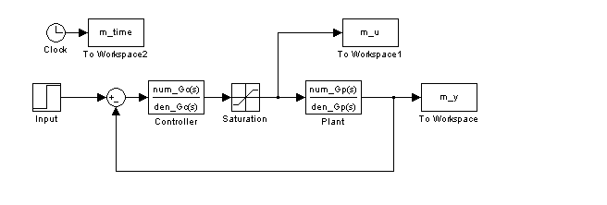
This is a closed loop system, in that we are feeding back the output and comparing this output to what we wanted the output to be. We have also added a new transfer function, the controller or compensator, usually denoted as Gc(s).

c) Now we need to try and figure out how to choose our controller. This is one of the main topics of this course, so at this point I'll just tell you.

Lets assume that we want the closed loop transfer function (the transfer function from input to output) to be of the form
for some . To enter this into Matlab, for we could type something like

wo = 1;

Go = tf(1,[1 1.8*wo wo^2]);

Type this to closedloop_driver.m, before the sim command. We will be varying wo so leave it a variable.

d) To determine the controller, we need to solve the equation (we will show where this comes from later in the class)

In Matlab we just have to type

Gc = Go/(Gp*(1-Go));

Be sure to eliminate pole/zero cancellations, and extract the numerator and denominator of the controller transfer function so Simulink can use the controller.

e) If you run closedloop_driver.m with wo = 5, Amp = 1, and Tf = 2 you should get the following plot.

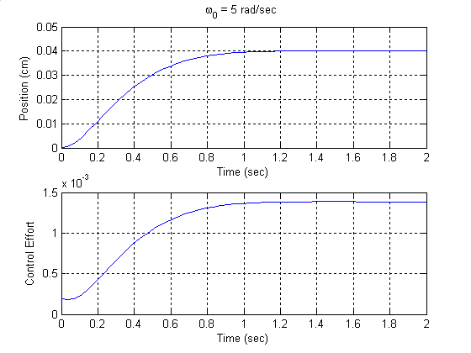

f) Run closedloop_driver.m with wo = 10, 50, and 100. Be sure to vary the final time for each graph to include only that portion of the graph that is interesting. Include the plots in your memo. What happens to the settling time as wo is increased? What happens to the
control effort? What happens to the steady state value?

g) We now need to fix the final value, or the position error. There are many ways to do this (in this case we could have just modified Go), but we will use a prefilter, since this is what we will do with many of our controllers. Modify closedloop.mdl so it looks as follows:

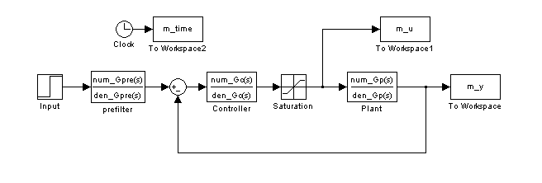
h) For our system, we need to set the prefilter so the closed loop transfer function has a value of 1 as . You should modify closedloop_driver.m to determine the steady state value of the closed loop transfer function (without the prefilter), and then set the prefilter gain to one over this. Although it is easy to determine analytically what this value should be in this case, you need to have Matlab compute it numerically. In this particular case the prefilter is a constant but we will still implement it as a transfer function, to keep it general. The denominator of this transfer function should be set to 1.

i) One of the things you will soon notice for a step input is that the control effort is usually largest just after the step. Since we are mostly concerned about the control effort at this point in time, modify closedloop_driver.m using the axis command to limit the time we look at the control effort to be from 0 to 0.1 seconds, no matter how long the Simulink simulation is run. Because of the limiter, the control signal will always be between -saturation_level and saturation_level.

j) If you have done steps (h) and (i) properly, the steady state value of the output should be the same as the steady state value of the input. For wo = 10, Amp =1, and Tf = 1.0, the output of closedloop_driver.m should look as follows:

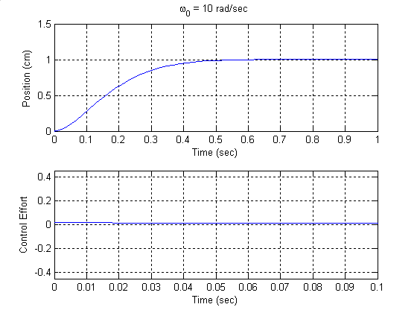

k) Now run the simulation for wo = 20 and 40 rad/sec. What happens to the settling time? What happens to the control effort? Be sure to include these plots in your memo.

l) Run closedloop_driver.m again for wo = 50 rad/sec, then for wo = 60 rad/sec. You should notice that once we hit the limiter we start to get fairly weird behavior. This is because our system has suddenly become nonlinear. Whenever we utilize the ECP system we want to be sure to stay within the linear range, if possible. Include both of these plots in your memo.

Your final memo should have a short cover page which answers the various questions that were asked. As attachments you should have each of the plots (these should be included in the document file), each with a figure number and a caption. You should also attach your final version of closedloop_driver.m and closedloop.mdl. The last page of your memo should have the following page signed by the instructor and attached, verifying you successfully connected to the ECP models 210 and 205.

Part 4 - ECP Model 210

Be sure the connector box (black and gray box on the top of the shelf) is off before connecting the system. Do not force the connectors. If they don't seem to fit, ask for help! You need to read through the handout on the real-time windows and the ECP systems, and use Model210_Openloop.mdl with an input of 0.01sin(4t) cm. The instructor needs to sign below verifying your work.

Verified by ___________________________________________________

Part 5 - ECP Model 205

Be sure the connector box (black and gray box on the top of the shelf) is off before connecting the system. Do not force the connectors. If they don't seem to fit, ask for help! You need to read through the handout on the real-time windows and the ECP systems, and use Model205_Openloop.mdl with an input of 1sin(4t) degrees. The instructor needs to sign below verifying your work.

Verified by ___________________________________________________

