ECE 300
Signals and Systems

Exam 1
21 December, 2006

NAME ________________________________________

This exam is closed-book in nature. You are not to use a calculator or computer during the exam.

Problems 1-10________ / 40
Problem 11 ________ / 20
Problem 12 ________ / 20
Problem 13 ________ / 20

Exam 1 Total Score: _______ / 100

Problems 1-10 are worth 4 points each.

1. Which of the following statements is the best simplification of:
a) 0 b) c) d) e) none of these

2 . The average power in the signal $x(t)=e^{−(π/2)t}u(t)$ is

a) 0 b) $\frac{1}{2π}$ c) $\frac{1}{2π}(1−e^{−πT})$ d) $\frac{1}{π}$ e) none of these

3. If a system is defined by circle each of the following properties that always apply to this system

a) the system is linear
b) the system is causal
c) the system is time invariant
d) the system is memoryless
e) the system is BIBO stable

4. The signal$x(t)=e^{j(4t)}+e^{−j(4t)}$ is
a) not periodic
b) periodic with fundamental period 4π seconds
c) periodic with fundamental period 1/2 second
d) periodic with fundamental period π/2 seconds
e) none of the above

For problems 5-8 consider a system modeled by the equation $y(t)=3e^{−(t+1)}\text{cos}(2t)x(t)$
And answer the following questions.

5. Is the system linear? a) Yes b) No

6. Is the system time invariant? a) Yes b) No

7. Is the system memoryless? a) Yes b) No

8. Is the system causal? a) Yes b) No

9. Consider a system whose input is and the measured output for the given input is

Is this system time invariant? a) Yes b) No Explain your answer

10. Consider the system modeled by the equation $y(t)=\int_{0}^{∞}{x(λ)dλ}$

Is this a BIBO system? a) Yes b) No Explain your answer

11. (20 points)
Given a system with and , solve for the output of the system y(t) showing all of your steps for solving the convolution analytically, not graphically. You may use graphical convolution to check your work or to help you think about the problem, but it will not be graded.

12. (20 points)
Consider the following system, composed of two subsystems each receiving x(t) as their input. Assume both systems are initially at rest, both systems are causal.
Σ
y(t)
- Determine the impulse response for each subsystem

- Determine the impulse response between input and output

13. (20 points) Given the signals below for the input and output of a system
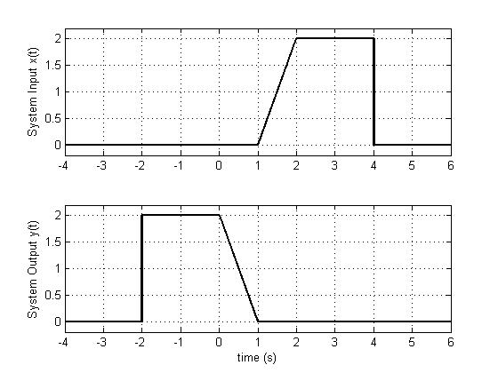
- Write an expression for x(t) using unit-step functions and ‘t’ as a variable.
- Write an expression for y(t) in terms of x(t).
- Is this system causal? Explain your answer.

Some Potentially Useful Relationships

