Name______________________________ CM____________

Quiz 6

1) Using Euler’s identity, we can write as

a) b) c) d)

2) Using Euler’s identity, we can write as

a) b) c) d)

3) Assume we are going to synthesize a periodic signal using where. Will be a real valued function?

a) Yes b) No

Problems 4 -6 refer to the following Fourier series representation

4) The average value of is a) 0 b) 1 c) 2 d) 3

5) The fundamental frequency (in Hz) is a) b) 0.5 c) d) 2

6) The average power in the first (fundamental) harmonic is

a) 0 b) 0.5 c) 1 d) 2 e) none of these

7) Assume is a periodic function with period seconds. is defined over one period as

The average power in (the power averaged over one period) is

a) 3 b) 5 c) 2.5 d) 1.5 e) none of these
Problems 8-10 refer to the following spectrum plot for a signal with fundamental frequency. All angles are multiples of 45 degrees.
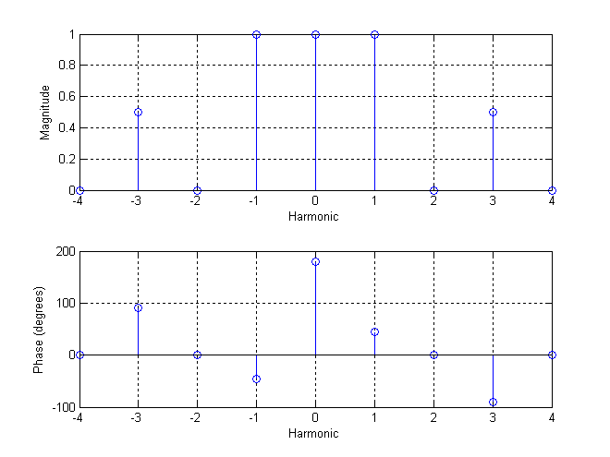
8) What is the average value of ? a) 4 b) 2 c) -1 d) 1

9) What is the average power in ? a) 4 b) 3.5 c) 2.25 d) 1.5

10) We can write as

a)
b)
c)
d)
e) none of these

