Real-Time Windows Target, Simulink,

and the ECP Model 210 and Model 205

Every station in C-116 should be set up to run the ECP Model 210 (rectilinear system) and/or Model 205 (torsional system) from Simulink using the Real-Time Windows Target software. However, it often takes a little effort to make sure all components are communicating with each other. This is a brief guide to help you get started.

Do not interchange the ECP Model 210 and ECP Model 205 Simulink blocks. They have scaling differences and are not interchangeable!

Step 1. We need to inform the ECP system that we will be using Simulink and the real-time windows target. To do this, click Start -> Programs -> ECP

The ECP window should pop up, something like the window shown below:

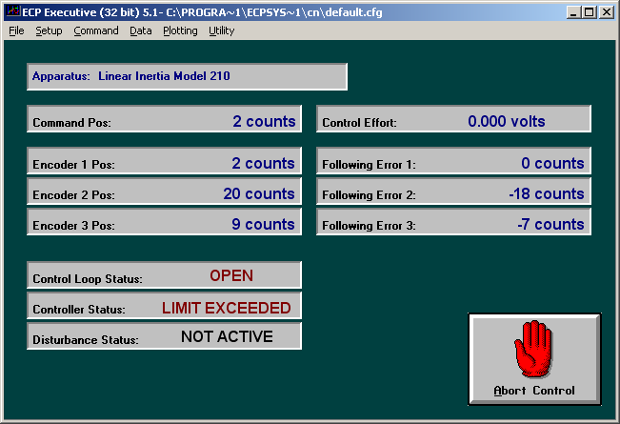

First select Utility-> Download Controller Personality File.

Then select C: -> Program Files -> ECP Systems -> cn

Select m210_rtwt_3.pmc (to use the Model 210) or m205_rtwt_3.pmc (to the use Model 205) and click on open. Wait for the ECP system to load the personality file.

Step 2. Select Utility -> Reset Controller.

Step 3. Close the ECP Executive (click on the X) Do not just minimize it!!!!

Step 4. You must be using Matlab 6.5.1 to use the real-time windows target with the ECP systems. Once you have started the correct version of Matlab, we need to get some communications started.

Step 5. To install Matlab’s Real-Time Windows Target, type

rtwintgt –setup

Matlab should respond with

You are going to install the Real-Time Windows Target kernel.
Do you want to proceed? [y] :

Since the whole point is the use the real time windows target, you should type y and hit the enter key.

At this point, Matlab will respond with

The Real-Time Windows Target kernel has been successfully installed.

The real-time windows target usually remains installed, so after you type
rtwintgt –setup you may get the message

The current version of the Real-Time Windows Target kernel is already installed.
Do you want to reinstall it? [n]

You can just type n (and enter) if you get this message, since you do not need to reinstall it.

Step 6. The real-time windows target utilizes Microsoft’s Visual C++ compiler. We need to tell Matlab to use this compiler. To do this, type

mex -setup

Matlab will respond with the message:

Please choose your compiler for building external interface (MEX) files:

Would you like mex to locate installed compilers [y]/n?

You need to type y (and enter), since we want Matlab to identify the available compilers

Matlab then responds with

Select a compiler:
[1] Digital Visual Fortran version 6.0 in C:\Program Files\Microsoft Visual Studio

[2] Lcc C version 2.4 in C:\MATLAB6P5\sys\lcc
[3] Microsoft Visual C/C++ version 6.0 in C:\Program Files\Microsoft Visual Studio

[0] None

Compiler:

You need to type 3 (and enter), since we are going to use Microsoft’s Visual C++ Compier

Matlab then responds with

Please verify your choices:

Compiler: Microsoft Visual C/C++ 6.0
Location: C:\Program Files\Microsoft Visual Studio

Are these correct?([y]/n):

And you should respond with a y (and enter)

At this point Matlab responds with a long-winded reply which basically means it’s done.

Step 7. Set the Matlab current directory to the folder where all of your files are located.

Step 8. Start Simulink by typing Simulink in the Matlab window.

Resetting the System Using Simulink

We often have to reset/reinitialize the system. In order to do this from Simulink we use the ECPDSPresetmdl.mdl Simulink model file. This model is our friend, you will probably use it a lot.

From Simulink select File->Open->ECPDSPResetmdl.mdl The following window should pop up.
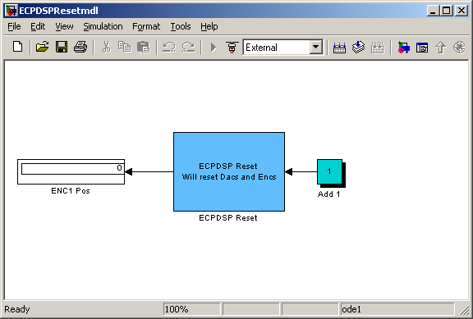

In order to make sure communications are OK, we need to be sure the address for the signal processing card is where we think it should be. To do this, double click on the ECP Reset block. You should get the following:
This address should be ‘0xDE00’ on the old computers and
‘0xB400’ on the newer computers

On
On
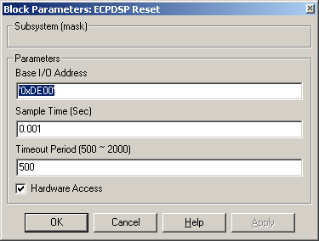

Next we need to compile ECPDSPResetmdl.mdl. To do this click on the compile icon

Click here to compile

A bunch of stuff will get written to to Matlab window, ending with the line:

### Successful completion of Real-Time Workshop build procedure for model: ECPDSPResetmdl
>>

Now we need to connect this model to the real system. To do this, first make sure the word External is showing in the box, and then click on the icon next to the box, as shown below.

This should say External
Click here to connect to the ECP system

The play button should now be available, as shown below. In the Matlab window, you should get the message Model ECPDSPResetmdl loaded.

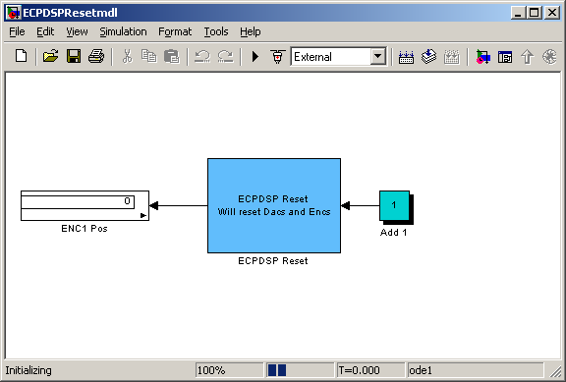

Play button now available

Now click on the play button. The window should look briefly like the following. The black box (where the play button was) is the stop button, you can use this to stop the simulation at any time.

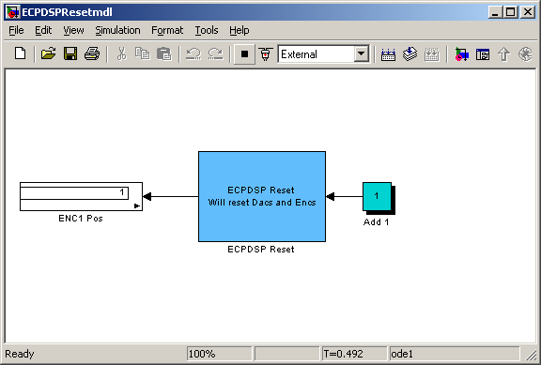
Stop button

If you’ve done everything correctly, after the system has run in the Matlab window you should get the message Model ECPDSPResetmdl unloaded. This routine is just used to initialize and reset values, the ECP system will not move.

Model210_Openloop.mdl

The first thing we usually need to do is to identify the system by constructing a Bode plot and fitting the measured frequency response to the expected frequency response of the transfer function in our model. To do this we will usually use the Simulink file Model210_Openloop.mdl. This is shown below:

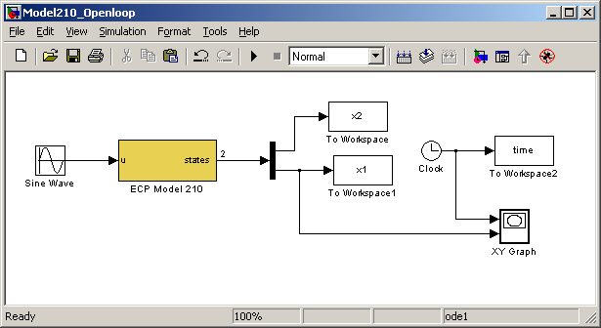

This particular implementation has the input signal in cm and the position of the two carts measured in cm. For this implementation, the position of the first cart (x1) is plotted as a function of time as the ECP system runs. (Note that the length of time the XY Graph plots the position of the first cart is hard coded, i.e. it cannot be a variable.)

The first thing we need to do is be sure Simulink is communicating with the signal processing board correctly. This means we need to be sure the Simulink model thinks the signal processing board is at the correct address. To do this, first click on the ECP Model 210 block. You should get the following:

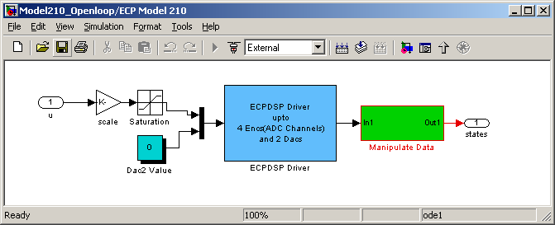

This basically shows us that the ECP Model 210 block is made up of subsystems, most of which you don’t have to worry about. To check the address of the DSP card, click on the ESPDSP Driver block. You should get the following:

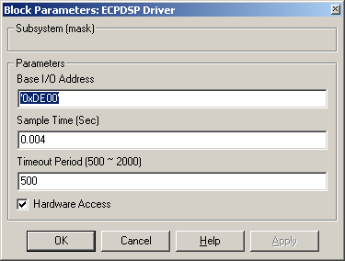

Be sure this address is correct!

Once the Base I/O address, Sample Time, and Timeout Period are OK, click on OK and go back to Model210_Openloop.mdl.

In order to plot sine waves of different frequencies, you need to click on the Sine Wave block, and both the input frequency and perhaps the input amplitude. The result of clicking on the Sine Wave block is shown below

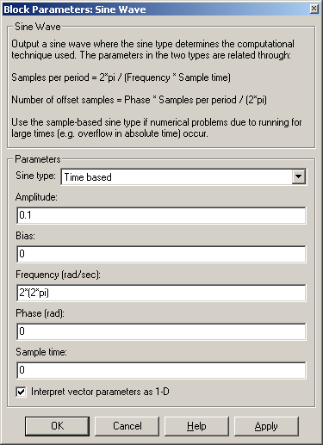

Amplitude of 0.1 cm

Frequency in radians/sec, which is frequency in Hz *(2*pi). This is a 2 Hz sine wave

Next we need to set up some simulation parameters. Select Simulation -> Simulation Parameters. You will get a screen something like the following:
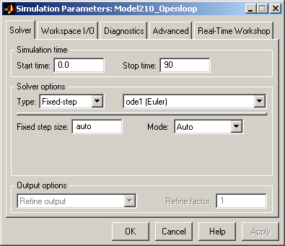
This needs to be Fixed-step
This is the length of time to run the simulation if you don’t stop it.
This needs to be ode1 (Euler)

Next, you might want to select Workspace I/O and modify it to look like the following:

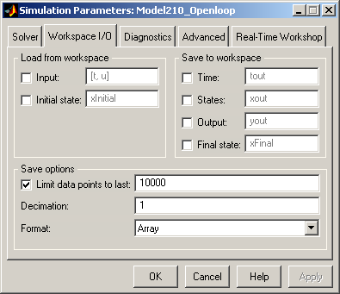

This should be a fairly large number

Finally, if you select Real-Time Workshop, it should look like this:

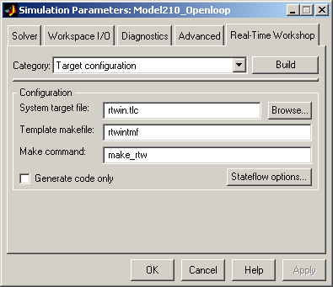

Sometimes, if the system is not saving enough of your data, you will need to select Tools->External Mode Control Panel and get the following display

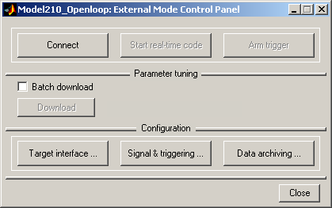

Select Signal & triggering and get the following:

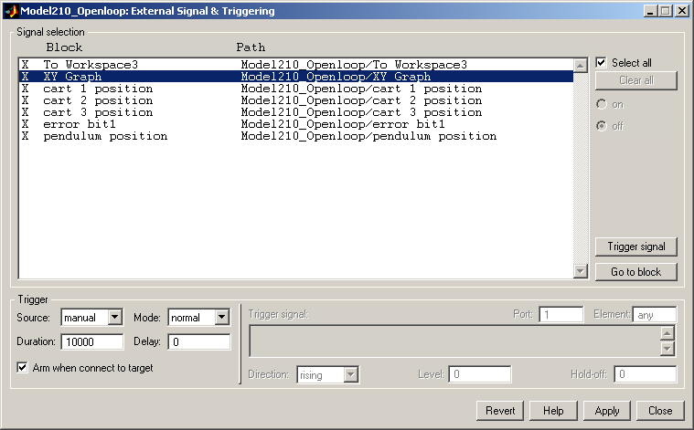
This should be a large number

At this point we a re ready to compile and run Model210_Openloop.mdl.

Click here to compile

After compiling, you should get the message

### Successful completion of Real-Time Workshop build procedure for model: Model210_Openloop

in the Matlab window. Sometimes you get a number of warnings, and if you compile it twice these go away.

Next connect to the ECP System
Be sure this says External

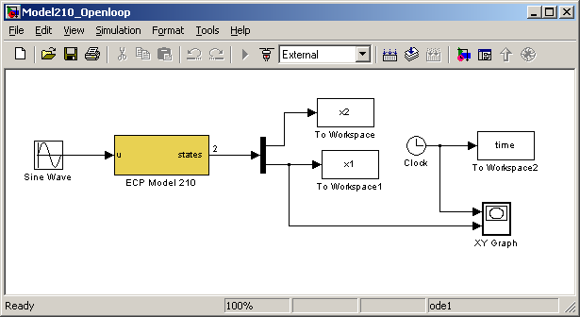

Click on this to connect

Sometimes when you try and connect you get an error, even though there is nothing wrong. Just clear the window that comes up and try again.

The play button should now be available, and a blank XY graph should appear.

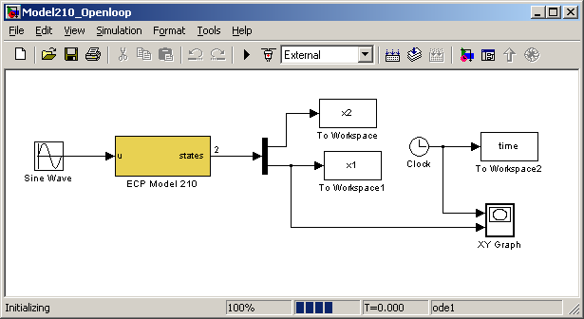
Play button now available

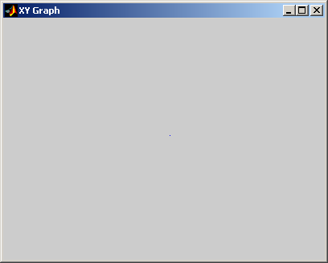
Blank XY Graph

Note that if you want to disconnect from the ECP system, we click on the button next to the play button.

Click here to disconnect from the ECP system

Finally, we can run the system, the XY-graph (for the model I used) will look like
If your cart moves more then 3 cm in either direction, something is wrong with the communications between Simulink and the ECP system. Ask for help!
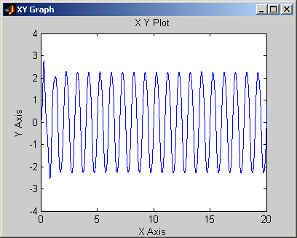

Once we have started running the ECP system, we can disconnect by clicking on the stop button. Any data that has been collected will be saved in the workspace.

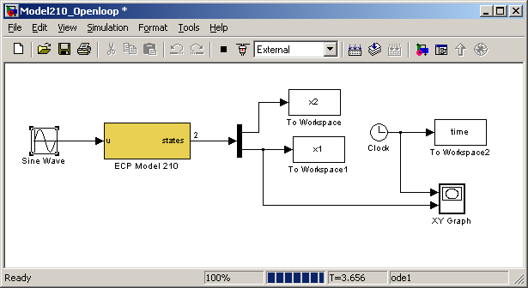
Stop button, use this to disconnect from the ECP system

Model205_Openloop.mdl

This section only contains the basic differences between the Model 205 and Model 210 files.

The first thing we usually need to do is to identify the system by constructing a Bode plot and fitting the measured frequency response to the expected frequency response of the transfer function in our model. To do this we will usually use the Simulink file Model205_Openloop.mdl. This is shown below:

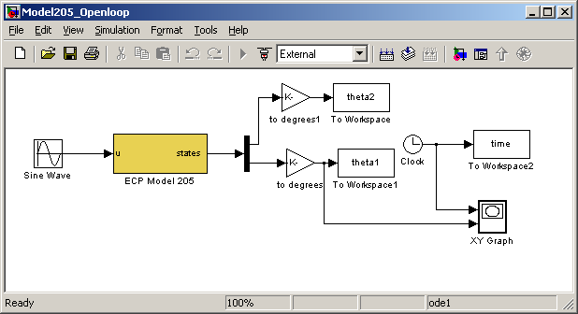

This particular implementation has the input signal in radians and the position of the two disks measured in degrees. For this implementation, the position of the first disk (theta1) is plotted as a function of time as the ECP system runs. (Note that the length of time the XY Graph plots the position of the first cart is hard coded, i.e. it cannot be a variable.)
Note that in general, the Model 205 works in radians. In this case we have converted to degrees for convenience.

The first thing we need to do is be sure Simulink is communicating with the signal processing board correctly. This means we need to be sure the Simulink model thinks the signal processing board is at the correct address. To do this, first click on the ECP Model 205 block. You should get the following:

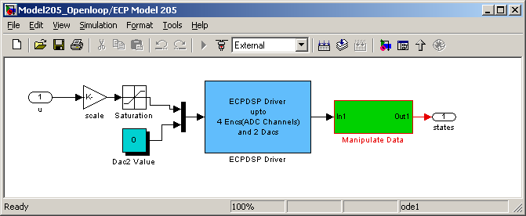

This basically shows us that the ECP Model 205 block is made up of subsystems, most of which you don’t have to worry about. To check the address of the DSP card, clock on the ESPDSP Driver block. You should get the following:

Be sure this address is correct!

Once the Base I/O address, Sample Time, and Timeout Period are OK, click on OK and go back to Model205_Openloop.mdl.

In order to plot sine waves of different frequencies, you need to click on the Sine Wave block, and both the input frequency and perhaps the input amplitude. The result of clicking on the Sine Wave block is shown below
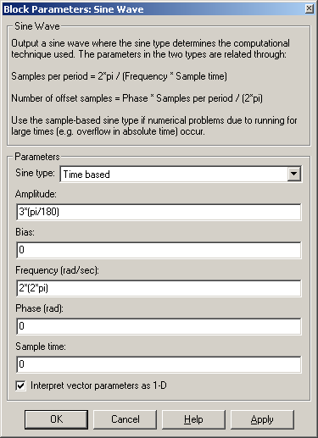
Frequency in radians/sec, which is frequency in Hz *(2*pi). This is a 2 Hz sine wave
Amplitude in radians, which is degrees*pi/180. This is a 3 degree amplitude

