ECE331 Final Project Report

Eric Lindberg, Andrew Toth
ECE 331-01
Nov. 14, 2006

Introduction
The goal of this project was to construct an embedded system capable of controlling our digital cable box via infrared signals. We wanted our system to be able to turn on the cable and change the channel at a specified time, effectively making it an unattended remote-control. We were successful in our design and implementation. This report will describe the details of our system and the process by which we developed our system.

Objectives and Specifications
We have a digital cable box in our room. We also have a TV-tuner card in a computer close by, and enjoy the luxury of being able to make digital recordings of TV shows. However, to accomplish this, we must pay particular attention to the channel number that the cable box is set to, as the recording computer has no way of changing the channel to the desired one. This project aimed to overcome this problem by creating an embedded system that emulates our cable box remote control.

The system must be able to:
- Change the channel on the cable box to a particular channel number
- Power on/off the cable box
- Schedule a time when the channel will change, so that the channel change can happen at an unattended hour
- Run reliably for at least 24 hours

The system must also:
- Be controlled over RS232 by the host computer, running Windows XP

Strategy and Implementation
Our first step in emulating a remote control was to take an existing remote control from our cable box and decode the infrared signals that it generated. In order to visualize the infrared signal, we hooked up an infrared photodiode to an audio-in jack of a computer sound card. We recorded the signal received when pointing our actual remote control at the diode and pressing a button. After applying some gain correction, we were able to discern the following coding system used in the waveforms:

Each button press has a unique set of data bits, 16 in all, that represents the message. Each data bit consists of a 550us period high, followed by either a short or long low period. We characterized the long low periods as ‘1’ bits, and the short ones as ‘0’ bits. Using this, we were able to construct a table consisting of the codes for all of the necessary buttons on the remote control.

In addition to there being a set up pulses containing data, there were also some synchronization (we assume) pulses sent out .1s after the data. The following figure indicates this:

Each ‘sync pulse’, as we called them, consisted of a long high period, followed by a .0045s low period, followed by another short high period. The timings for the long high period matched the init pulse of the data segment, and the .0045s timing matched those in a ‘1’ data bit. This meant that we really only had 4 main time periods to worry about -- .009s, .00055s, .0045s, and .0022s. With these periods, we could reproduce the codes on a microcontroller.

While talking with Dr. Song about our project, we found out that the infrared signal was probably being sent with a carrier wave, instead of being directly digitally controlled, as in the figures above. He gave us an IR receiver from a TV or VCR he had, and after looking through its datasheet, found that it had a peak frequency response at around 33kHz. From this, we decided on using a PWM block set at 33kHz to drive our IR signal. It would be turned on and off according to the figures above.

We chose to implement our project on our MC9S12C32 microprocessor because of its PWM outputs, its high-precision timers, and our previous experience with it. We also wanted to be able to control our device via RS232, and we knew that there were drivers (sci.c, sci.h) that would make this easy to implement.

Our circuit design can be found in Appendix A. It is very straightforward. On PTT5 is an IR transmitting LED. We weren’t quite sure about the correct wavelength to use for the IR, but the LED we got from the ECE parts room (often used in ECE310) worked fine for us. Also, not having a datasheet for the LED, we connected it directly from the output pin to ground for maximum (reasonable) power. Additionally, there is a status LED on pin M2 that flashes periodically when the unit is operational.

Testing Procedure and Results
For the most part, our testing and development took place concurrently. In the lab, we scoped out the outputs of our PWM and tweaked our code until the measured waveforms matched the ones from our actual remote control. Once we were able to emulate all of the appropriate buttons from the remote, we tested our IR output with our cable box. We were immediately successful, and the cable box responded as expected. Once we implemented our serial command set, we simply tried out all the commands and made sure they all worked. Our commands consist of ‘channel ###’, ‘chup’, ‘chdown’, ‘power’, ‘exit’, ‘prog’, and ‘time’. We have tested each of these, and they perform as expected. Further details on each command can be found in the user’s guide. The final version of our code can be found in Appendix B.

Here are a couple of pictures of our setup, showing the cable box and our breadboarded circuit:
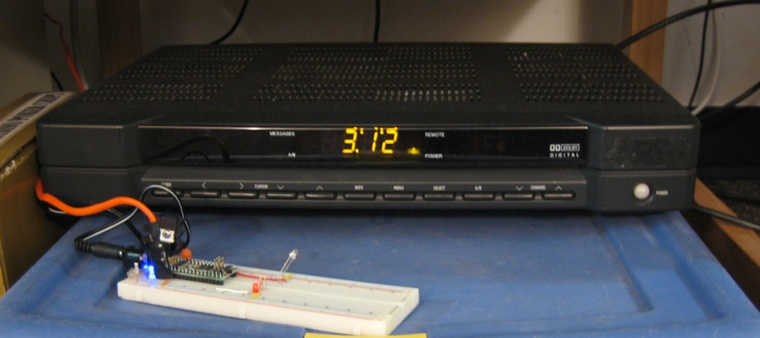
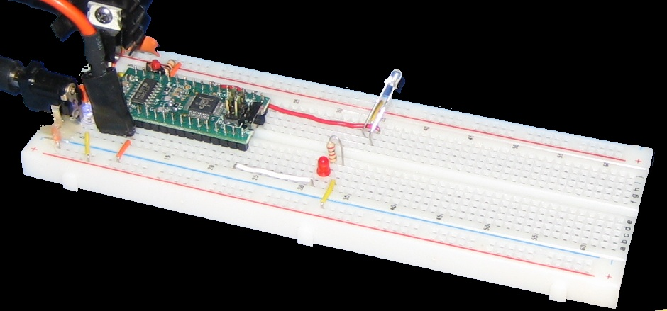

Bill of Materials

IR emitter LEDs $0.50
IR receiver LED $0.25
IR sensor from VCR/TV $0.00 (Dr. Song)
Microcontroller $0.00 (already purchased)
2.5 mm audio plug $0.00 (checked out from parts room)

User Manual
For the best results, the system should be placed such that the infrared LED faces the receiver. The Remote Control program interfaces over a serial connection, so to get started a connection must be made. This can easily be done with HyperTerminal since it is included with Windows. Open a new connection on whatever COM port the serial cable is connected to. Set the connection properties as shown below:
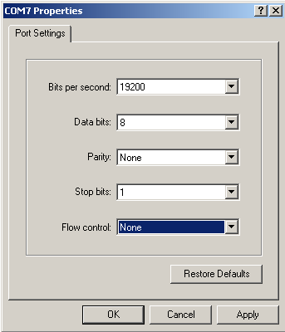

Connect power to the microcontroller, and then press the Connect button in HyperTerminal. Then reset the microcontroller. You will then see the startup screen for the program. It will prompt you to enter the current time. Please note that all times are in 24 hour format.

Once the time is entered, the system will provide a list of functions. The program will interpret known commands, and give an error with all other inputs. The known commands are power, channel, exit, chup, chdown, time, and prog.

power
This command will toggle the cable box power on and off by sending the power signal over IR

channel
This command will change the channel to the specified number. Only numbers from 0 to 999 are valid. Numbers can be entered with leading zeros or without. Example: channel 002 will do the same thing as channel 2. If no number is entered, or if the number is out of range, an Invalid Channel message will be shown.

exit
This command will exit out of the cable box’s on screen display, like the ‘exit’ button on a remote.

chup
This command will increment to one channel higher than the current one, like the Ch + button on a remote

chdown
This command will decrement to one channel lower than the current one, like the Ch – button on a remote

time
This command displays the microcontroller’s current time. This can be used to check its accuracy.

prog
This initiates the program function which allows you to specify a channel to change to and a time for that change to occur at. After prog is typed the system will prompt for a time and then a channel. Then when the system clock reaches the programmed time it will send out the channel signal to change to the specified channel.

Conclusion and Future Plans
The implementation of our project went smoothly, and our end-product works exactly as we had hoped it would. We were surprised to find that interacting with the cable box over infrared was as easy as it was – we were able to send it a command on only our second try. Once we had the framework for the codes set up, adding in new buttons from the remote became very easy. It was simply a task of decoding the received signal into a 16-bit binary code, and importing that into the program. That simplified things considerably, as we did not have to re-write our timing scheme for each individual command.

Our project will be put to use in our room, as we had hoped. We plan on using it to set up the cable box so that we can record TV shows over this coming quarter break. One improvement would be to incorporate a real-time clock chip into the design. Our microcontroller does a pretty good job of keeping time, but interrupts every 50ms don’t guarantee that the timing is accurate. A 32.768kHz crystal and an external time-keeping chip would rectify this.
Appendix A: System Schematic

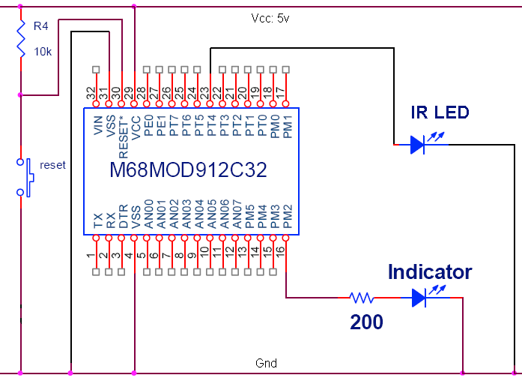

Appendix B: Microcontroller Code

Note: For brevity, vector address code is not included. ISRs are clearly labeled.

/********************************************************************************
* Description: ECE331 term project - Cable box IR transmitter.
* Source: project_main.h
* Date: 11-14-2006
* Author: Eric Lindberg, Andrew Toth
********************************************************************************/

#include <hidef.h> //Includes Code Warrior definitions
#include "per_C32_L45J.h"

//macros
#define CLI() {asm cli;} // enable global interrupts
#define SEI() {asm sei;} // disable global interrupts

//macros to turn on/off the carrier wave
#define CARRIER_OFF {Pwm.pwmdty[4].byte = 255;}
#define CARRIER_ON {Pwm.pwmdty[4].byte = CARRIER_DTY;}

//function signatures
void SetLedindicator();
void SetClockSpeed();
void send_ir_signal(char);
void change_to_channel(int);
void output_init_pulse();
void output_zero_bit();
void output_one_bit();
void output_sync_pulse();
void send_code(ulong);
void delay_50_ms();
void clock_isr();

//these timings correspond to how long the pwm output should be on or off
#define SHORT_HIGH 370
#define LONG_LOW 3472
#define SHORT_LOW 1748
#define LONG_HIGH 6750
#define SYNC_TIME_1 60000
#define SYNC_TIME_2 15000
#define FIFTY_MS 37500

//how long to wait between sending digits of a channel number
#define NUMBER_OF_50MS_DELAYS_BETWEEN_DIGITS 20

//Constant to disable the programmed channel change timer
// Works because the hours variable never equals -1.
#define PROG_DISABLED -1

//Some time-based constants
#define FIFTY_MS_IN_A_SECOND 20
#define SECONDS_IN_A_MINUTE 60
#define MINUTES_IN_AN_HOUR 60
#define HOURS_IN_A_DAY 24

//Number of bits in each binary code
#define BITS_IN_CODE 16
//Mask of the MSB
#define FIRST_BIT_MASK 0x8000

//Sets the pwm output to a 33kHz square wave.
#define CARRIER_PER 182;
#define CARRIER_DTY 91;

//Our osc clock is 24MHz
extern ulong busclk;
#define oscclk 24000
#define BaudRate 9600

//SCI includes
#include "sci.h"
extern int sprintf (const char *format, ...);
extern int printf (const char *format, ...);
extern int scanf (const char *format, ...);
#define XOn 0x11
#define XOff 0x13
#define RxBufSize 64
#define TxBufSize 32
#define XOnCount RxBufSize - 8
#define XOffCount 18

/********************************************************************************
* Description: ECE331 term project - Cable box IR transmitter.
* Source: project_main.c
* Date: 11-14-2006
* Author: Eric Lindberg, Andrew Toth
********************************************************************************/

#include "project_main.h" //include the header file
#include "String.h" //we use strcmp() from the string library

//These are the IR codes --
// A '1' represents of a short high, then long low signal
// A '0' represents of a short high, then short low signal
const ulong number_codes[10] = {
0b0000000000000000, //0
0b1000000000001111, //1
0b0100000000000111, //2
0b1100000000001011, //3
0b0010000000000011, //4
0b1010000000001101, //5
0b0110000000000101, //6
0b1110000000001001, //7
0b0001000000000001, //8
0b1001000000001110 //9
};
const ulong power_code = 0b0101000000000110;
const ulong exit_code = 0b0100100000001011;
const ulong chup_code = 0b1101000000001010;
const ulong chdown_code =0b0011000000000010;

int hours,minutes,seconds,fiftyms; //for our clock;
int progchannel, proghour, progminute; //for a scheduled channel change

/****************************************************************************
* Main routine.
*
* Takes in commands over serial, and sends IR signals out over PT5
* according to the received command. Commands supported at this time
* include 'channel ###', 'power', 'chup', 'chdown', 'exit', 'time' and
* 'prog'.
***************************************************************************/
void main ()
{
SEI(); // Disable Interrupts
SetLedindicator();
CLI(); // enable I bit interrupts

SetClockSpeed();
busclk = oscclk/2; // Set Bus Freq. = (1/2) * Oscillator Freq.
(void) InitSCI(BaudRate); // Initialize SCI module
(void) printf("ECE331 Fall 06\n\r");
(void) printf("Eric Lindberg and Andrew Toth\n\r");
(void) printf("Term Project\n\r");

//Setup pwm output carrier wave
Pwm.pwmdty[4].byte = 0xff; //We set duty to 0xff here to drive the output
// low initially. To enable the output, just
// set duty to the correct value. That way, we
// get clean square waves.
Pwm.pwmprclk.bit.pcka = 0b010; //Use bus clock/4 to drive clka
Pwm.pwmper[4].byte = CARRIER_PER; //Set the period
Pim.modrr.bit.modrr4 = 1; //Enable pwm output on T4
Pwm.pwme.bit.pwme4 = 1;

//Setup timers
Tim0.tios.bit.ios1 = 1; //Enable output compare on ch1
Tim0.tios.bit.ios2 = 1; //Enable output compare on ch2
Tim0.tios.bit.ios3 = 1; //Output compare for the real-time clock
Tim0.tie.bit.c1i = 0; //Disable interrupt on ch1
Tim0.tie.bit.c2i = 0; //Disable interrupt on ch2

//Intialize the real-time clock
(void) printf("please set the 24hr time (hh:mm:ss):\r\n");
scanf("%d:%d:%d", &hours, &minutes, &seconds);
printf("\r\n");
printf("\r\n");
printf("Commands include [power, channel ###, exit, chup, chdown, time]\r\n");
proghour = -1; //Disable the programmed channel changes
Tim0.tie.bit.c3i = 1; //Enable clock interrupt

//Main loop
for (;;) {
char n[16];
int chan,t;
int d1,d2,d3;
chan = -1; //Reset the channel input, in case it is not scanned correctly
scanf("%s %d",&n[0],&chan); //Scan for input commands over serial
if(strcmp(&n[0],"power") == 0) {
//Send the 'power' command over IR
(void)printf("\n\rSending Power Button\n\r");
send_ir_signal('p');
} else if (strcmp(&n[0], "exit") == 0) {
//Send the 'exit' command over IR
printf("\r\nSending exit button\r\n");
send_ir_signal('e');
} else if (strcmp(&n[0], "chup") == 0) {
//Send the 'channel up' command over IR
printf("\r\nSending channel up button\r\n");
send_ir_signal('u');
} else if (strcmp(&n[0], "chdown") == 0) {
printf("\r\nSending channel down button\r\n");
//Send the 'channel down' command over IR
send_ir_signal('d');
} else if(strcmp(&n[0],"channel") == 0) {
if(chan >= 0 && chan <= 999){
//Change the channel to the number specified
(void)printf("\n\rChanging to channel %d\n\r", chan);
change_to_channel(chan);
} else {
//Invalid channel input
(void)printf("\n\rInvalid Channel Number %d Try again\n\r", chan);
}
} else if (strcmp(&n[0], "time") == 0) {
//Display the time of the real-time clock over serial
printf("The current time is: %d:%d:%d\r\n", hours, minutes, seconds);
} else if (strcmp(&n[0], "prog") == 0) {
//We are programming a time to change the channel
printf("\r\nEnter time for channel change (hh:mm): ");
scanf("%d:%d", &proghour, &progminute);
printf("\r\nEnter channel to change to at that time: ");
scanf("%d", &progchannel);
printf("\r\nProgrammed.\r\n");
} else {
(void)printf("\n\rInvalid Command\n\r");
chan = -1; //Clear the channel value
for(t=0;t<16;n[t++]=0); //Also, reset the command buffer
}
}

//This should never be reached
while(1) {};
}

/****************************************************************************
* Changes the cable box to a certain decimal channel number.
*
* The function splits the number into three digits and sends codes for each
* number, with delays between the digits.
*
* @param chan The channel number
***************************************************************************/
void change_to_channel(int chan) {
int d1,d2,d3,t;
d1 = chan % 10;
d2 = (chan / 10) % 10;
d3 = (chan / 100) % 10;
send_ir_signal(d3);
for(t=0;t<NUMBER_OF_50MS_DELAYS_BETWEEN_DIGITS;t++) {
delay_50_ms();
}
send_ir_signal(d2);
for(t=0;t<NUMBER_OF_50MS_DELAYS_BETWEEN_DIGITS;t++) {
delay_50_ms();
}
send_ir_signal(d1);
}

/****************************************************************************
* ISR that updates the counters in the real-time clock.
*
* This function is designed to be called every 50ms. It updates the
* variables fiftyms, seconds, minutes, and hours. It also checks the
* programmed channel change time every minute, and triggers that channel
* change if the appropriate time has arrived.
***************************************************************************/
void clock_isr() {
Tim0.tflg1.bit.c3f = 1; //Clear the flag;
Tim0.tc[3] += FIFTY_MS; //Re-set the timer for another 50ms interrupt
fiftyms ++;
if (fiftyms >= FIFTY_MS_IN_A_SECOND) {
fiftyms %= FIFTY_MS_IN_A_SECOND;
seconds ++;
if (seconds >= SECONDS_IN_A_MINUTE) {
seconds %= SECONDS_IN_A_MINUTE;
minutes ++;
if (minutes >= MINUTES_IN_AN_HOUR) {
minutes %= MINUTES_IN_AN_HOUR;
hours ++;
if (hours >= HOURS_IN_A_DAY) {
hours %= HOURS_IN_A_DAY;
}
}
//Every minute, check our programmed channel change variables
if (proghour == hours && progminute == minutes) {
//Time to initiate channel change
change_to_channel(progchannel);
proghour = PROG_DISABLED;
}
}
}

}

/****************************************************************************
* Sends out a single IR command.
*
* This function is essentially a wrapper around send_code().
*
* @param s A character/integer corresponding to the code to be sent.
* Currently supported are the digits 0-9, 'p' for power, 'e' for exit, 'u'
* for channel up, and 'd' for channel down.
***************************************************************************/
void send_ir_signal(char s) {
ulong code;

switch(s) {
case 0x0:
case 0x1:
case 0x2:
case 0x3:
case 0x4:
case 0x5:
case 0x6:
case 0x7:
case 0x8:
case 0x9:
code = number_codes[s];
send_code(code);
break;
case 'p':
send_code(power_code);
break;
case 'e':
send_code(exit_code);
break;
case 'u':
send_code(chup_code);
break;
case 'd':
send_code(chdown_code);
break;
}
}

/****************************************************************************
* Utility function to delay program execution by 50ms.
*
* Makes use of timer channel 2.
***************************************************************************/
void delay_50_ms() {
Tim0.tflg1.bit.c2f = 1; //clear the flag;
Tim0.tc[2] = Tim0.tcnt.word + FIFTY_MS; //set the compare register
while (!Tim0.tflg1.bit.c2f);
}

/****************************************************************************
* Sends a code over IR given a 16-bit binary sequence.
*
* This function makes use of the output_xxx function listed below to
* generate the correct series of on/off transitions of the carrier wave,
* emulating a remote control.
*
* @param ir_code The 16-bit IR code -- one of the xxx_code definitions
* from the header file.
***************************************************************************/
void send_code(ulong ir_code) {
int n;
//Start our second timer to generate the later sync pulses
Tim0.tflg1.bit.c2f = 1;
Tim0.tc[2] = Tim0.tcnt.word + SYNC_TIME_1;

output_init_pulse();
for (n=0;n<BITS_IN_CODE;n++) {
if (ir_code & FIRST_BIT_MASK) {
output_one_bit();
} else {
output_zero_bit();
}
ir_code = ir_code << 1;
}
CARRIER_ON;
//Keep the carrier on for SHORT_HIGH amount of time.
Tim0.tflg1.bit.c1f = 1;
Tim0.tc[1] += SHORT_HIGH;
while (!Tim0.tflg1.bit.c1f);
CARRIER_OFF;

//Wait for our sync timer to hit
while (!Tim0.tflg1.bit.c2f);
//Set it again, and wait
Tim0.tflg1.bit.c2f = 1;
Tim0.tc[2] += SYNC_TIME_2;
while (!Tim0.tflg1.bit.c2f);

//set up the next one
Tim0.tc[2] += SYNC_TIME_1;

//now we are ready for a sync pulse
output_sync_pulse();

//Wait for the sync timer to hit again
while (!Tim0.tflg1.bit.c2f);
//set it again, and wait
Tim0.tflg1.bit.c2f = 1;
Tim0.tc[2] += SYNC_TIME_2;
while (!Tim0.tflg1.bit.c2f);

//Send the second sync pulse
output_sync_pulse();
}

/****************************************************************************
* Sends out a sync pulse, consisting of a long high, short low, and short
* high signal.
*
* Sync pulses, as we like to call them, appear exactly .1 sec after the
* first signal from the remote control and repeat two or three times. We
* assume they are used to synchronize the timing of the bits sent in the
* coded signal. We send two of them in send_code(), which seems to work.
***************************************************************************/
void output_sync_pulse() {
CARRIER_ON;
Tim0.tflg1.bit.c1f = 1; //clear the flag;
Tim0.tc[1] = Tim0.tcnt.word + LONG_HIGH; //set the compare register
while (!Tim0.tflg1.bit.c1f);
CARRIER_OFF;
Tim0.tflg1.bit.c1f = 1; //clear the flag
Tim0.tc[1] += SHORT_LOW;
while (!Tim0.tflg1.bit.c1f);
CARRIER_ON;
Tim0.tflg1.bit.c1f = 1; //clear the flag
Tim0.tc[1] += SHORT_HIGH;
while (!Tim0.tflg1.bit.c1f);
CARRIER_OFF;
}

/****************************************************************************
* Sends out an init pulse, the first thing sent. It consists of a long high
* 'on' period followed by a long low 'off' period.
***************************************************************************/
void output_init_pulse() {
CARRIER_ON;
Tim0.tflg1.bit.c1f = 1; //clear the flag;
Tim0.tc[1] = Tim0.tcnt.word + LONG_HIGH; //set the compare register
while (!Tim0.tflg1.bit.c1f);
CARRIER_OFF;
Tim0.tflg1.bit.c1f = 1; //clear the flag
Tim0.tc[1] += LONG_LOW;
while (!Tim0.tflg1.bit.c1f);
}

/****************************************************************************
* Sends out a coded 'zero' bit. It consists of a short high
* 'on' period followed by a short low 'off' period.
***************************************************************************/
void output_zero_bit() {
CARRIER_ON;
Tim0.tflg1.bit.c1f = 1; //clear the flag;
Tim0.tc[1] += SHORT_HIGH; //set the compare register
while (!Tim0.tflg1.bit.c1f);

CARRIER_OFF;
Tim0.tflg1.bit.c1f = 1; //clear the flag
Tim0.tc[1] += SHORT_LOW;
while (!Tim0.tflg1.bit.c1f);
}

/****************************************************************************
* Sends out a coded 'one' bit. It consists of a short high
* 'on' period followed by a long low 'off' period.
***************************************************************************/
void output_one_bit() {
CARRIER_ON;
Tim0.tflg1.bit.c1f = 1; //clear the flag;
Tim0.tc[1] += SHORT_HIGH; //set the compare register
while (!Tim0.tflg1.bit.c1f);

CARRIER_OFF;
Tim0.tflg1.bit.c1f = 1; //clear the flag
Tim0.tc[1] += LONG_LOW;
while (!Tim0.tflg1.bit.c1f);
}

/****************************************************************************
* Sets the clock speed to 24MHz.
***************************************************************************/
void SetClockSpeed() {
Crg.clksel.byte &=~PLLSEL; // disconnect PLL
Crg.pllctl.byte |=PLLON; // turn on PLL
Crg.synr.byte = 2; // set PLL multiplier
Crg.refdv.byte = 0;
while(!(Crg.crgflg.byte & LOCK)){ }; // wait for PLL to lock in
Crg.clksel.byte |=PLLSEL; // connect PLL
}

/******************************************************************
* DESCRIPTION: Use Output Compare interrupt to generate
* a squarewave on PM2 for HCS12C32
* SOURCE: ledindicator.c
* Date: 10-14-2006
* AUTHOR: Eric Lindberg, Andrew Toth
******************************************************************/
#include "project_main.h"
//set up interrupt service on for output compuare to toggle PM2
#define InterruptInterval 46875 //.5 second @ 24MHz osc

#define PRESCALER 0b101 // divide bus clock by 32

#define WaveChannel C0F //channel 0 mask byte
#define WaveCompareReg Tim0.tc[0] //EQU TC0
#define TogglePin PTM2 //EQU mPTM_PTM2 ; toggle this pin
#define TogglePinPort Pim.ptm.byte //EQU PTM ; toggle this port
#define TogglePinDirection Pim.ddrm.byte //EQU DDRM ;

void SetLedindicator(){
TogglePinDirection = TogglePinDirection | DDRM2; //make it output pin
Tim0.tscr1.bit.ten = 1; // turn on timer1
Tim0.tscr2.bit.pr = PRESCALER; //
Tim0.tios.byte = Tim0.tios.byte | WaveChannel; //select timer channel 0 for output compare
//Clear the timer FLAG in TFLG1 by writing a ``1'' to it.
Tim0.tflg1.bit.c0f = 1;
Tim0.tie.bit.c0i= WaveChannel; //Enable timer channel 0 interrupt

WaveCompareReg = Tim0.tcnt.word+(tU16) InterruptInterval; // LDD offset
return;
}

//Vector Address for Timer Channel 2 is $FFEA
interrupt void ServiceLedindicator() {
TogglePinPort = TogglePinPort^TogglePin; // ^ is bitwise exclusive OR operation
Tim0.tflg1.bit.c0f = 1; // Clear the timer ch0 flag
// load offset to start a new output compare
WaveCompareReg = Tim0.tcnt.word+ (tU16) InterruptInterval;
}

