3D Game Motion Controller

Noah Desch
Bryan Jefferson

Project Overview

We designed a 3D game controller based off of 3 single axis accelerometers. Our device communicates over a serial connection to an interface program on a PC. By moving the controller in 3-dimensional space the user can control a cube within the program. We have created a 3D game to demonstrate the functionality of the controller.

Parts Used

- (x 3) MMA1260D Accelerometer
- (x 3) 1 kOhm resistors
- (x 1) 330 Ohm resistor
- (x 1) 10 kOhm resistor
- (x 2) LEDs
- (x 1) .1 micro Farad capacitor
- (x 1) HC12 Microprocessor
- (x 1) Push button
- (x 1) 5 Volt Supply

Breadboard Implementation

We began by constructing the circuit shown in Figure 1. The Accelerometers output a voltage depending on their orientation to the direction of gravity. We read the voltages using the ATD channels. An interrupt is generated periodically to read ATD and send values over serial to the 3D game.

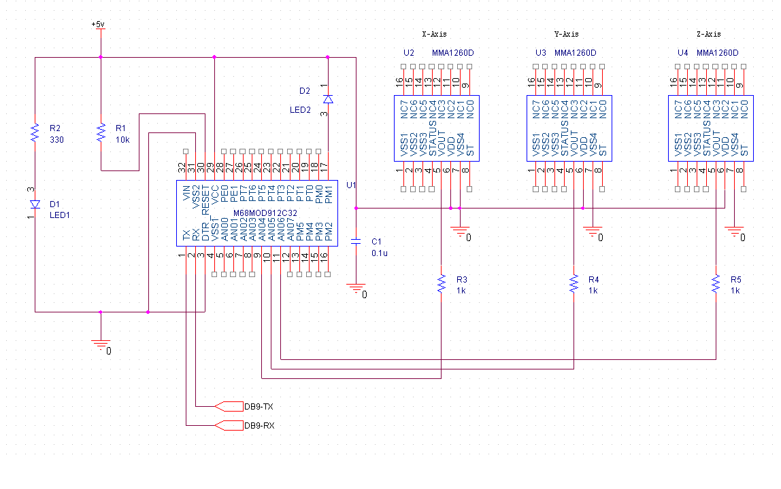 Figure 1: Schematic layout of breadboard design

Each accelerometer only uses 3 pins for operation. Power, ground, and voltage out. The pin assignments are shown below in Figure 2. Vout changes with the orientation of the chip to the direction of gravity.
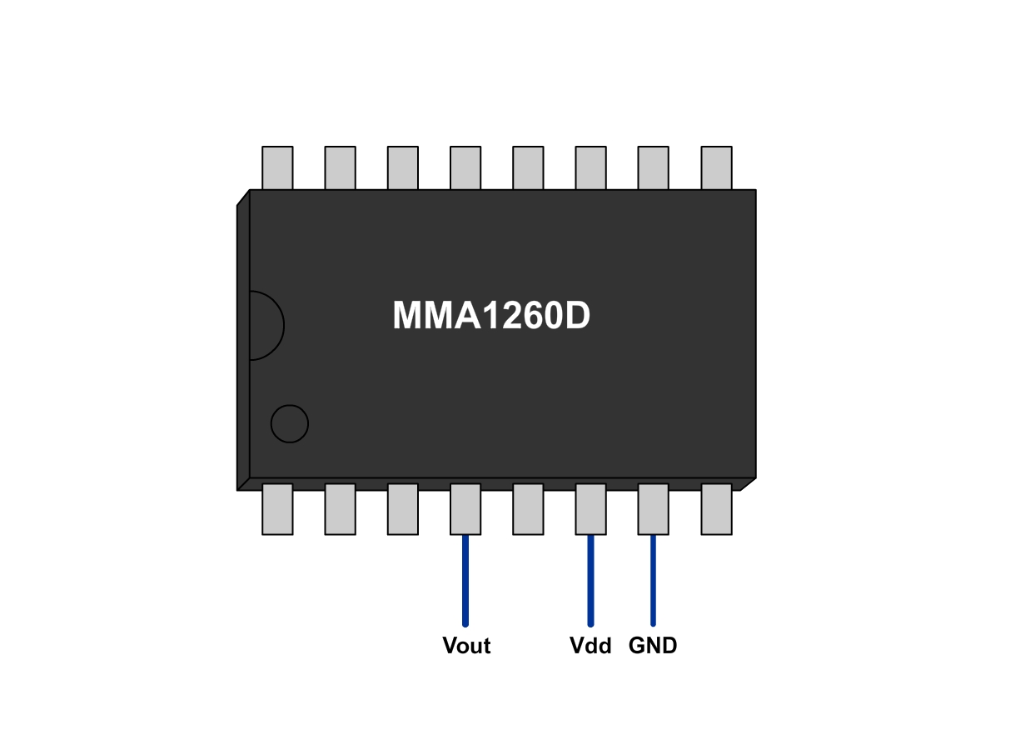
Figure 2: Pin out for MMA1260D accelerometer

The 3 accelerometers are in a self contained handheld enclosure. They are orientated as shown in Figure 3. This allows us to read all three dimensions in order to control a 3D cube in the game.

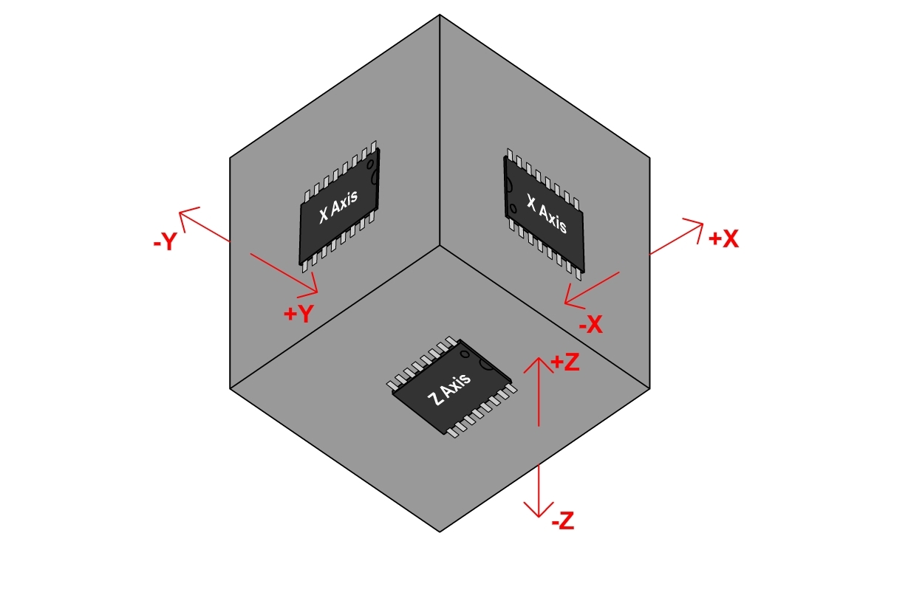
Figure 3: Layout of accelerometers within controller

Figure 4 shows how our breadboard implementation turned out. You can also see the handheld controller is in a self-contained enclosure, connected to the breadboard via long wires for easy maneuverability.

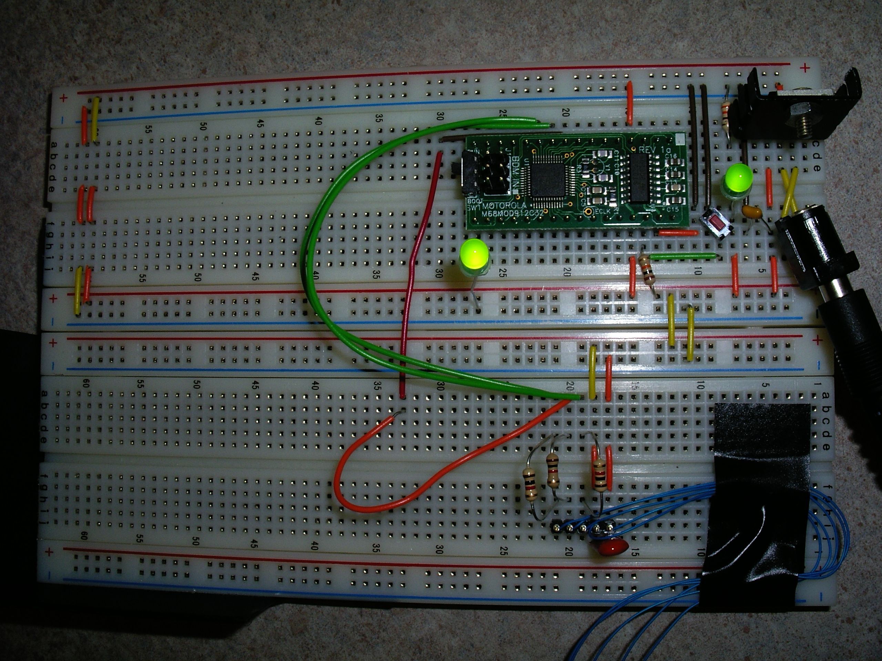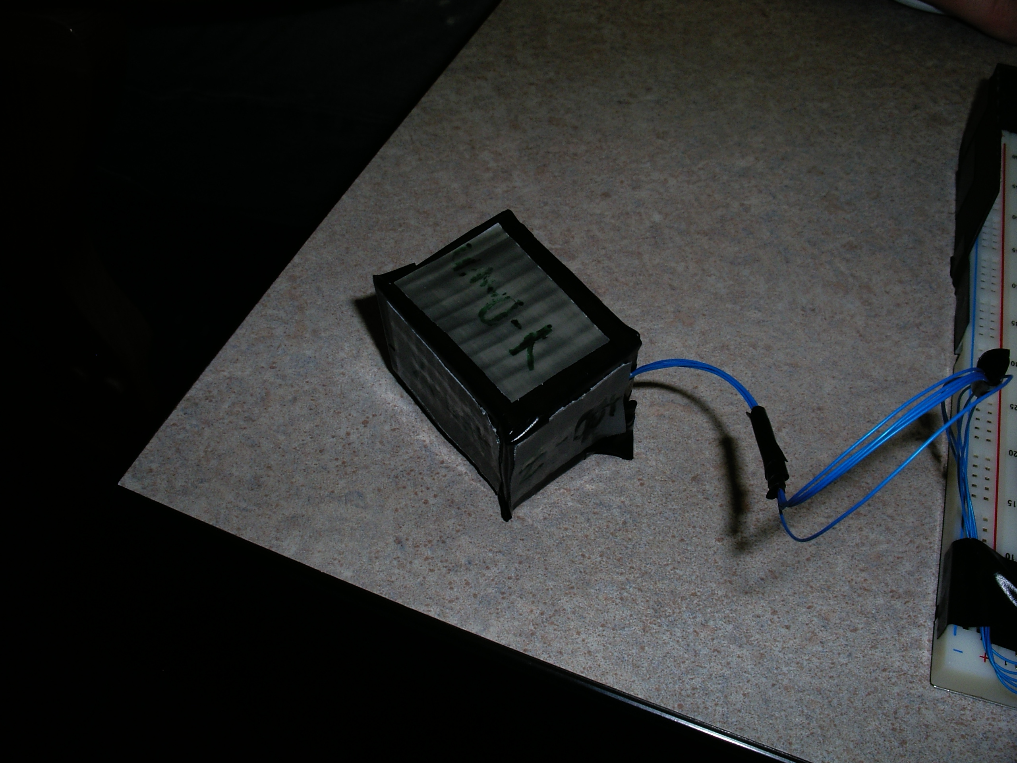

Figure 4: Breadboard implementation and 3D controller

3D game

Game is implemented in REALbasic, a language similar to Visual Basic. The game uses 3D projection techniques to draw a 3D scene consisting of two boxes inside a wire-frame room. One box is controlled through the motion of the accelerometers, while the other box is stationary. The game constantly scans the serial connection for data and uses the acceleration data to change the coordinates of the cube. The objective of the game is to touch the two boxes together for as long as possible to score points. The score is displayed at the left of the screen. Figure 5 shows a screen shot of the game, and the code for the game is attached at the end of this report.

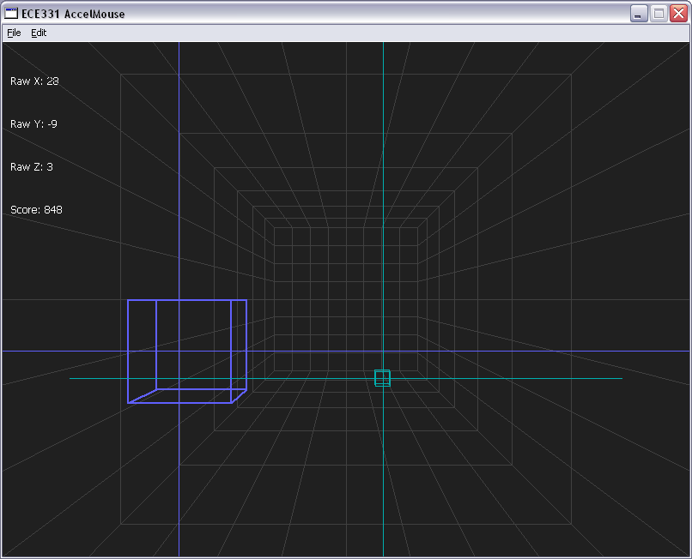

Figure 5: Screenshot of game

Problems Encountered

Originally we intended to use a pre-built demo board with accelerometers already attached, however we were unable to download any code to this board. We opted to get samples of the accelerometers ourselves and attach them to our breadboard with the HC12 module.

Our original concept involved the device integrating the acceleration readings twice to solve for the actual position of the device so it could be used like a sort of three dimensional mouse. This proved to be too difficult in the time allotted, so we decided to use the orientation of the device as the basis for the game control. This was simpler because the device will always be able to detect the acceleration of gravity. It also gave us the idea for the game because controlling the position of the cube by rotating our controller can be quite challenging.

Budget

Part | Detail | Price
Processor | HC12 | $0 (owned)
3 Accelerometers | MMA1260D | $0 (free samples)
LED | Green LED | $0 (owned)
Input Buttons | Standard Push Button | $0 (owned)
Total |  | $0

Summary

We developed a cheap, self-contained 3D game controller. We also developed a game to demonstrate an application for our device. In all the project took roughly 36 man hours to complete.

