Handout for EC331 Lab #4:

-- Foreground task with background interrupt-driven tasks

Jianjian Song and Keith Hoover

Department of Electrical and Computer Engineering
Rose-Hulman Institute of Technology

April, 2008

Table of Contents

1. Objectives 2
2. Deliverables 2
3. Equipment 2
4. Pre-written source code 2
5. Interrupt Processing on the 9S12C32 2
6. Blinky program in foreground, square wave generator in background 3
7. Adding the Interrupt-Driven Digital Combination Lock 4
8. Adding the “Middle A” Instrument Tuner 6
9. Adding the 0 – 5V Digital Voltmeter (DVM) 7
Appendix A. Listing of BLINKY.ASM Example Program 10
Appendix B. Block Diagram and Pin-out of the 74HC595 Serial-in, Parallel-out Shift Register with Parallel-in, Parallel-out “Output Holding” Register. (See complete TI 74HC595 data sheet in the class folder.) 12
Appendix C. LDD5111 Dual 7-Segment Common-Cathode LED Display 13
Appendix D: Debugging hints 14

Objectives
- To learn how to write interrupt service routines.
- To learn how to hardware debounce an SPST pushbutton switch.
- To learn how to work with the analog-to-digital (ATD) converter.
- To learn how to work with the serial peripheral interface (SPI).
- To learn how to work with the interrupt-driven timer “output compare” output.
- To learn how to work with interrupt-driven timer “input capture” input.
- To learn how to work with the real-time interrupt (RTI) mechanism.

Deliverables
You have two weeks to complete this lab. Two memo-style lab report must be submitted: Lab Report 4A is due at the beginning of the second week of lab, and it must report on the combination lock and the instrument tuner application. Lab Report 4B is due one week later, and it must report on the DVM application, and all four interrupt-driven applications in addition to the main program LED blinking application must be demonstrated to run “simultaneously” at this time. Both lab reports must include and refer to the following attachments: (1) schematic diagrams (drafted using ORCAD) of all interfacing hardware, (2) flow chart, (3) commented assembly source code, (4) description of testing procedures and test results.

Equipment
Your 9S12C32 microcontroller module and project board, one common-cathode dual 7-segment display (Ligitek LDD5111 – see Appendix C), two 8-bit shift registers with output holding register (74HC595 – see Appendix B), a 10 uF capacitor, assorted resistors.

Pre-written source code
Source code for the foreground “LED blinking program” and square wave generating background interrupt-service routine is supplied in the class folder as blinky.asm

Interrupt Processing on the 9S12C32
The 9S12C32’s hardware interrupt mechanism will be used in this lab to implement four background tasks, each of which is written as a separate interrupt service routine, while a simple (non-interrupt driven) LED-blinking program will run as a main program in the foreground.

The key thing to remember is that each interrupt service routine (ISR) must be structured so that it executes very quickly (within only a few microseconds). Then the interrupt service routine must return to the main program (foreground) task, as soon as possible, so that the foreground task has a chance to run, and so that other interrupts can be serviced as they occur, in a timely (“real time”) fashion. This is important, because while an interrupt service routine is executed, the 9S12C32’s CPU disables (masks out) other I-related interrupts by setting the condition code register’s I (IRQ Mask) bit to 1, thereby locking out other pending interrupts, making them wait until the currently executing interrupt routine is finished. We do not want other pending interrupt request to go without being serviced for too long.

When a hardware interrupt occurs, the 9S12C32 CPU hardware performs the following steps (See Section 7.8 of the 9S12 Family CPU Reference Manual, S12CPUV2.pdf):
- Finish executing the current instruction.
- Update the PC to point to the next instruction in the program.
- Flush the instruction prefetch queue, which has already fetched the contents of this next instruction for “pipelined” operation.
- Push the PC (save the return address) onto the stack
- Push Y, X, D, and finally the CCR on the stack. This is done to automatically preserve the Y, X, D, and CCR contents, since these registers may be in use in the program when the interrupt occurs, and we cannot let the interrupt service routine (ISR) alter them, causing the interrupted program to lose data! After all, we have no control over when an interrupt will occur in a program once interrupts are enabled by clearing the I bit! Note that these registers need NOT be preserved by the programmer, as they must when writing a subroutine.
- The CCR’s I bit (IRQ Mask bit) is then set to 1 by the 9S12’s CPU interrupt processing hardware in order to mask out any further I-bit related interrupts from disrupting the interrupt service routine.
- Set X bit if an XIRQ routine is pending (to disable further XIRQ-related interrupts while this one is being processed.)
- Load contents of interrupt vector into PC for the highest-priority request that was pending at the beginning of the interrupt sequence. See Table 5-1 of the MC9S12C Family Device User Guide, 9S12C128DGV1.pdf, for the interrupt vector addresses and also the prioritization of the interrupts, and whether they are X-bit related or I-bit related, etc.
- The 9S12C32 begins executing the interrupt service routine (ISR) at the location pointed to by this interrupt vector.
- At the end of the ISR, a “Return From Interrupt service routine” (RTI) instruction will unstack CCR, D, X, Y, and finally unstack the PC, thereby restoring the I bit and X bit to their original state before the interrupt occurs (re-enabling I-bit and possibly X-bit related interrupts, since the present interrupt service routine has now finished), restore the CPU registers to their pre-interrupt values, and allow the interrupted program to resume where it left off!

Blinky program in foreground, square wave generator in background

Appendix A presents a listing of program file “blinky.asm”, which is the program that will serve as the “starting point” and the model upon which you will build this entire laboratory project. This program implements an LED blinking main program running (without interrupts) in the foreground, and a single interrupt-driven 500 Hz square wave generating program running in the background. The square wave is generated using Timer Channel 6 (TC6) as an output compare register, and its associated output pin (PT6) is programmed to automatically toggle each time an output compare event occurs between TC6 and TCNT. Each time an interrupt occurs, the interrupt routine schedules another output compare event to occur in 1 ms, which corresponds to 1ms /(1/ (8 MHz / 32)) = 250 timer ticks, assuming the clock prescaler value is set to PR2:0 = 101. These are the least significant 3 bits in the Timer System Control Register 2 (TSCR2). (See Section 3.3.11 in the TIM16B8C Timer Block Guide, S12TIM16B8CV1.pdf.

Before entering the led blinking loop, the program must perform a number of initialization steps to get the hardware timer ready for square wave generation. This is done by performing the following steps:

- Initialize the Timer Channel 6 (TC6) interrupt vector to point to the starting address of the Timer Output Compare 6 interrupt service routine (TOC6ISR). This is done on our 9S12C32 modules in the same way the RESET vector is initialized using the ORG assembler directive followed by the “form double byte” (FDB) directive to load the appropriate pair of memory locations that correspond to the Timer Channel 6 interrupt vector, $FFE2:$FFE3 (See Section 5.2.1 of the MC9S12C Family Device User Guide, 9S12C128DGV1.pdf), with the starting address of the user-written TOC6ISR.
- Set the prescale bits PR2:0 = 101 in the least significant 3 bits of the TSCR2 register.
- Set the Timer Enable (TEN) bit (Bit 7 of TSCR1) as done in the previous lab.
- Locally enable TC6 interrupts by setting Bit 6 of the timer interrupt enable (TIE) register; recall timer channel interrupts were disabled in the previous lab, but in this lab we are enabling them.
- Configure TC6 to be an output compare (as opposed to an input capture) register, by setting to 1 the appropriate bit (Bit 6) in the Timer Input Capture/ Output Compare Select Register (TIOS).
- Write the appropriate data to the Timer Control Register 1 (TCTL1) to configure Pin PT6 to toggle when the output compare event occurs (See Section 3.3.8 of the TIM16B8C Timer Block Guide.)
- Add TCNT to N = 1 ms / (8 MHz / 32) = 250, then write the result (TCNT + N) to the output compare register TC6, thereby scheduling an output compare interrupt to occur, along with the toggling of Pin PT6, in 1 ms.
- Clear the TC6 flag in the TFLG1 register so that an interrupt will not occur until the first output compare event occurs. Remember, this is done by writing a 1 to Bit 6 of TFLG1. Writing a zero to a flag in TFLG1 does not change the flag at all. Thus “MOVB #$40,TFLG1” will clear the TC6 flag and leave all of the other flags alone, as we desire.
- Finally, globally enable all of the I-bit masked interrupts by clearing the processor’s condition code register’s I bit using the “CLI” instruction.

The interrupt service routine TOC6ISR must (1) reset the TC6 flag in TFLG1, (2) schedule a new output compare event to occur in 1 ms (by writing TCNT + 250 to TC2), and then (3) return from the interrupt via the “return from interrupt” (RTI) instruction. Note that there is a very significant difference between the RTI and the RTS instruction, since the RTI must restore all of the CPU registers (CCR,D,X,Y, and the PC) by pulling them (in the order specified) from the stack, while the RTS only restores the PC by pulling it off of the stack. Since an interrupt will stack all of these registers, trying to return from an interrupt routine with RTS will not properly restore the PC, since the first bytes pulled of the stack are the CCR byte and the high byte of the D register.
Download the blinky.asm file from the class folder, create a project, and run it under control of the Metrowerks debugger. Observe that the LED flashes even while the desired 500 Hz square wave is generated on pin PT6. Make sure that you completely understand how this program works.
Once you have completely understood, downloaded, and observed the correct operation of this given example program, you are expected to add three other interrupt-driven background tasks to this program: (1) a combination lock, (2) a 440 Hz (Middle A) Instrument Tuner, and (3) a 2-digit, 0 - 5V, digital voltmeter. You should add just one application at a time, test and thoroughly debug it, before adding the next application.

Adding the Interrupt-Driven Digital Combination Lock

The first interrupt-driven function to be added to the demonstration program is a digital combination lock. A block diagram of the necessary hardware interface is shown in Fig. 2. It consists of a (non-debounced) 4-bit SPST DIP switch (with external 10 kΩ resistive pull-ups and 10 kΩ protective current limiting resistors) connected to AN3:0 (be sure that PORT AD has its internal pull-ups turned off and that Pins AN3:0 have been configured as digital inputs) and a debounced SPDT “ENTER” pushbutton (or toggle) switch that is connected to Timer Channel 4 (TC4) on Pin PT4, which must be software-configured as a falling-edge sensitive input capture pin. To simulate the lock solenoid, interface an LED (in series with a 1 kΩ resistor) on Pin PT5 (which must be configured as a digital output.

Figure 2. Hardware Interface Block Diagram for Combination Lock Application

PT4 (Input Capture)

9S12C32 Module
PT5

AN3
AN2
AN1
AN0
Debounced
Button
“ENTER”

LED
(Simulates
Lock)

4-Bit DIP Switch

You will have to add several statements to your main program, before global I-related interrupts are enabled by the CLI instruction, in order to:

(1) Set up PORT AD so the PTAD3:0 pins are digital inputs with pull-ups turned off by properly
setting the ATDDIEN, DDRAD, and the PERAD registers.

(2) PORT T must be configured so that PT5 is configured as a digital output via the DDRT register.

(3) Initialize the TC4 interrupt vector.

(4) Configure Pin PT4 as an “input capture” pin by setting the appropriate bit in the TIOS register.

(5) Make PT4 falling-edge sensitive by setting the appropriate bits in the TCTL3 register.

(6) Clear the TC4 interrupt flag in the TFLG1 register.

(7) Locally enable TC4 interrupts (as well as continuing to enable TC6 interrupts needed by the
500 Hz square wave generating routine) using the Timer Interrupt Enable (TIE) register.

You will then have to write an associated interrupt service routine that accomplishes the following:

(1) Clear the TC4 interrupt flag (to avoid re-interrupting the program at the instant the
CPU returns from this interrupt-service routine!).

(2) Read the data from the 4-bit DIP switch and saves it to memory.

(3) Decide, based upon the last four codes entered, whether the lock should be opened
(LED turned on), and

(4) Return from the interrupt via the RTI instruction.

The combination should consists of four 4-bit codes, such as “$B, $A, $D, $0”. Your program should store your combination in a 4-byte table, constructed using the Form Constant Byte (FCB) directive, that resides in program flash ROM (So it will not go away when the power is turned off), just after the program code. Each 4-bit code must be set up on the DIP switch, and then the ENTER pushbutton must be pushed and released. Because your software will be looking for a single falling edge on the PT4 pin, this pushbutton must be debounced in hardware. This may be done using the circuit shown below.

Remember to connect
Pin 16 of the 74HC14
to +5 V and Pin 7
to 0 V (ground).

This capacitor forms an “RC time constant” with the pull-up resistor, and this RC time constant acts to absorb any switch bounce, as long as the time constant τ = RC = 10kΩ * 10uF = 0.1 second, is greater than the switch bounce time.

When the fourth code is entered, an LED that is connected to PT5 must turn on to indicate the lock opens. The lock must close (LED must turn off) when you press the ENTER button one more time. Then the lock must stay closed until the proper combination sequence is once again entered.

Note that in this application, we are making use of the input capture pin simply to generate an interrupt when PT4 falls, and we have no need to read the value of TCNT that is captured in the input capture register at the instant the falling edge occurs on PT0.

Adding the “Middle A” Instrument Tuner

The next interrupt-driven function to be added is a “Middle A Instrument Tuner”. This application is shown in Figure 3. Note that a TTL-level (0V / 5V) square wave, produced by your bench function generator, must be connected to Timer Channel 0 (Pin PT0). This square wave simulates the incoming signal from the musical instrument to be tuned, such as a clarinet or flute, whose length is to be adjusted to produce a note that is suitably close to the frequency of Middle A on the piano keyboard, which is 440 Hz.
Caution: To avoid burning out the PT0 pin, please use your bench oscilloscope to carefully adjust the signal produced by your function generator to produce a 440 Hz square wave that changes between 0V and 5 V before connecting this signal to your 9S12C32 module! For further protection, please connect your signal generator in series with a 1 kΩ resistor to limit the current if the signal generator voltage exceeds the 0 – 5 V range.
Like Pin PT4, Pin PT0 should also be configured as an input capture pin set to interrupt on the falling edge of the signal. The only difference is that this time, the input capture register contents will be used. By reading the TC0 input capture register contents, and subtracting from this the previous TC0 value that was read the last time the TC0 interrupt occurred (which must be stored in a RAM memory location which you have symbolically tagged and allocated using the “RMB” directive), the period of the periodic waveform (musical tone) on TC0 is calculated. Based upon the period of the musical tone, one of 3 LED’s should light. These LEDs should be interfaced to PT3, PT2, and PT1. If the frequency of the incoming square wave is very close to the frequency of middle A on the piano keyboard (440 Hz), say between 435 and 445 Hz, then the center LED should light, meaning the instrument is “on pitch”. But if the incoming frequency is greater than 445 Hz, the right LED should light, indicating the note is “sharp”, and if the incoming frequency is less than 435 Hz, the left LED should light, indicating the note is “flat”.
You will need to write an interrupt service routine that does the following:
(1) Reset the PT0 interrupt flag. Remember: an interrupt condition needs to be disabled by
its service routine, in order not to cause endless interrupts!
(2) Read the TC0 input capture register contents.
(3) Subtract this value from the (stored) previous TC0 register contents.
(4) Store the present input capture register contents for use when the next TC0 input capture
interrupt occurs.
(5) Also, appropriate initialization statements will need to be added to the main program (before
the CLI is executed), similar to what was suggested in the previous section.

Figure 3. Hardware Interface Block Diagram for Middle A Instrument Tuner

PT0 (Input Capture) PT3

9S12C32 Module
PT2

PT1
0 – 5 V
Variable
Sq. Wave
Generator
“Sharp” LED

“On Pitch” LED

“Flat” LED

Adding the 0 – 5V Digital Voltmeter (DVM)

The third, and last, interrupt-driven feature to be added is a 0 - 5 V, two - digit, digital voltmeter, that uses the 9S12C32’s on-chip Analog-to-Digital (ATD) converter to convert a variable dc voltage (set up by your bench variable dc power supply that is connected in series with a 1 kilohm resistor) and connected to Pin AN7. The purpose of the1 kilohm resistor is to protect the 9S12C32 in case the voltage on Pin PAD7 is accidentally varied above 5 V, so please be sure to include this resistor!
The 9S12C32’s Serial Peripheral Interface (SPI) port is then used to serially clock the appropriate 7-segment data into two octal shift registers, which are in turn connected to a dual 7-segment, common-cathode display (see Appendix C), as shown in the block diagram of Fig. 4. Don’t forget to put 220 ohm current limiting resistors in series with each of the data segment lines, or alternatively, put a single 220 ohm resistor in series with the common cathode connection and ground (this will result in a dim display, especially if all segments are on, but at least it will protect the 74HC595 from burning out.) A decimal point is assumed to be located between the two displays, so the display should take on 50 different values: 0.0, 0.1, …. 4.9, 5.0 V, as the input is varied between 0 V and 5 V. A new conversion should occur every 131.1 ms, in response to a real-time interrupt (RTI).
Start by reading about the 9S12C32’s real-time interrupt (See Section 4.2.6 of the Clock Reset Generator (CRG) User Guide, S12CRGV4.pdf). Next, read about the analog-to-digital converter subsystem (See Section ATD10B8C Block User Guide, S12ATD10B8CV2.pdf). Finally, read about the serial peripheral interface (SPI) port operation in the SPI Block Guide, S12SPIV3.pdf.
Add RTI initialization statements to your main program that enables the RTI interrupt and causes it to interrupt once every 131.1 milliseconds (assuming an 8 MHz bus clock). Note that this is the maximum RTI period possible with an 8 MHz bus clock.
Add ATD subsystem initialization statements that power up the ATD and disable ATD interrupts (ATDCTL2 register), select a single conversion per sequence (ATDCTL3), select 10-bit operation, select a 2-clock sample time, and select a clock prescaler value of 1/16 (ATDCTL4). This will result in fast, but reliable ATD conversion time, so that the ATD conversion itself need not be made interrupt-driven, which would make the software more complex.
Finally, you will need to add several serial peripheral port interface (SPI) initialization commands to your main program. Port M pins PM5:2 are used to perform SPI functions, providing that the SPI port is enabled. From Section 2.3.21 – 2.3.24 in the 9S12C Design Guide 9S12C128DGV1.pdf, note that PM5 = SCK (serial clock), PM4 = MOSI (master out, slave in), PM3 = SS\ (Slave select), and PM2 = MISO (master in, slave out). We will use the PM5, or the SCK signal, to clock serial data from PM4, the MOSI signal, into two chained 74HC595 octal shift registers. We will use PM3 not as a SS\ pin, but as a general purpose programmable digital output pin that our software must lower and then raise in order to clock parallel data into the holding register (via the RCLK pin) of the 74HC595s at the end of the data transfer procedure, after serial shifting is complete. The PM2, or MISO signal, will not be used at all, since serial input is not needed in this application.
Figure 4. Block diagram of SPI Port DVM Hardware Interface
PM3
SS\
9S12C32 Module
PM4
AN7 (MOSI)
(Analog Input)
PM5
(SCLK)

SER RCLK QH’
74HC595
SERCLK
SER RCLK
74HC595
SERCLK

0 – 5 V
Analog

Dual 7-segment
Displays
Connected to QA:QG of each 74HC595 ShReg

First set the Port M Data direction Register (DDRM) to make pins PM5, PM4, and PM3 all outputs. Then properly set the serial peripheral interface control register 1 (SPICR1) to enable the SPI, disable the SPI interrupt (SPIE=0 and SPTIE=0), set the SPI to “master mode”, and select the proper SPI clock phase and polarity (CPOL and CPHA) suitable for clocking 8-bits of data out of the Master Out Slave In, or “MOSI” pin (Pin PM4), using the SPI’s serial Clock “SCK” pin, assuming a rising-edge sensitive serial-in, parallel-out shift register (74HC595). The proper choice of the CPOL and CPHA bits (see Fig. 4-2 and Fig. 4-3 of S12SPIV3.pdf ) is very important, because you want to allow adequate set-up and hold-time for the external shift registers, that is, the data must be held steady well before and also well after the rising of the clock, and thus you want to have the clock rise in the middle of the time that each of the 8 data bits is held valid.
Note once again that we will be using the SS\ output (Pin PS7) not as an SPI “serial select” pin -- which would only be needed in slave mode, but simply as a general purpose output pin for latching the serially-shifted data, once it has been shifted into its final position, into the internal “output holding register”, which drive the output pins of each 74HC595, as shown in the 74HC595 block diagram of Fig. 4. Your software will be responsible for lowering and then raising PM3, which is connected to the RCLK inputs of each of the 74HC595s, at the end of the serial data transfer. The use of a serial-in, parallel-out shift register, and also a separate parallel-in, parallel-out holding register inside the 74HC595, allows the output data to remain steady, while a new value is shifted into place.
Next the SPI baud rate generator (SPIBR) register must be loaded with the desired baud rate. In order for the SPI to do its job as quickly as possible, thereby shortening the length of the DVM interrupt routine, I suggest using a reasonably fast baud rate that is still compatible with the 74HC595 maximum allowable clock rate (21 MHz). From the design equations in Section 3.1.3 of S12SPIV3.pdf, a value of SPPR2:0 = 010 SPR2:0 = 011 should yield a baud rate = bus clock / {(SPPR + 1)*(2^(SPR+1))} =
8 MHz/{3*(2^4)} = 166.67 kHz.
Your RTI interrupt service routine must do the following:
  - Clear the RTI interrupt flag. (Write a 1 to RTIF flag in the MSB of CRGFLG register.)
  - Start an ATD conversion on channel 7 (by writing $87 to ATDCTL5), and wait until it is done by looping on the Sequence Complete Flag (SCF), which is the MSB of ATDSTAT0.
  - Convert the result to a range of 0 - 50. This may be done by multiplying the 10-bit converted result “R”, which is in the range of 0 ($0000) to 1023 ($03FF) into an integer in the range of 0 – 50. This can be done by multiplying the result by 50, add 25 for rounding, and then divide this result by 1024.
  - Convert the result to BCD. Conversion to BCD can be done by a single division by 10. For example, the value $26 divided by 10 yields 3 with a remainder of 8, and the decimal value of $26 is 38.
  - Convert the two BCD digits into their corresponding 7-segment representation by indexing into a lookup table, which you have placed in flash program memory using the form constant byte (FCB) directive. The entries in this lookup table depend upon how you have your segments wired to your shift register.
  - Send the 7-segment data for each display out of the SPI port. Do this by following these steps:
    - Lower PM3 (the 74HC595 RCLK inputs).
    - Loop until the SPI Transmit Empty flag (SPTEF), which is Bit #5 of the SPSR, goes to 1, to indicate the SPIDR register is empty.
    - Write the first byte of data into the SPI data register (SPIDR). This also clears SPTEF flag.
    - Loop on the SPI Finished (SPIF) flag, which is Bit #7 of the SPISR, goes to 1.
    - Clear SPIF flag by reading SPIDR (even though we do nothing with what is read).
    - Loop until the SPI Transmit Empty flag (SPTEF), which is Bit #5 of the SPISR, goes to 1, to indicate the SPIDR register is empty.
    - Then write the second byte of data into the SPI data register (SPIDR). This also clears SPTEF flag.
    - Loop on the SPI Finished flag (SPIF), which is Bit #7 of the SPISR, goes to 1, which indicates both data bytes have been completely shifted into the external 74HC595 shift registers.
    - Clear SPIF flag by reading SPIDR (even though we do nothing with what is read).
    - Raise PM3 (the 74HC595’s RCLK inputs) in order to clock the newly shifted data into the 74HC595’s output holding register.

Remember that the length of this interrupt service routine must be kept as short of possible. Hopefully, all of this can be done fast enough that it does not keep other time-critical interrupts that might occur at the time this one is being processed from waiting too long. The good news is that this interrupt will occur relatively infrequently… only once every 131.1 ms.

Appendix A. Listing of BLINKY.ASM Example Program
;***************************************************************
; ECE331 Lab 4 Starter Program (KEH, August 2004)
; BLINKY.ASM - Demonstrates simultaneous operation of a non-interrupt driven
; main program that flashes an LED (on PT7) on and off at an approximate 1-second rate
; and also a precisely timed 500 Hz square wave (on PT6) generating program using Timer Channel 6
; as an output compare register.
;
XDEF BLINKY
ABSENTRY BLINKY
INCLUDE 'mc9s12c32.inc'
ORG ROMStart
BLINKY:
movb #$80,DDRT ;Make PT7 a digital output.
movb #5,TSCR2 ;Set prescaler bits to 5 so TCNT increments every
;32/8MHz = 4 microseconds.
movb #$80,TSCR1 ;Enable Timer TCNT to begin counting
movb #$40,TIE ;Locally Enable TC6 interrupts
movb #$40,TIOS ;Make TC6 an Output Compare register
movb #$10,TCTL1 ;Make TC6 pin toggle when output compare event occurs.
ldd TCNTHi ;Load TCNT into register D
addd #250 ;Add 250 TCNT increments to it. Note 250*4us = 1 ms.
std TC6Hi ;Schedule next output compare interrupt to occur in 1 ms
movb #$40,TFLG1 ;Make sure TC6 interrupt flag is cleared
cli ;globally enable interrupts
blinkagain:
bclr PTT,$80 ;Turn off LED on PT7
bsr onesecdelay
bset PTT,$80 ;Turn ON LED on PT7
bsr onesecdelay
bra blinkagain
;*********Here ends the main program "BLINKY"

onesecdelay: ;Software timing loop delay routine --
;Delays approx 1 second,depending upon how
pshx ;much time is taken away to process interrupts.
pshy
ldx #46
outerloop:
ldy #$ffff
innerloop:
dey
bne innerloop
dex
bne outerloop
puly
pulx
rts

TOC6ISR:
ldd TCNTHi
addd #250 ;Schedule another interrupt in 1 ms from now
std TC6Hi
movb #$40,TFLG1 ;Relax the TC6 interrupt flag
rti

;**************************************************************
;* Initialize Reset Vector and TC6 Interrupt Vector *
;**************************************************************
ORG $FFFE
fdb BLINKY ;Make reset vector point to entry point of BLINKY program
ORG $FFE2
fdb TOC6ISR ;Make TC6 interrupt vector point to TC6 interrupt rtn

Appendix B. Block Diagram and Pin-out of the 74HC595 Serial-in, Parallel-out Shift Register with Parallel-in, Parallel-out “Output Holding” Register. (See complete TI 74HC595 data sheet in the class folder.)
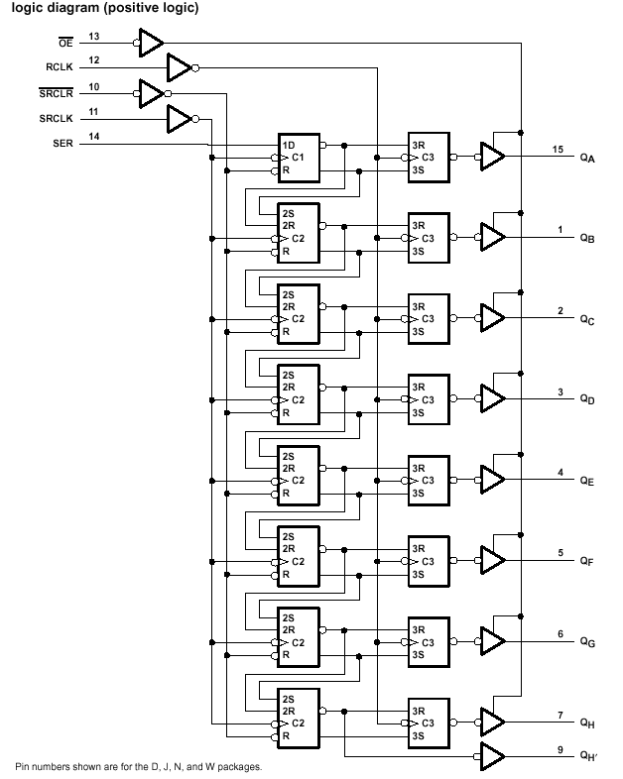

Appendix C. LDD5111 Dual 7-Segment Common-Cathode LED Display

Standard segment lettering: top horizontal bar = A, right top vertical= B, right bottom vertical = C, bottom horizontal = D, left bottom vertical = E, left top vertical = F, middle horizontal = G.
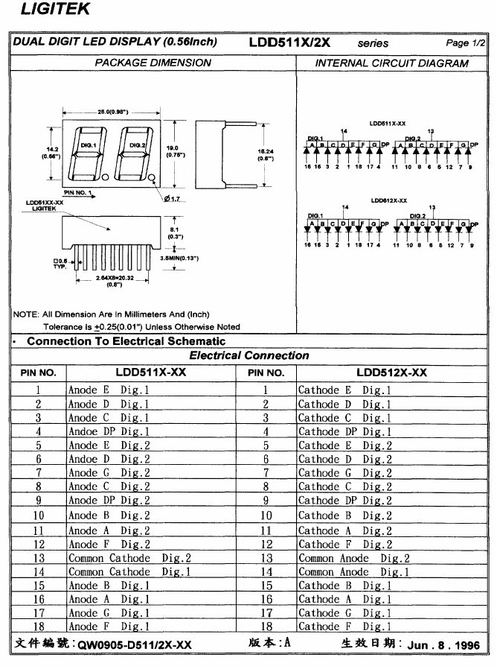

Appendix D: Debugging hints
- Whenever a new subroutine is created, check to make sure it ends with RTS and that the appropriate registers have been pushed onto the stack at the beginning of the subroutine and pulled off of the stack (in reverse order) at the end of the subroutine.
- Whenever an interrupt service routine is created, check to make sure the RTI instruction is the last one in the routine. Recall that all registers are automatically saved and restored automatically by the CPU, so you do not need to save and restore them in your software as you do in a subroutine.
- Always work with implementing one interrupt-driven application at a time first. Make sure it works as expected before you add a second interrupt-driven application or a third, etc.
- Make sure to carry out all initialization steps needed by your interrupt application correctly in the main program. All of your interrupt initialization must be done BEFORE you globally enable I-bit related interrupts by executing the CLI in your main program.
- Remember to initialize each relevant interrupt vector with the starting address of the interrupt routine.
- To find out if an interrupt service routine (ISR) is being properly vectored into, you should set a breakpoint at the beginning of the ISR. If the breakpoint is not hit, meaning that the ISR is not entered, you need to check the ISR’s initialization steps back in the main program. If, on the other hand, you do hit the breakpoint, you can then begin to single step through the ISR to see exactly what is going on and to debug it.
- Do NOT clear an interrupt flag using BSET, instead use MOVB
For example:
BSET TFLG1,4 ;do not clear TC2 this way—it is not reliable
MOVB #4,TFLG1 ;this is the reliable way to clear TC2
;as recommended by FreeScale (See FreeScale
;Application Note AN2554D.)
- You cannot single step into an SPIF flag (bit #7 of SPISR) flag testing instruction, such as
WT_SPIF_SET: BRCLR SPISR, $80, WT_SPIF_SET
because the SPIF flag is somehow reset by stepping through this instruction. You will get hung up in this loop forever! The workaround is to set a breakpoint just beyond this instruction…or you can click on the “step over” button instead of the “step into” button.
- For some reason, setting DDRAD bit #x to a 1 and also setting ATDDIEN bit #x to a 0 (declaring PADx to be an analog input) will still make PADx a digital output! If you are going to clear ATDDIEN bit #x, then you must also clear DDRAD bit #x as well.

