ECE342 Lab #3 Magnetic Field Coupling and Self and Mutual Inductance

Notes
- You should record your hardware setup, draw circuit diagrams if needed, and record all parameters and measured data for each experiment in your notebook. Each figure should be referred to in the text of your lab book write-up, and each figure must be labeled with both a figure number and also a descriptive caption.
- As with all lab project entries in your lab book in this course, you are expected to include enough text in each section of your lab book to explain what you are doing in each section of the lab. Your lab book should be written in “diary style”, and enough information must be present in your lab write-up so that it “stands alone”. Your lab book must include enough text, figures, and calculations so that a colleague with the same background as you could look at your notebook months later and be able to understand fully and easily what you were doing. Your lab book must be complete enough to allow your colleague to be able to completely reproduce your work from JUST the lab book.
- The three prelab problems for this lab MUST be correct and match the given answers in order to get any credit for this lab. Each group should submit one solution to the prelab questions in writing at the beginning of class. I will return these right away, so you can tape your solutions into your lab book.

Objectives
- To understand and find sefl-inductances of solenoidal and toroidal coils.
- To understand find mutual inductance and magnetic coupling coefficient of a transformer.
- To investigate magnetic field coupling with respect to distance between two coils and the magnetic permeability of the medium.

Deliverables
- Record procedure descriptions, circuits constructed, lab measurements and calculations in your lab notebook.
- Record your observations and explanations in your lab notebook.
- Submit your notebook the second class period after our lab session.

Equipment and Components
- Ruler with a cm scale (please bring with you.)
- Breadboard and lab kit components and wire stripper (bring with you)
- Soft iron laminations from an old power transformer (provided)
- Agilent Oscilloscope 54622D (100MHz, 200 Msa/s).
- Agilent Signal Generator 33120A (15 MHz).
- Two coils (provided)
- Two BNC to banana adaptors and one BNC T connector (provided)
- Powdered Iron Toroidal Core (provided)
- Hookup wire (provided)

Introduction and Prelab Problems

Self-inductance Calculation of Solenoidal Inductor and Toroidal Inductor
We found in class (Lecture 7) that the self-inductance of a long, thin solenoidal coil is given by
$L=\frac{{μN}^{2}A}{l}$ (Henrys),
where “L” is the self-inductance, “μ” is permeability of medium; “N” is the number of turns on the solenoid; “A” is the cross-sectional area of the solenoid; and “l” is the length of the solenoid. Recall that μ = μoμ_{R}, where μo = 4π*10⁻⁷ F/m.
We also showed in class (Lecture 7) that the self-inductance of a toroidal coil is given by
$L=\frac{{μN}^{2}h}{2π}\text{ln}(\frac{b}{a})$ (Henrys)
where “h” is the height of the toroidal core; “a” is its inner radius; and “b” is its outer radius (see the figure on p. 28 of Lecture 7 of the course notes).
Recall that the circuit model of an inductor is
$v=L\frac{\text{di}}{\text{dt}}$ (Volts)
where “v” is the voltage across the inductor, and “i” is the current flowing into the (+) terminal of the inductor, and L is inductance of the inductor.

Measurement of self inductance with an LC resonant circuit
There are at least three ways to measure the inductance of an inductor. It can be done with an LCR meter. It can be done be measuring phase and amplitude of both voltage across the inductor and current through it. It can also be done with an LC resonance circuit when the capacitance of C is known.
In this lab, the third method will be used to find inductance of several inductors.
When an inductor and a capacitor are connected in series or parallel, they form a resonant circuit where the resonant frequency is
$\text{fres}=\frac{1}{2π\sqrt{\text{LC}}}$ (Hz)
At this resonant frequency, a parallel LC circuit acts like an open circuit (since the admittances of the L and C component add to zero), and a series LC circuit at resonance acts like a short circuit (since the impedances of the L and C components add to zero).
If a capacitor with a known capacitance is placed in parallel with an unknown inductor, and the resonant frequency is found, the inductance of the inductor can be calculated.
Recall that a non-ideal capacitor may be modeled as the series connection of a small lead inductance, a small plate and wire resistance and the desired capacitance. A non-ideal inductor may be modeled as a lead capacitance that is in parallel with the series combination of the desired inductance and a small winding resistance. Refer to Chapter 6 of [2] for more details.
Prelab Question 1. Self-inductance Calculation
(a) Calculate the self-inductance of a solenoidal wound coil consisting of 21 turns on a 1-cm diameter air core. The coil is 3.3 cm long. (Ans: 1.32 μH)
(b) Calculate the self-inductance of a toroidal wound coil consisting of 16 turns of wire on a powdered iron coil form (μR = 15000) with an inner radius of 0.7 cm, an outer radius of 1.2 cm, and a height of 0.9 cm. (Ans: 3.73 mH)
Prelab Question 2. Self-inductance Measurement
(a) In the lab we may measure the inductance of an inductor by resonating it with a known capacitance. If you connect a known capacitor in series with the unknown inductor and then place this in parallel with an ac generator (with a built-in 50 ohm output resistance) and An oscilloscope, you may adjust the frequency of the generator for a sinusoidal voltage amplitude “dip”, which corresponds to the series resonant frequency “fres”, at which the series resonant circuit approximates a short circuit. The same method may be used if the capacitor is connected in parallel with the unknown inductor, except now you must adjust the frequency for a sinusoidal voltage maximum to find the resonant frequency “fres”. Which of these two methods do you expect will be more accurate? Do you expect the maximum or the dip to be more pronounced? Therefore, which of the two methods, series LC or parallel LC do you recommend for measuring the inductance of an unknown inductor? (Ans: Series LC)
(b) If fres is found to be 1.10 MHz for the solenoidal wound coil. The resonating capacitor is known to be 20.4 nF. Calculate the measured value of inductance of this coil. (Ans: 1.03 μH) Why might you suspect that the observed value will come out a bit lower than the predicted value. Explain in turns of flux linking each turn of the coil. (As was discussed in class.)
(c ) If fres is found to be 19 kHz for the toroidal wound coil, and the resonating capacitor is still 20.4 nF, find the measured value of inductance of this coil. (Ans: 3.44 mH)

Mutual Inductance M and magnetic coupling coefficient K_{m}
Recall that the mutual inductance between two coils, Coil 1 and Coil 2 is defined as
$M=\frac{v_{2}}{{\text{di}}_{1}\text{dt}}$ (Henrys),
where “M” is the mutual inductance between Coil 1 to Coil 2, “v₂” is the induced open-circuit voltage around Coil 2, and “i₁” is the source current flowing through Coil 1 [1].
Recall that the magnetic coupling coefficient is defined as
$K_{m}=\frac{M}{\sqrt{L_{1}L_{2}}}$.
where “M” is mutual inductance between Coil 1 and Coil 2, “L1” is the inductance of Coil 1 and “L2” is that of Coil 2.

Prelab Question 3. Mutual Inductance Measurement
- Two magnetically coupled coils L1 and L2 have self inductances of L1 = 1 mH and L2 = 3 mH. If a 1 MHz sinusoidal ac voltage of peak amplitude 2.00 V is placed across L1. In response, an open-circuit sinusoidal voltage of 1.50 V peak amplitude is observed across L2. Find the mutual inductance between the two coils and the coefficient of coupling “k”. (Hint: Recall that the mutual inductance measurement procedure was outlined at the end of Lecture 7.) (Ans: 0.75 mH, 0.433)
- Now if the 1 MHz sinusoidal voltage of 2.00 V peak amplitude is placed across L2, and if an open-circuit sinusoidal voltage of 0.50 V is observed across L1, find the mutual inductance “M” between the two coils and the coefficient of coupling “k”. Should we find the same M and k as in Part (a)? (Ans: 0.75 mH, 0.433)

Self Inductance Measurement
The signal source should be set to deliver a sinusoid whose frequency will be varied to find the resonant frequency of either the series or parallel LC resonant circuit. You are free to set its amplitude to any convenient value between 1 V, rms and 10 V, rms. Please record your settings.
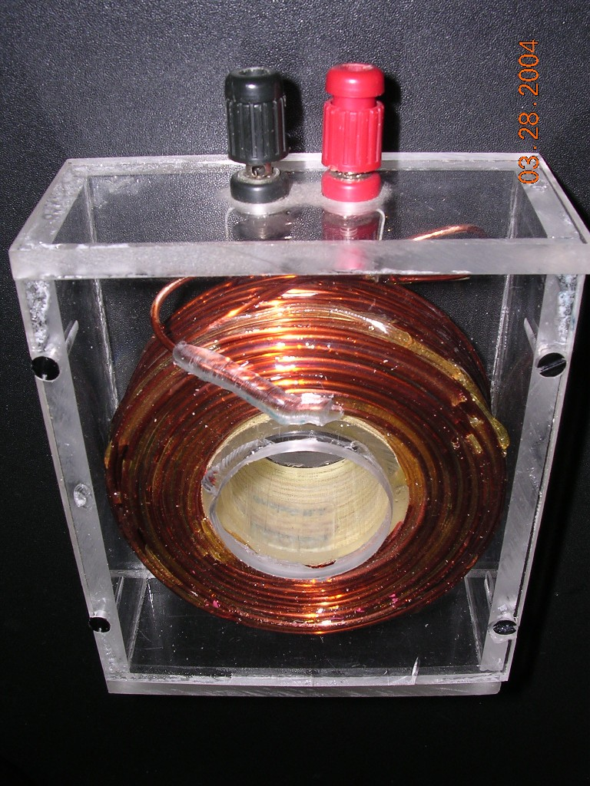
Two coils are provided and their pictures are shown in Fig. 1 below. In this lab handout, the larger of the two is assumed to be inductance L1 and the other L2.The inductors are borrowed from the Power Lab, courtesy of Professor Cliff Grigg.

Fig. 1. Air-wound inductors that are to be used in the first part of this lab project.
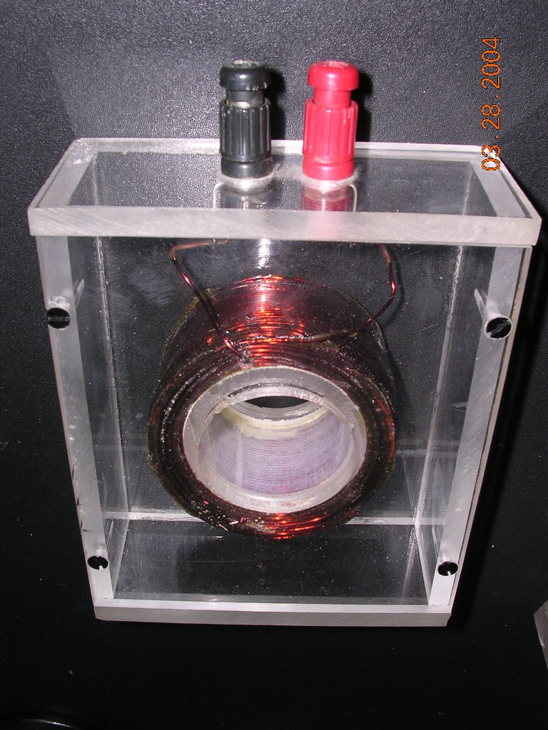

Estimating the inductances
- Measure the geometries of the coils and estimate the number of turns on each coil.
(Record)
- Use the long solenoid formula to estimate the inductance of each coil, assuming that medium is air.
(Record)
- Discuss possible errors with this method.
(Record)

Measuring inductances with your proposed resonance circuit
- Use a 22 nF = 0.022 μF capacitor. Measure its value with an LCR meter record the value. Use this more precise value for your calculations.
(Record)
- Use BOTH methods that were proposed earlier in your prelab work (parallel LC and series LC) to measure the self inductance of the coil. Compare your two results. If they differ significantly, do you trust one result more than the other? Explain.
(Record)
- Insert three iron strips and measure the inductance using the method that you trust the most.
(Record)
- Insert three more (six total) iron strips and measure the inductance using the method that you trust the most.
(Record)
- Repeat the three measurements (the inductance with 0, 3, and 6 iron strips) for the other inductor.
(Record)
- Discuss possible reasons for error.
(Record)

Measuring the inductances with the LCR meter
- Find the self-inductances of the two coils with a LCR meter.
(Record)
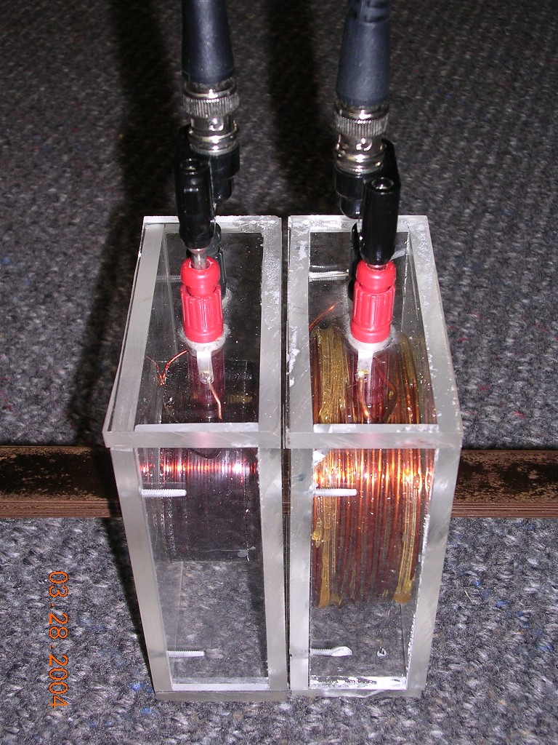
- Are they close to the measured values from the resonant circuit? Why or why not?
(Record)

Mutual Inductance Measurement
Two investigations are performed in this section. One is to measure mutual inductance between two closely-coupled coils with an iron core. The emphasis is on the frequency response of this setup. The other is to see how magnetic field coupling is related to distance and permeability of medium at a fixed frequency.

Mutual inductance of closely coupled coils
- Place L1 and L2 next to each other with no gap In between them. Insert six iron strips to couple the two coils.
- Connect the signal source to L1 and leave L2 open so that a voltage is induced in L2 when a voltage source is applied to L1.
- Find mutual inductance at 1 kHz, 10 kHz, 100 kHz, and 1 MHz. Record primary and induced peak voltage amplitude values. Calculate mutual inductance and magnetic coupling coefficient at each of these frequencies. Summarize your results in tabular form.
(Record)
- Do mutual inductance and induced voltage appear to depend on frequency of the signal source? Why or why not? Hint: You may find out that the permeability of soft iron appears to decrease with increasing frequency, thereby resulting in lower mutual inductance at higher frequency. This is due to the fact that the magnetic domain walls take time to move, and in the presence of a quickly changing H field, the domain walls may not have time to move to their final position before the direction of the applied H field changes!
(Record)

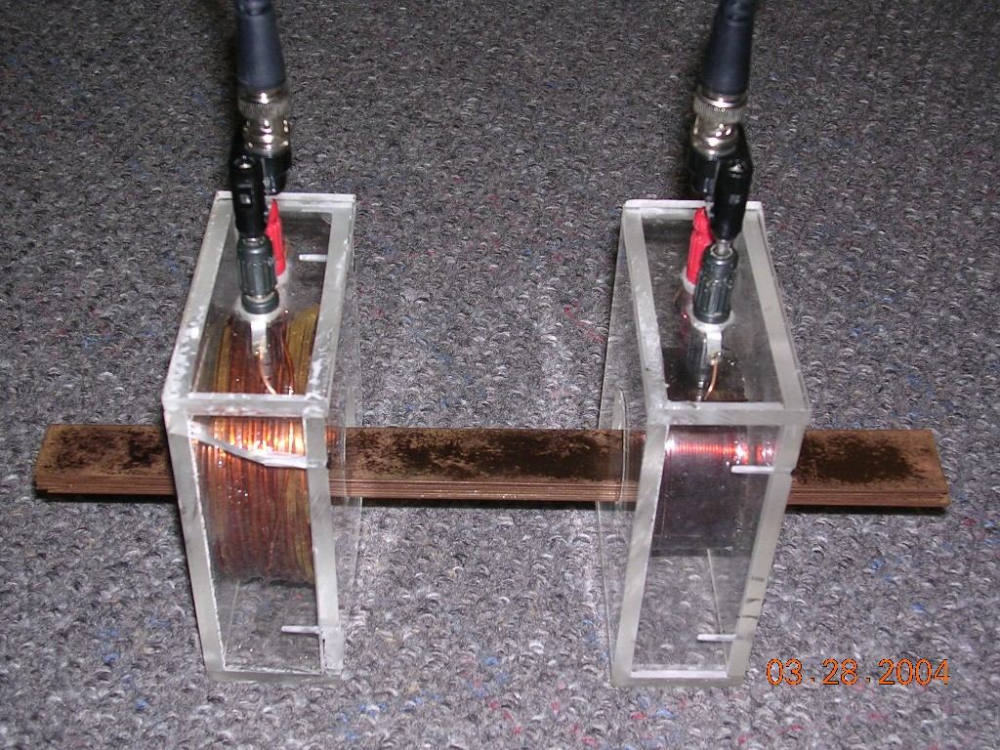
Magnetic field coupling investigation
- Set the frequency of the input signal to 10 kHz.
- From the last setup, move the coils to be 3” apart. Put six iron strips between the two inductors, as shown in the picture. Measure the mutual inductance, and calculate the coefficient of coupling “k”.
(Record)
- Now remove the six iron core strips, and measure the mutual inductance and calculate “k” when (a) the coils are 3” apart, (b) the coils are tightly coupled (0” apart), (c) the coils touch each other at a right (90 degree) angle.
(Record)
- Compare the five results and record your thoughts.
(Record)

Rolling Your Own Inductors!
(a) Solenoidal Inductor
  - Using ordinary hookup wire, wind a 25 turn solenoidal coil (closely wound) on a pencil or pen, and then remove the pencil or pen and let the coil expand. Being careful not to bend or pull apart this coil, carefully measure the relevant dimensions of the coil in centimeters, and then calculate its inductance using the formula derived in class, just as you did in Prelab Question 1.
  - Measure the self-inductance of the coil by resonating it with the 22 nF capacitor you used earlier.
  - Attempt to measure the self-inductance using the LCR meter. (The inductance of this coil may be too small to register on the LCR meter, but try it and see!)
  - Compare all three inductance results. Why do you expect the calculated inductance to be higher than the observed inductance?
(b) Toroidal Inductor
    - Using ordinary hookup wire, wind a 5-turn closely wound coil (L1) around one side of a toroidal powdered iron core (μ_{R} = 15000). Closely wind a 15-turn coil (L2) on the other side of the form. Measure the relevant dimensions of the coil form in centimeters, and then calculate the self-inductances of coils L1 and L2, using the formula derived in class, just as you did in Prelab Question 1.
    - Now measure each of these inductances (with the other coil’s terminals open-circuited) by resonating each of the coils with the 22 nF capacitor.
    - Measure each inductance using the LCR meter.
    - Compare all three self-inductance measurements.
    - Now connect a 2 V peak, 1 MHz sinusoidal voltage waveform across L1 and measure the peak open-circuit voltage across L2. (Also measure the voltage delivered by the signal generator across L1.) From these two voltage measurements, and the values of L1 and L2 that were measured in Step 2, find the mutual inductance “M” and the coefficient of coupling “k”.
    - Now connect the 2 V peak, 1 MHz sinusoidal voltage waveform across L2 and measure the peak open-circuit voltage across L1. From these two voltage measurements recalculate the mutual inductance and the coefficient of coupling. Your results should agree (within a reasonable error margin) with the results of Part 5.
    - Now attempt to increase the coefficient of coupling by rewinding the coil with one coil wound “inside” of (between the turns of, and in the middle of) the other coil. Assuming that the values of L1 and L2 have not changed, repeat Steps 5 and 6. The resulting coefficient of coupling should now come closer to unity, since the coils are more tightly coupled.

References
- Electromagnetics, John D. Kraus, 4th Edition, 1992.
- Introduction to EMC, Clinton R. Paul, 1992.

