Large inductor of 1.96 mH.

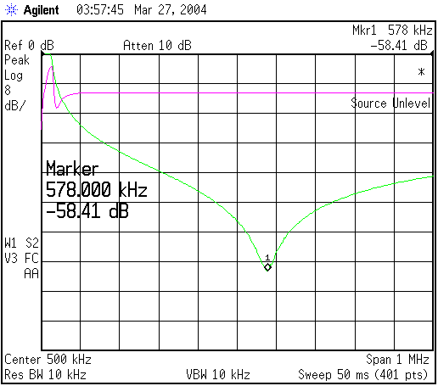

Small coil inductor of 3.26 mH

